Correspondence Functional Specification

  - Certificate of Insurance- CBA

Name of Publication/Attachment: | COI_Publication
Publication or Attachment: | Publication

Document Control

1.1 Document Revision History
Date | Version | Name | Description
20/11/2022 | 0.1 | Prakash K | Created Initial Draft
06/12/2022 | 0.2 | Prakash K | Added Motor
2/05/2023 | 0.3 | Prakash K | Added BPAY Changes
26/06/2023 | 0.4 | Muttu K / William T/Lokesh | Added screenshots , Endorsement scenarios & Special conditions
29/06/2023 | 1.0 | Muttu K / William T/Lokesh / Kester | Review & tidy up of old markups & comments
25/08/2023 | 1.0 | Will Turner
29/08/2023 | 1.1 | Andrew Froude | Transferred to new FSD Template  Started reformatting.
01/12/2023 | 1.2 | Sam Sehgal | FSD uplifted to new format and Logic broken down in different scenario.
18/12/2023 | 1.3 | Sam Sehgal | Uplifted logic and minor updates, final version of Baseline COI.
27/12/2023 | 1.4 | Sam Sehgal | Logic updates and Cosmetic updated from Dev and QA feedback.
04/01/24 | 1.5 | Sam Sehgal | Updated Odometer reading (start/end) for QA query 32.  Your start odometer: <OdoStartValue> KMS  Your end odometer: <OdoEndValue> KMS
04/01/24 | 1.5 | Sam Sehgal | Updated Sum insured & Basic Excess (style issue) Your policy summary (Home & Landlord) and headings updated to not bold for About your policy (motor) section (Bug 34)
04/01/24 | 1.5 | Sam Sehgal | Updated field name to <NonPAYDSwitchToPAYD> for Odometer reading section.
08/01/24 | 1.6 | Sam Sehgal | BldElectricMotorCovered & CntElectricMotorCovered data mapping query 15/16, logic updated
wte08/01/24 | 1.6 | Sam Sehgal | DiscountTypeCode variable name updated in discount section for data mapping query 17/18
08/01/24 | 1.6 | Sam Sehgal | <DocumentSubType> is to be used instead of PolicyTerm throughout the FSD.
08/01/24 | 1.6 | Sam Sehgal | NightLocation used for Parked at night field.
08/01/24 | 1.6 | Sam Sehgal | EndorsementClause logic in place instead of Driveragerestictions.
10/01/24 | 1.6 | Sam Sehgal | Removed duplicate instance of next payment due date for bug 321079
03/04/2023 | 1.7 | Sam Sehgal | - Updated the following to align with the PL201 mapping sheet:  - Changed the variable names to adhere to CCM standard  - Added revised logic for Option Selection fields which have both a code and a display value passed and we will define the logic against the code.  - Updated the Variables section to add the type of variable and any relevant comment  - Updated Common Content to align with the document
18/04/2024 | 1.8 | Sam Sehgal | - Updated Branding Layout and styles.
19/04/2024 | 2.0 | Sam Sehgal | - Accepted all changes prior to DD review
22/04/2024 | 2.1 | Sue Simnor | - Updated the First Page of the COI PH1, PH2 & PH3 - to use internal variables for the StartDate and EndDate year Eg: 2023 - 2024
01/05/2024 | 3.0 | Sam Sehgal | - Updated various section highlighted in yellow as per Will’s log of changes for COI sections as per the word doc and Version 1 maintained in Collaboration folder.
23/05/2024 | 4.0 | Sam Sehgal | - All updates for DD highlighted by William Turner have been made with track changes and highlighted in Yellow.
24/06/2024 | 5.0 | Sam Sehgal & William Turner | - Uplifted the FSD with all DD round 1 feedback highlighted in blue.
08/07/2024 | 6.0 | Sam Sehgal & William Turner | - Round 2 feedback from DD updated and highlighted in Green.
10/07/2024 | 6.1 | Sam Sehgal | - Created V6.1 to merge DD and QA/Dev issues fix which are now highlighted in Olive.
02/08/2024 | 6.4 | Andrew Froude | - Changed type to Publication  - Updated Phone/Email logic for Person/Organisation  - Updated the Renewal Migration Customer Retention Page 3 Logic  - Updated the TMD_EXCEPTIONS_Publication Logic  - Updated logic for EXH5/7/8/12  - Added and changed various references for clarity  - Removed duplicated text in logic  - Updated Transaction Date specification  - Added examples of Renewal Payment Summaries  - Simplified Your Odometer Reading section logic  - Split YP6 into multiple rows to simplify the logic
6/8/2024 | 6.5 | Sue Simnor | Accepted all changes except those defined in this change plus the changes defined for V6.4  Renewal Migration Customer Retention – Page 3 – Updated the logic section  Updated YRP10 & YRP11 section to use <CurrentTermGrossPremium>
8/8/2024 | 6.6 | Sue Simnor | Defect 440871 – Updated EXH 7/8/12 to change the field values and field label  DDH3 – Updated Total Claims Count field variable to use the new field of <VehicleTotalClaimsCount>  AYP7 – Updated <NoOfClaims> to <HomeNoOfClaims> to match variable in PL201 mapping sheet  YPM4 – Added new row to cater for Migrated Policies to show ‘Not ‘Recorded’ for overnight location
13/8/2024 | 6.7 | Sue Simnor | Defect 452796 - YC 10 – Clarified the logic to avoid duplicated text being displayed  Defect 437657 – SCM 6 - Updated Endorsement clause of MANUEND05 to be AUTOEND04  Defect 455061 – YB6 - Clarified the logic to avoid duplicated text being displayed  YB6 – updated text from ‘its’ to ‘it is’ for the text: “not confirmed whether it is heritage listed”  PS4 V1 & PS4 V2 & PS4 V3 – Added logic to ensure the display of the renewal text is unique  Added highlights in Aqua to the Renewal migration text for DD. NOTE: The dev has already been done on these updates but there may be green changes included for Dev/Test
14/8/2024 | 6.8 | Sue Simnor | Defect: 457625 - HIghlighted in Green  DDH 10 – Added new row for Migrated/Not Migrated policies  DDH 12 – Added new row for Migrated/Not Migrated policies  DDH 13 – Added logic for field label
20/08/2024 | 6.9 | Sam Sehgal | Updated YB 6, DDH 10-23 with logic and highlighted in Teal. Bug card- 437665 also updated in FSD.
21/8/2024 | 6.91 | Sue Simnor | DDH 2 & DDH 3 & DDH 4 – Added additional logic so the sections do not display if there are no claims. Also use the <VehicleTotalClaimsCount> instead of the Driver Claim Count for these sections.  Change in Yellow
27/8/2024 | 6.92 | Sue Simnor | Defect 461146 – MissingBPAY section – PM1 fragment - Updated the logic to use <CurrentTermGrossPremium> instead of <TotalAmountDue> as this field will not be populated prior to the first billing cycle.
28/8/2024 | 6.93 | Sue Simnor | - Defect 464776 – Change the logic for <NonPAYDSwitchToPAYD> to use ‘1’ and ‘0’ instead of ‘Yes’ and ‘No’. Fragments updated are: OR 2, AYM 8 and AYM 9
- Defect 465107 - PS 3/4/6/7 – Update the field from <transactionPremium> to <CurrentAnnualGrossPremium

- <IsAfterFinalPayment> field is being passed as ‘0’ or ‘1’. Updated the logic to change from ‘True’ or ‘False’ in the following rows: PS 2 V10/11/12 & PS 3 V4/5 & YRP 20/21/22/23/27
02/09/2024 | 6.94 | Sam Sehgal | Updated YB 6 section with YearOfConstruction logic for bug- 463430.
5/09/2024 | 6.95 | Sue Simnor | - Defect 463538 – SCM 2 - Special Conditions section (Motor) – Reformatted to ensure the ‘No Special Conditions apply’ text is only displayed when no other text in this section is displayed. The section contains multiple different field logic so we can default to ‘No Special Conditions apply’ text if no other is applicable  - SCH 2 – Special Conditions (Home) – Reformatted the section to ensure the ‘No Special Conditions apply’ text is only displayed when no other text in this section is displayed. The section contains multiple different field logic so we can default to ‘No Special Conditions apply’ text if no other is applicable  - Defect 467660 – Section Declarations & Driver History DDH 25 & DDH 26 - Remove superfluous left bracket from text as highlighted  - YC 13 – Updated to use the new <DamageOptionsDisplay> field passed in an array in the payload. Display all options passed if <ExistingDamageCode> is ‘True’.  - Defect 437662 YRC 9 – Updated the fields for Unspecified Items to now use the specified items fields as <SpecifiedItemsCategoryDisplay> and <Suminsuredunspecifiedportableitems>  - Removed Invoice condition in PS 2 V6-V9 to cater for all payment method raised under Bug- 468056, 473468 & 473193.  - Updated YB 6 for logic for Occupancy for bug- 471371  - Defect 475198 : Two changes:  - PS2 V4 – Changed to use <RefundAmount> rather than <CurrentAnnualGrossPremium>  - PS2 V3 – Reverted back to use <TransactionPremium> for Endorsement  - YRP 14 – Changed to use <RefundAmount> rather than <CurrentAnnualGrossPremium>  - Defect 471253 – YRP 8 – Updated to use <CardNumber> instead of <AccountNumber>
12/9/2024 | 6.96 | Sue Simnor/Sam Segal | All changes in GREEN  Changes to use the new <CurrentTermEffective Date> and <CurrentTermEffectiveTim>e in the following segments:  P1H1, P1H2, YPS 3, YPM 3, YB 6, CB 4, CB 5  YRP 11 & YRP12 - Use CurrentTermGrossPremium  YRP 14 - Added <RefundAmount> to logic  YRP 16 & YRP 17 - Changed to use <CurrentAnnualGrossPremium> and removed <PaymentMethod = INV logic  YRP 18 - Removed <PaymentMethod = INV logic  YRP 19 - Changed to use <CurrentAnnualGrossPremium> and removed <PaymentMethod = INV logic  YRP 22 - Changed to use <CurrentAnnualGrossPremium>  YRP 23 - Changed to use <RefundAmount>  Defect- 471371 - Updated SCH 4 V1 logic to “2|UnoccupiedNo” instead of “1|UnoccupiedYes” to display text in Special condition..  Defect- 475682 - Updated DDH 10-23 to add “Code” to logic
16/9/2024 | 6.97 | Sue Simnor | SIT Defects:  - Defect 475433 - SCM 3 & SCM 4 – Updated the Special Conditions Motor logic as follows:  SCM 3 – Use <EndorsementClause> = “AUTOEND01”  SCM 4 – Use <EndorsementClause> = “AUTOEND02”  - PS6 V3 & PS6 V4 – Added DD requested additional text as follows: ‘Monthly instalments may vary  slightly due to rounding but will not be more than the figure above during this period of insurance.’  - YB 6 – Updated the logic to <CurrentlyOccupiedCode> instead of <Occupied>  - Defect 477520 - SCH 5 - Update logic to <BusinessPurposeCode> = “1|HomeUsageBusinessUseYes”  - YPM 3 – Added a new row for Endorsements to use <DocumentDate> and <DocumentTime> to ensure the Endorsement is showing when the policy was updated.  - YPS 3A & YPS 3B – Added a new row for Endorsements to use <DocumentDate> and <DocumentTime> to ensure the Endorsement is showing when the policy was updated.  - PS2 V7 & YRP 17 - <TotalAmountDue> to be used instead of <CurrentAnnualGrossPremium> for bug – 478389. Change made by Sam on 17/09/2024.  - PS2 V6 & YRP 16 - <TotalAmountDue> to be used instead of <CurrentAnnualGrossPremium> for bug – 480551. Change made by Sam on 18/09/2024.  - Defect 468065 - YC 9 S1 – Added logic to ensure it does not display when YC 9 S2 displays. Added by Sue 18/9/2024  Also updated YPM 4 – renamed to YPM S1 and added a new row called YPM 4 S2 to display the Migration text which was missed previously. Added by Sue 18/9/2024  - Defect 481071 – PS3 V4 – Added an extra scenario for <PaymentDate> to be displayed when Transaction premium is < 0 and Amount Due > 0. Added by Sam 19/09/2024  - Defect 468080 - YB6 – Added further criteria for ‘currently or planned to be under construction or renovation text and for ‘used for business purposes. See section “Speical conditions and important notices’ below.  - Defect 463941 YB6 – Updated the logic to use <CurrentlyOccupiedCode> instead of <Unoccupied60days> Added by Sam 19/09/2024  - Updated logic and comments for Renewal Migration Customer Retention – Page 3. Added by Sam 20/09/2024  - Defect 482680 – SCM 2 & SCH 2 – Updated 2|Manual to be 3|Custom to cater for user entered Endorsements (Special Conditions). Added by Sue 23/09/2024  - SCM 7 – Added further logic of AUTOEND03 to ensure we are sent the Endorsement clause for the Excluded drivers  - Defect 473468 PS3 V4 & YRP 27 – Added further logic for Transaction premium = 0 & Amount Due > 0 to display <PaymentDate>.  - Task 487717- Updated sections P1 H1,P1 H2, YPS 3B, YPM 3, YB 6, CB 4 with <NextTermEffectiveDate> instead of <CurrentTermEffectiveDate>.  Updated sections P1 H1,P1 H2, YPS 3A, YPS 3B,YPM 3, CB 4 with <NextTermExpiryDate> instead of <CurrentTermExpiryDate>.  Added P1H3, YPS 3C, YPM 3C  Updated section CB5 with column 1 logic to use <NextTermEffectiveDate> & <NextTermExpiryDate> and Column 2 to use <CurrentTermEffectiveDate> & <CurrentTermExpiryDate> Updated by Sam 30/09/2024.  - Defect 475465 - OR2 – Update logic to not check for NonPAYDSwitcToPAYD field for New Business and also add Endorsement to the logic when checking for NonPAYDSwitcToPAYD  - Defect 492110 - AYM8 & AYM9 – Added logic for Odometer Reading footnote as it was displayed for all in error. Only display for PAYD.  - Defect 490904- Updated YPM 5 & YC 2 to only use <VehicleDescription>
14/10/2024 | 7.1 | San Sehgal | Updates made to Migration X value logic as per Will’s version of COI FSD and have also combined all QA/SIT/UAT bugs as captured in versions prior to V6.97. Also updated YRP 11 & 12 to use <NextTermEffectiveDate> instead of <RenewalDate>
21/10/2024 | 7.11 | Sue Simnor | - P1H4 – Remove the CoverageName from the start of the line so we have more room for the Vehicle Year/Make/Model to display  - AYM 11 – Change Digicall Roadside Assistance to Hollard Roadside Assistance  - YD3 – Change ‘Digicall’ to ‘Hollard’  - Updated YPS 10 to display sub-heading for Building & Contents Optional covers.
7/11/2024 | 7.12 | Sue Simnor | Defect 504703 – EXH 5 – Added further criteria to only shown the Portable Valuables excess if the policy has portable items selected as part of the Contents insurance  Updated the logic for PolicyHolders and Additional PolicyHolders to cater for:  - Temporary fix for Salutation for an Estate to prefix with ‘Estate of the Late’  - Use the <Trustee_CompanyName> or <TrusteeIndividualName> for a Trust if it is populated
12/11/2024 | 7.13 | Sam Sehgal | Defect 505307- Added condition for <HasAnyCriminalConvictionCode> = “1|CriminalTrue” AND <ConvictionTypeCode> = "7|Noneoftheabove" for sections AYP 8 V5, AYP 8 V13, DDH 12  Updated DDH 29 with extra logic added for 1st column display for <VehicleModificationCode>
14/11/2024 | 7.14 | Sue Simnor | Business Request: Do not display SMSF Name or Trust Name in the Policy Holder section. Logic is:  AYP3 & AYM 3 - If <ClientTypeCode> = ‘6|Trust or 7|SMSF  THEN DO NOT DISPLAY  ELSE
21/11/2024 | 7.15 | Sam Sehgal | - Updated CDC 2 with <PartnerPrivcyURL> & <BrandPrivacyURL> instead of hardcoded link.  - Added Weekly rental display for Landlord under YB 6  - Updated DDH 29 logic for modification for Migration.  - Updated YD 3 text as per Will’s confirmation.
06/12/2024 | 7.16 | Sam Sehgal | - Updated DDH 6 & 7 to use <EndorsementClause> instead of <HasDriverAgeRestrictions> for text logic.  - Updated WTE 4 hardcoded link to <BrandVunerableURL>
19/12/2024 | 7.17 | Sam Sehgal | - Incorporated all DD feedback for Migration and some cosmetic changes to certain sections of FSD. Updated sections AYP 8 V1, V2, V3, V4, V8, V10, V11,V12,V14.  - AYP 9-1,9-2,9-3  - AYM 8, 9  - YB 6  - DDH 13, 15, 19, 23, 24,2  - PS7 V2, YPS 11, YPM 5, CDC 2
30/01/2025 | 7.18 | Sam Sehgal | - Updated Cost Breakdown CB10-15 with new EO field and logic  - Updated previous term logic under CB9, CB11, CB13, CB15.
11/3/2025 | 7.19 | Sue Simnor | Defect 556466  Updated the following after discussing with Will Turner:  - AYP 9-4 to include additional logic to check if Hobby farm selected as currently it displays for every migrating customer.  - AYP 9-3B – Add a new row to cater for migrating customers who do not have a hobby farm.  Defect 503514  - YB 5AB – added a new row for Rental Property where the user selects ‘I rent’ in the UI as this did not have associated text (CR) to display “A rental property”  Defect 558520- Added extra logic or <BusinessPurposeCode> = ‘3|YesDisclosedInLegacyOnlyForMigration’)  Defect 558596- Updated the logic in YB 6 for <UnderConstruction> to use "3|YesCommencedBeforeMigrationMigrationOnly" instead of "1|UnderConstructionYes"
15/04/2025 | 7.20 | Sam Sehgal | Added AYP9-3B for logic to cater for Government owned residence only applicable for Contents only. Updated AYP9-3A logic to cater for this change.
30/04/2025 | 7.21 | Sam Sehgal | Updated YPM 3A, YPM 3C, YPS 3A,YPS 3C, CB 5 & P1H3, YRP 11 and YRP 12  to cater for date and time changes that DCOD have done under bug-572033.
16/05/2025 | 7.22 | Sam Sehgal | Updates made to section for Endorsement changes to not use <AmountDue> and <RefundAmount> and only use <TransactionPremium> that will be passed by DCOD as per the discussed changes  YRP 14,15,16,17,18,19,23,27  PS2 V3,V4,V5,V6,V7,V8,V9,V12  PS3 V4,V5
28/05/2025 | 7.23 | Sam Sehgal | Added PS 6 V6 wording and updated logic for DDH 3 and DDH 4 to always display.
06/06/2025 | 7.24 | SamSehgal | Updated PS2 V5 & YRP 15 to display “payment” instead of “premium”
21/07/2025 | 7.25 | Sam Sehgal | Updated YB 6, SCH 7 and SCH 8with changes made to Home and Landlord for Unoccupancy logic updates.

Document Review
Primary Distribution and Endorsement
Name | Role | Action Required | Approval | Comments

Document Approval
Primary Distribution and Endorsement
Name | Role | Action Required | Approval | Comments

Table of Contents
1. Document Control 1
1.1 Document Revision History 1
Document Review 9
Document Approval 9
2. Table of Contents 10
3. About this Document 12
3.1 Purpose 12
3.2 Scope 12
3.2.1 Brands 12
Journey Type 12
3.2.2 Documents in Scope 12
3.2.3 Delivery Channels 12
Attached to 12
Products 13
Audience 13
Assumptions 13
Document Dependencies 13
Attachment and Inserts 13
Document Type 14
Initiation/Trigger 14
4. Overall Certificate of Insurance Structure 15
4.1 Print/PDF (IF Delivery Channel = “Print” or “PDF” or “Email”) 15
4.2 Example 16
5. Content – A4 17
5.1 TMD Exceptions 17
5.2 Page 1 18
5.2.1 Example 18
5.2.2 Page 1 Header 19
Page 1 Body content 22
5.2.3 22
Cooling-off period (ALL) Left Column 31
Please note (ALL) (Right column) 33
Your Odometer Reading (Motor) - Right column 34
Your policy summary (Home & Landlord) Right Column 36
Your policy summary (Motor) 43
Page 2- COI 48
Check this document carefully – is it accurate, complete and up to date? (ALL) 48
Paperless (ALL) 50
Need to get in contact? (ALL) 51
Payment method (ALL) 53
About your policy (Home/Landlord) 55
About your policy (Motor) 80
Your building (Home/Landlord) 91
Your car (Motor) 110
Declarations and driver history (Motor) 119
Excesses (Motor) 133
Security Features (Home/Landlord) 136
Your contents (Home/Landlord) 140
Special Conditions (Home/Landlord) 143
Excesses (Home/Landlord) 149
Special Conditions (Motor) 155
Cost Breakdown (ALL) 159
Your payments (ALL) 183

About this Document

3.1 Purpose
This document specifically covers off the detailed information that is required to be shown on the Certificate of Insurance

3.2 Scope

3.2.1 Brands
This document is to be used with the following Brand/s
- CBA Insurance

Journey Type
New Business | Endorsement | Renewal
x | x | x

3.2.2 Documents in Scope
The following documents are required to be developed as part of this functional design document:

- Certificate of Insurance

3.2.3 Delivery Channels
The delivery channel is determined by the Delivery Option in the initiation request and the <DeliveryChannelCode> in the XML data. As all communications are archived as part of the central process they do not need to be specified here.

Email (Body) | Email as Attachment | Email Attachment | Print | PDF | Print Attachment | SMS
 | x |  | x |  | x

Attached to
If this is an Attachment, then please list the Publications it is used with. If this is NOT an Attachment please leave this table blank

Publication Name | Scenario or DocSubType | Mandatory or Optional
Policy Welcome | NewBusiness | Mandatory
Policy Endorsement | Endorsement | Mandatory
Policy Auto Renewal | Renewal | Mandatory
Renewal Offer | Renewal | Mandatory

Products
Applicable for the following products:

Motor | Home | Landlord
x | x | x

Audience
This document will be used by:
- Direct business to validate that the requirements have been accurately detailed.
- Development Team for designing and developing the preferred solution.
- User Acceptance test team for testing the delivered solution and determining whether it adequately satisfies all agreed requirements

Assumptions
The following assumptions have been made:
- All text fields that exceed the designated space on the line on which they initially appear, should wrap to second and subsequent line(s)
- Table rows should not be split unless specified

Document Dependencies
This document depends on the following documents and therefore they must be read in conjunction with this document.

Document | Purpose | Comments
Global Decode Sheet | Provides the common/active content definition | Values from this document are shown in the following specification as follows.  **ContentID**
Styles | Defines the Styles used per Brand | Styles are not to include Brand or Channel details, which will be added dynamically within the Publication/Template design
Attachments | Details the static attachments that may or may not be required, and their related Mailhouse Insert equivalent | This document is not designed for dynamically created attachments which are generated within EngageOne

Attachment and Inserts
This Publication uses, or may use, the following attachments and/or ‘Inserts’.
All Static Attachments must be registered in the Attachments register file.

Attachment Name | Source | Mandatory/Optional (+ Optional logic) | Static Attachment Journal Reference Name
NA | NA | NA | NA
Please note: An Attachment CAN NOT have an attachment. If there is another attachment related to the primary communication it needs to be specified separately, and the above table needs to be updated in the primary communication.

Document Type

Document Type | Host System Input required | Host System Input
On-demand | N

Initiation/Trigger
This table defines the method in which this Publication is initiated/triggered, which is either manually or automatically as part of Host System event. If a Publication requires additional input either in the Host System or within an EngageOne Interactive document this must be set to Manual.

Trigger Type | Auto Trigger Event | Comment
Automatic | Sent with Policy Welcome, Policy Endorsement, Policy Renewal & Renewal Offer

Overall Certificate of Insurance Structure

Print/PDF (IF Delivery Channel = “Print” or “PDF” or “Email”)
Please note the COI does not follow the standard letter layout. It follows Layout 4 as defined below. Therefore, this document specifies all aspects of layout including Headers and Footers. Below an overview of the structure that will be used across the Certificate of Insurance. In addition to the Content for the Banner and Footers, will be as detailed in the Branding and Layout Functional Specification.

Layout 1 | Layout 2 | Layout 3 | Layout 4
 |  |  | X

Please note the COI is always formatted as an A4 Page and therefore there is not an Email version.

Example
…

Please note the examples pages above need to be revised to reflect recent changes

Content – A4

TMD Exceptions

The following Publication is to be inserted into the COI as the First Page (Page 1 – which will appear after the Cover Letter if Printed and the first page of the COI Email attachment), based on the following logic:

Publication | Logic | Comment
TMD_EXCEPTIONS _Publication | Insert TMD_EXCEPTIONS_Publication  IF DocumentSubType> = ‘Renewal’ AND  (<TPPDTPFTFinanceTMD> IS NOT NULL  OR IF <TPFTSumInsuredTMD> IN NOT NULL  OR IF <SumInsuredRatioTMD> IS NOT NULL)  ELSEIF SKIP | The content of the inserted pages is based on the logic within the TMD_EXCEPTIONS_Publication FSD, which can be found here: FSD

Please note the TMD EXCEPTIONS are to be Layout 1 Page 2-n to match the Cover Letter, and therefore does not have page numbering.

Page 1

Example
Please note this example does not show the System Date (Document creation date in EO), which is to be added the top of the page.

Page 1 Header
P1H3
P1H4
P1H2
Icon

Ref | Variables | Content | Logic | Style
P1H1 | <ProductCode>  <CurrentTermEffectiveDate>  <CurrentTermExpiryDate> | CBA_icon_home.jpg {StartYear} – {ExpiryYear} Certificate of Insurance | IF <ProductCode> = “Home”  AND <DocumentSubType> = "NewBusiness" OR "Endorsement"  THEN Display  Dev Note – Use the 4 digit YYYY from <CurrentTermEffectiveDate> to display the {StartYear} variable and <CurrentTermExpiryDate> to display the {ExpiryYear} variable | Heading_1_COI
 |  | CBA_icon_car.jpg {StartYear} – {ExpiryYear} Certificate of Insurance | IF <ProductCode> = “Auto”  AND <DocumentSubType> = "NewBusiness" OR "Endorsement"  THEN Display  Dev Note – Use the 4 digit YYYY from <CurrentTermEffectiveDate> to display the {StartYear} variable and <CurrentTermExpiryDate> to display the {ExpiryYear} variable | Heading_1_COI
P1H2 | <ProductCode>  <CurrentTermEffectiveDate>  <CurrentTermExpiryDate> | CBA_icon_landlord.jpg {StartYear} – {ExpiryYear} Certificate of Insurance | IF <ProductCode> = “Landlord”  AND <DocumentSubType> = "NewBusiness" OR "Endorsement"  THEN Display  ENDIF  Dev Note – Use the 4 digit YYYY from <CurrentTermEffectiveDate> to display the {StartYear} variable and <CurrentTermExpiryDate> to display the {ExpiryYear} variable | Heading_1_COI
P1H3 | <ProductCode>  <CurrentTermEffectiveDate>  <CurrentTermExpiryDate> | CBA_icon_landlord.jpg {StartYear} – {ExpiryYear} Certificate of Insurance | IF <ProductCode> = “Home” or “Auto” or “Landlord”  AND <DocumentSubType> = "Renewal"  THEN Display  ENDIF  Dev Note – Use the 4 digit YYYY from <CurrentTermEffectiveDate> to display the {StartYear} variable and <CurrentTermExpiryDate> to display the {ExpiryYear} variable | Heading_1_COI
P1H4 | <ProductCode>  <ProductCover Type>  <HomeCoverTypeCode>  <VehicleCoverTypeDisplay>  <VehicleYear>  <VehicleMake>  <VehicleModel> | Building Insurance | IF <ProductCode> = "Home" AND <HomeCoverTypeCode> = "2|Building" THEN display  ELSEIF | Heading_3_COI
 |  | Building and Contents Insurance | ELSEIF <ProductCode> = "Home" AND <HomeCoverTypeCode> = "5|BuildingAndContents"  THEN display  ELSEIF
 |  | Contents Insurance | ELSEIF <ProductCode> = "Home" AND <HomeCoverTypeCode> = "3|Contents" THEN display ELSEIF
 |  | Landlord Insurance | ELSEIF <ProductCode> = "Landlord"  THEN display  ELSEIF
 |  | <VehicleYear> <VehicleMake> <VehicleModel> | IF <ProductCode> = "Auto"  THEN display  ELSE do not display
P1H5 | <PolicyNumber> | <PolicyNumber> | Always display | Heading_3_COI

Page 1 Body content

Transaction Date

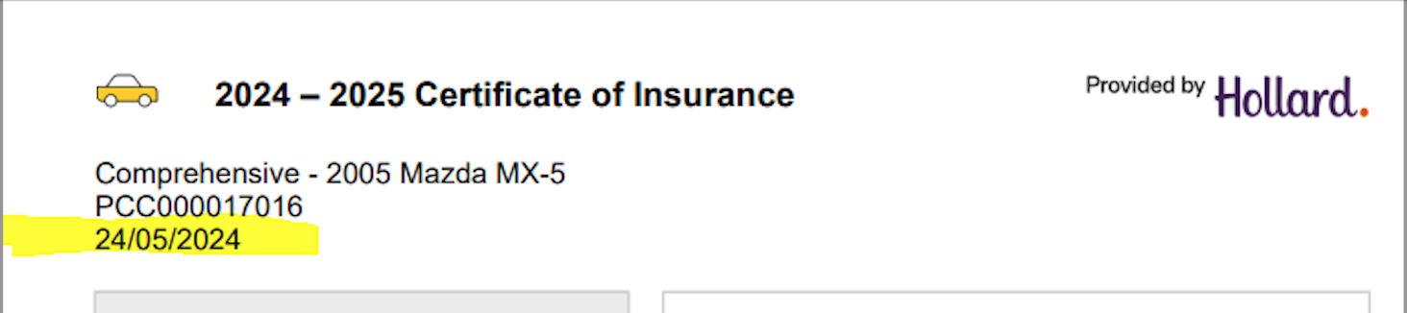
TD 1

Date to be displayed after and outside the Header, as a full-page width row that spans across the 2 columns that follow.
Please note the example is a screen shot and although it is highlighted this is not the be in the output.

TD 1 | EO System Date | Date: EO System date (example DD/MM/YYYY) | Always display  Note: This is the date document gets generated once EO gets a request to generat. | Bodycopy_COI

Your payment summary (ALL) Left Column

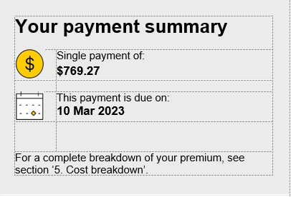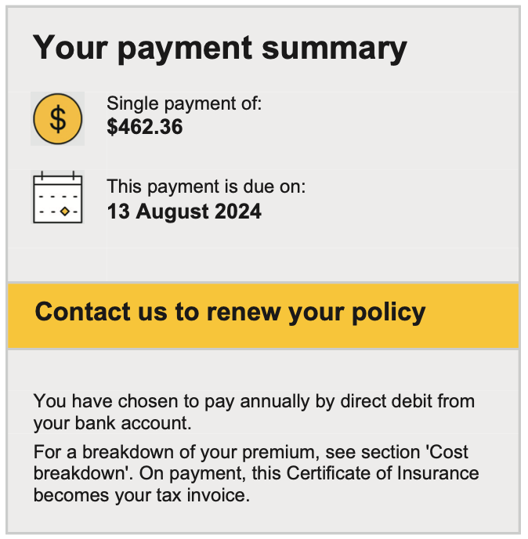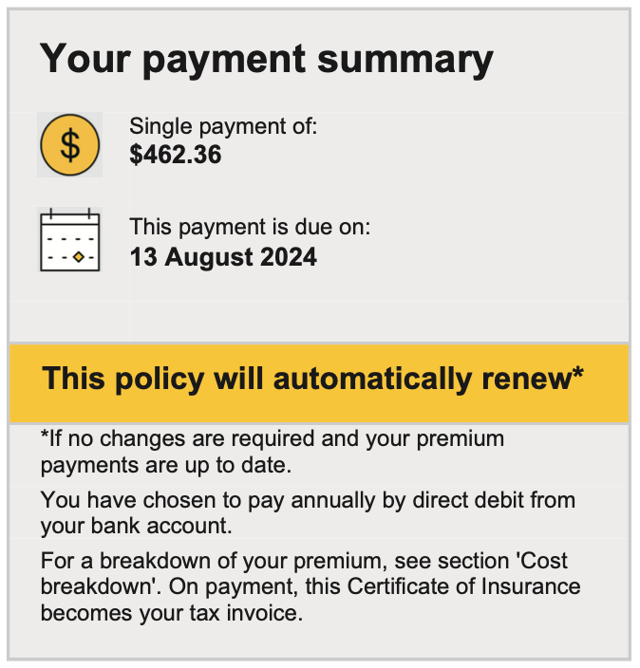
PS 6
PS 7
PS 6
PS 5
PS 7
PS 7
PS 4
PS 4
PS 3
PS 3
PS 3
PS 2
PS 2
PS 2
PS 1
PS 1
PS 1

Ref | Variables | Content | Logic | Style
PS 1 |  | Your payment summary | Always display | Heading_1_COI
PS2 V1 | <DocumentSubType> <PaymentFrequencyCode>  <CurrentTermGrossPremium> | Brand_icon_dollarcircle1.jpg Single payment of:  $ <CurrentTermGrossPremium> | IF<DocumentSubType> = "NewBusiness" OR "Renewal" AND <PaymentFrequencyCode> = "2|PaymentPlanAnnual" THEN display | Heading text:  Table_Bodycopy_S_COI  $ amount text:  Table_Bodycopy_B_COI
PS2 V2 | <DocumentSubType> <PaymentFrequencyCode>  <CurrentTermGrossPremium> | Brand_icon_dollarcircle1.jpg Your monthly instalment:  $ <CurrentTermGrossPremium> | ELSEIF<DocumentSubType> = "New Business" OR "Renewal" AND <PaymentFrequencyCode> = "1|PaymentPlanMonthly" THEN display | Heading text:  Table_Bodycopy_S_COI  $ amount text:  Table_Bodycopy_B_COI
PS2 V3 | <DocumentSubType> <PaymentFrequencyCode> <TransactionPremium>  <AmountDue> | – Your payment:  $ <TransactionPremium> | ELSEIF<DocumentSubType> = "Endorsement" AND <PaymentFrequencyCode> = " 2|PaymentPlanAnnual"  AND <TransactionPremium> >”0”  THEN display | Heading text:  Table_Bodycopy_S_COI  $ amount text:  Table_Bodycopy_B_COI
PS2 V4 | <DocumentSubType> <PaymentFrequencyCode> <TransactionPremium>  <AmountDue>  <RefundAmount> | Brand_icon_dollarcircle1.jpg Your refund:  $ <TransactionPremium> | ELSEIF<DocumentSubType> = "Endorsement"  AND <PaymentFrequencyCode> = "2|PaymentPlanAnnual"  AND <TransactionPremium> <”0”  THEN display | Heading text:  Table_Bodycopy_S_COI  $ amount text:  Table_Bodycopy_B_COI
PS2 V5 | <DocumentSubType> <PaymentFrequencyCode> <TransactionPremium>  <AmountDue> | Brand_icon_dollarcircle1.jpg Your payment:  No additional payment | ELSEIF<DocumentSubType> = "Endorsement" AND <PaymentFrequencyCode> = " 2|PaymentPlanAnnual " AND <TransactionPremium> = “0”  THEN display | Heading text:  Table_Bodycopy_S_COI  $ amount text:  Table_Bodycopy_B_COI
PS2 V10 | <DocumentSubType> <PaymentFrequencyCode> <TransactionPremium>  <CurrentTermGrossPremium>  <IsAfterFinalPayment> | Brand_icon_dollarcircle1.jpg Your new monthly instalment:  $ <CurrentTermGrossPremium> | ELSEIF<DocumentSubType> = "Endorsement"  AND <PaymentFrequencyCode> = "1|PaymentPlanMonthly " AND <TransactionPremium> != “0” AND when <IsAfterFinalPayment> = "0"  THEN display | Heading text:  Table_Bodycopy_S_COI  $ amount text:  Table_Bodycopy_B_COI
PS2 V11 | <DocumentSubType> <PaymentFrequencyCode> <TransactionPremium> <IsAfterFinalPayment> | Brand_icon_dollarcircle1.jpg Your payment:  $ <CurrentAnnualGrossPremium> | ELSEIF<DocumentSubType> = "Endorsement"  AND <PaymentFrequencyCode> = "1|PaymentPlanMonthly " AND <TransactionPremium> > “0”  AND <IsAfterFinalPayment> = "1"  THEN display | Heading text:  Table_Bodycopy_S_COI  $ amount text:  Table_Bodycopy_B_COI
PS2 V12 | <DocumentSubType> <PaymentFrequencyCode> <TransactionPremium> <IsAfterFinalPayment> | Brand_icon_dollarcircle1.jpg Your refund: Your monthly instalment:  $ <TransactionPremium> $ InstalmentAmount | ELSEIF <DocumentSubType> = "Endorsement"  AND <PaymentFrequencyCode> = "1|PaymentPlanMonthly " AND <TransactionPremium> < “0”  AND <IsAfterFinalPayment> = "1"  THEN display | Heading text:  Table_Bodycopy_S_COI  $ amount text:  Table_Bodycopy_B_COI
PS2 V13 | <DocumentSubType> <PaymentFrequencyCode> <TransactionPremium>  <CurrentTermGrossPremium> | Brand_icon_dollarcircle1.jpg Monthly instalment:  $ <CurrentTermGrossPremium> | ELSEIF<DocumentSubType> = "Endorsement"  AND <PaymentFrequencyCode> = "1|PaymentPlanMonthly"  AND <TransactionPremium> = “0”  THEN display  ENDIF | Heading text:  Table_Bodycopy_S_COI  $ amount text:  Table_Bodycopy_B_COI
PS3 V1 | <DocumentSubType> <PaymentFrequencyCode> <TransactionPremium>  <PaymentDate> | Brand_icon_calendar1.jpg This payment is due on:  <PaymentDate> | IF<DocumentSubType> = "New Business" OR "Renewal" AND <PaymentFrequencyCode> = “2|PaymentPlanAnnual”  THEN display | Heading text:  Table_Bodycopy_S_COI  $ amount text:  Table_Bodycopy_B_COI
PS3 V2 | <DocumentSubType> <PaymentFrequencyCode> <TransactionPremium>  <PaymentDate> | Brand_icon_calendar1.jpg First payment is due on:  <PaymentDate> | ELSEIF<DocumentSubType> = “New Business OR “Renewal” AND <PaymentFrequencyCode> = “1|PaymentPlanMonthly” THEN display | Heading text:  Table_Bodycopy_S_COI  $ amount text:  Table_Bodycopy_B_COI
PS3 V3 | <DocumentSubType> <PaymentFrequencyCode> <TransactionPremium>  <PaymentDate> | Brand_icon_calendar1.jpg Payment due date:  <PaymentDate> | ELSEIF<DocumentSubType> = "Endorsement"  AND <PaymentFrequencyCode> = "2|PaymentPlanAnnual "  AND <TransactionPremium> > ”0”  THEN display | Heading text:  Table_Bodycopy_S_COI  $ amount text:  Table_Bodycopy_B_COI
PS3 V6 | <DocumentSubType> <PaymentFrequencyCode> <TransactionPremium> <IsAfterFinalPayment>  <PaymentDate> | Brand_icon_calendar1.jpg Next payment due date:  <PaymentDate> | ELSEIF<DocumentSubType> = "Endorsement" and <PaymentFrequencyCode> = “1|PaymentPlanMonthly”  AND <IsAfterFinalPayment> = "0"  THEN display | Heading text:  Table_Bodycopy_S_COI  $ amount text:  Table_Bodycopy_B_COI
PS3 V7 | <DocumentSubType> <PaymentFrequencyCode> <TransactionPremium> <IsAfterFinalPayment>  <PaymentDate> | Brand_icon_calendar1.jpg Premium due date:  <PaymentDate> | ELSEIF<DocumentSubType> = "Endorsement"  AND <PaymentFrequencyCode> = "1|PaymentPlanMonthly " AND <TransactionPremium> >”0” AND <IsAfterFinalPayment> = "1"  THEN display | Heading text:  Table_Bodycopy_S_COI  $ amount text:  Table_Bodycopy_B_COI
PS4 V1 | <DocumentSubType> <RenewalTypeCode> | This policy will automatically renew* | IF <DocumentSubType>= "Renewal"  AND <RenewalTypeCode>=”1|AutoRenewal” and <PaymentMethodCode> NOT = “INV”  THEN display | Heading_1_COI  Background:  RGB Colour 255,204,0  HEX Colour #FFCC00  CMYK Colour 0/24/94/0
PS4 V2 |  | Pay now to renew your policy | ELSEIF <DocumentSubType>= "Renewal"  AND <PaymentMethodCode> = “INV” AND <RenewalTypeCode> NOT =”2|ForceManualRenewal”  THEN display | Heading_1_COI  Background:  RGB Colour 255,204,0  HEX Colour #FFCC00  CMYK Colour 0/24/94/0
PS4 V3 |  | Contact us to renew your policy | ELSEIF <DocumentSubType>= "Renewal"  AND <RenewalTypeCode>=”2|ForceManualRenewal”  THEN display  ELSE do not display  ENDIF | Heading_1_COI  Background:  RGB Colour 255,204,0  HEX Colour #FFCC00  CMYK Colour 0/24/94/0
PS5 V1 | <DocumentSubType> <RenewalTypeCode>  <PaymentMethodCode>  <PaymentFrequencyCode>  <BrandPhoneNumberServicing> | *If no changes are required and your premium payments are up to date. | IF <DocumentSubType>= "Renewal" AND <RenewalTypeCode>=”1|AutoRenewal”  THEN display | Table_Bodycopy_S_COI
PS5 V2 |  | Please contact us on <BrandPhoneNumberServicing> before the due date. | ELSEIF <DocumentSubType>= "Renewal"  AND <RenewalTypeCode>=”2|ForceManualRenewal”  THEN display  ENDIF | Table_Bodycopy_S_COI  Table_Bodycopy_S_B_COI
PS6 V1 | <PaymentFrequencyCode>  <PaymentMethodCode> | You have chosen to pay annually by direct debit from your bank account. | IF <PaymentFrequencyCode> = "2|PaymentPlanAnnual "  AND <PaymentMethodCode> = “EFT”  THEN display | Table_Bodycopy_S_COI
PS6 V |  | You have chosen to pay annually by direct debit from your credit card. | ELSEIF <PaymentFrequencyCode> = "2|PaymentPlanAnnual "  AND <PaymentMethodCode> = “EFTC”  THEN display | Table_Bodycopy_S_COI
PS6 V3 |  | You have chosen to pay monthly by direct debit from your bank account. Monthly instalments may vary slightly due to rounding but will not be more than the figure above during this period of insurance. | ELSEIF <PaymentFrequencyCode> = "1|PaymentPlanMonthly"  AND <PaymentMethodCode> = “EFT”  THEN display | Table_Bodycopy_S_COI
PS6 V4 |  | You have chosen to pay monthly by direct debit from your credit card. Monthly instalments may vary slightly due to rounding but will not be more than the figure above during this period of insurance. | ELSEIF <PaymentFrequencyCode> = "1|PaymentPlanMonthly "  AND <PaymentMethodCode> = “EFTC”  THEN display | Table_Bodycopy_S_COI
PS6 V5 |  | You have chosen to pay annually by invoice. | ELSEIF <PaymentFrequencyCode> = "2|PaymentPlanAnnual "  AND <PaymentMethodCode> = “INV”  THEN display  ENDIF | Table_Bodycopy_S_COI
PS6 V 6 |  | This amount relates to the changes made to your policy effective <TransactionDate>. | IF <DocumentSubType> = "Endorsement" AND <PaymentFrequencyCode> = " 2|PaymentPlanAnnual"  AND <TransactionPremium> <> “0”  THEN Display  Else do not display | Table_Bodycopy_S_COI
PS7 V1 | <DiscountTypeCode> | Your discount has been applied. For a breakdown of your premium and any applicable discounts, see section 'Cost breakdown’. On payment, this Certificate of Insurance becomes your tax invoice. | IF <DiscountTypeCode> <> NULL  THEN display | Table_Bodycopy_S_COI
PS7 V2 |  | For a breakdown of your premium, see section 'Cost breakdown’. On payment, this Certificate of Insurance becomes your tax invoice. | ELSEIF  <DiscountTypeCode> = NULL  THEN display  ELSEIF Do not display  ENDIF

Cooling-off period (ALL) Left Column
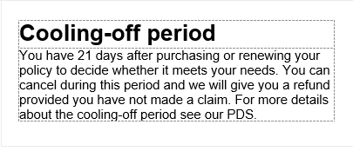

Ref | Variables | Content | Logic | Style
CO1 |  | Cooling-off period  You have 21 days after purchasing or renewing your policy to decide whether it meets your needs. You can cancel during this period and we will give you a refund if due, provided you have not made a claim. Even after this cooling off period ends, you still have cancellation rights. For more details about the cooling off period see the PDS. | Always display | Heading:  Heading_1_COI  Text:  Table_Bodycopy_S_COI

Please note (ALL) (Right column)
PN 1

Ref | Variables | Content | Logic | Style
PN 1 V1 | <DocumentSubType>  <ProductCode> | Please note: Your sum insured may have changed. If you wish to adjust the sum insured, please contact us on <BrandPhoneNumberServicing> between <BrandWorkhoursServicing>. | IF <DocumentSubType> = "Renewal" AND <ProductCode> = “Auto”  AND <Cover Type> = ("Comprehensive" OR "Comprehensive Saver")  AND <SumInsuredType> = "Agreed Value")  THEN display | Bodycopy_B  Bodycopy_COI Bodycopy_B_COI
PN 1 V2 | <DocumentSubType>  <ProductCode> | Please note: Your sum insured may have changed. If you wish to adjust the sum insured, please contact us on <BrandPhoneNumberServicing> between <BrandWorkhoursServicing>. | ELSEIF <DocumentSubType> = "Renewal"  AND <ProductCode> = “Home” OR “Landlord”  THEN display  ELSE do not display  ENDIF

Your Odometer Reading (Motor) - Right column

Ref | Variables | Content | Logic | Style
 | <VehicleCoverTypeCode> | INSERT Your Odometer Reading Section | IF <ProductCode>=”Auto”  AND <VehicleCoverTypeCode>= "2|Payasyoudrive”  ELSEIF Do not display
OR1 | <VehicleCoverTypeCode> | Your odometer reading | Always display | Heading_1_COI
OR 2 | <DocumentSubType>  <NonPAYDSwitchToPAYD>  <OdoStartValue>  <OdoEndValue> | Your start odometer: 0 7 6 8 0 0 KMS  Your end odometer: 0 9 0 8 7 7 KMS | IF <DocumentSubType> = "New Business"  OR (<DocumentSubType> = "Renewal" OR "Endorsement" AND <NonPAYDSwitchToPAYD> = “1”)  THEN display  <OdometerStartValue> &  <OdometerEndValue> | Your start odometer & Your end odometer style:  Table_Bodycopy_S_COI  ODO kms Table Style:  Odo_Table_1_COI  ODO kms Style:  Odo_1_COI  KMS Style:  Table_Bodycopy_S_COI
 |  | Your end odometer: 0 9 0 8 7 7 KMS | ELSEIF <DocumentSubType> = “Endorsement” OR "Renewal"  AND <NonPAYDSwitchToPAYD> = “0”  THEN display  <OdometerEndValue> | Your end odometer style:  Table_Bodycopy_S_COI  ODO kms Table Style:  Odo_Table_1_COI  ODO kms Style:  Odo_1_COI  KMS Style:  Table_Bodycopy_S_COI
OR 3 |  | Check you are comfortable with your end odometer reading. Additional excesses may apply . See section ' About your policy' for further details on your Comprehensive Saver cover. | Always display | Table_Bodycopy_B_COI

Your policy summary (Home & Landlord) Right Column
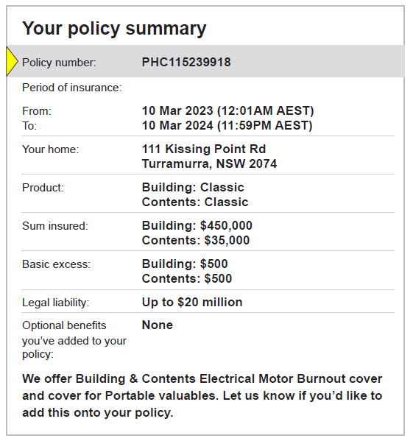
YPS 10
YPS 9
YPS 8
YPS 7
YPS 6
YPS 5
YPS 4
YPS 3
YPS 2
YPS 1

Ref | Variables | Content | Logic | Style
YPS 1 V1 | <DocumentSubType> | Your policy summary | IF <DocumentSubType> = "NewBusiness"  THEN display | Heading_1_COI
YPS 1 V2 | <DocumentSubType> | Your updated policy summary | ELSEIF <DocumentSubType> = "Endorsement"  THEN display | Heading_1_COI
YPS 1 V3 | <DocumentSubType> | Your renewal policy summary | ELSEIF <DocumentSubType> = "Renewal”  THEN display  ELSE do not display  ENDIF | Heading_1_COI
YPS 2 | <PolicyNumber> | Brand_icon_triangle1.jpg Policy number: <PolicyNumber> | Always display | Column 1 text:  Table_Bodycopy_S_COI  Column 2 text:  Table_Bodycopy_B_COI  Brand_icon_triangle1.jpg  Image Size: 47 x 94px (4x8mm)  Resolution: 300 x 300dpi
YPS 3A | <TransactionDate>  <TransactionTime>  <CurrentTermExpiryDate>  <CurrentTermExpiryTime> | Period of insurance:  From: <TransactionDate> (<TransactionTime> AEST/AEDT)  To: <CurrentTermExpiryDate> <CurrentTermExpiryTime> AEST/AEDT) | IF <ProductCode> = "Home" OR “Landlord” and <DocumentSubType” = “Endorsement”  THEN display | Column 1 text:  Table_Bodycopy_S_COI  Column 2 text:  Table_Bodycopy_B_COI
YPS 3B | <CurrentTermEffectiveDate>  <CurrentTermEffectiveTime>  <CurrentTermExpiryDate>  <CurrentTermExpiryTime> | Period of insurance:  From: <CurrentTermEffectiveDate> (<CurrentTermEffectiveTime> AEST/AEDT)  To: <CurrentTermExpiryDate> <CurrentTermExpiryTime> AEST/AEDT) | ELSE IF <ProductCode> = "Home" OR “Landlord” <DocumentSubType” = “New Business”  THEN display | Column 1 text:  Table_Bodycopy_S_COI  Column 2 text:  Table_Bodycopy_B_COI
YPS 3C | <NextTermEffectiveDate>  <NextTermEffectiveTime>  <NextTermExpiryDate>  <NextTermExpiryTime> | Period of insurance:  From: <CurrentTermEffectiveDate> (<CurrentTermEffectiveTime> AEST/AEDT)  To: <CurrentTermExpiryDate> <CurrentTermExpiryTime> AEST/AEDT) | ELSE IF <ProductCode> = "Home" OR “Landlord” <DocumentSubType” = “Renewal”THEN display | Column 1 text:  Table_Bodycopy_S_COI  Column 2 text:  Table_Bodycopy_B_COI
YPS 4 | <RiskAdddressLine1>  <RiskAdddressLine2>  <RISKCITY>  <RISKSTATE>  <RiskPostcode> | Insured Address: <RiskAddressLine1>, <RiskAddressLine2>, <RISKCITY> <RISKSTATE> <RiskPostcode> | IF <ProductCode> = "Home" OR “Landlord”  THEN display  ELSE do not display  ENDIF | Column 1 text:  Table_Bodycopy_S_COI  Column 2 text:  Table_Bodycopy_B_COI
YPS 5 V1 | <ProductCode>  <BuildingCoverageLevelName>  <BuildingOptionalCoverageInd>  <BuildingSelectedCoverageInd>  <BuildingSelectedCoverLevelInd> | Product: Building Cover: <BuildingCoverageLevelName> | IF <ProductCode>=”Home” AND  <BuildingOptionalCoverageInd> = “1”  AND <BuildingSelectedCoverageInd> = “1”  AND <BuildingSelectedCoverLevelInd> = “1”  THEN display | Column 1 text:  Table_Bodycopy_S_COI  Column 2 text:  Table_Bodycopy_B_COI
YPS 5V2 | <ProductCode>  <ContentsOptionalCoverageInd>  <ContentsSelectedCoverageInd>  <ContentsSelectedCoverLevelInd>  <ContentsCoverageLevelName> | Product: Contents Cover: <ContentsCoverageLevelName> | IF <ProductCode>=”Home” AND  <ContentsOptionalCoverageInd> = “1”  AND <ContentsSelectedCoverageInd> = “1”  AND <ContentsSelectedCoverLevelInd> = “1”  THEN display | Column 1 text:  Table_Bodycopy_S_COI  Column 2 text:  Table_Bodycopy_B_COI
YPS 5 V3 | <HomeCoverTypeDisplay>  <ProductCode>  <HomeCoverTypeCode> | Product: <HomeCoverTypeDisplay> Cover | IF <ProductCode> = "Landlord"  AND <HomeCoverTypeCode>  = “2|Building” OR “3|Contents” OR “5|BuildingAndContents” THEN display | Column 1 text:  Table_Bodycopy_S_COI  Column 2 text:  Table_Bodycopy_B_COI
YPS 6 V1 | <BuildingSumInsured><ContentsSumInsured>  <HomeCoverTypeCode>  <ProductCode> | Sum Insured: Building Cover: $<BuildingSumInsured> | IF <ProductCode> = "Home" OR "Landlord" AND <HomeCoverTypeCode>  = "1|Home” or “2|Building” THEN display | Column 1 text:  Table_Bodycopy_S_COI  Column 2 text:  Table_Bodycopy_B_COI
YPS 6 V2 | <BuildingSumInsured><ContentsSumInsured>  <HomeCoverTypeCode>  <ProductCode> | Sum Insured: Contents Cover: $<ContentsSumInsured> | ELSEIF <ProductCode> = "Home" OR "Landlord"  AND <HomeCoverTypeCode>= "3|Contents"  THEN display | Column 1 text:  Table_Bodycopy_S_COI  Column 2 text:  Table_Bodycopy_B_COI
YPS 6 V3 | <BuildingSumInsured><ContentsSumInsured>  <HomeCoverTypeCode>  <ProductCode> | Sum Insured: Building Cover: $<BuildingSumInsured> Contents Cover: $<ContentsSumInsured> | ELSEIF <ProductCode> = "Home" OR "Landlord"  AND <HomeCoverTypeCode>= “5|BuildingAndContents” THEN display  ELSE do not display  ENDIF | Column 1 text:  Table_Bodycopy_S_COI  Column 2 text:  Table_Bodycopy_B_COI
YPS 8 | <BuildingExcessAmount>  <ContentsExcessAmount>  <HomeCoverTypeCode>  <ProductCode> | Basic excess: Building Cover: $ <BuildingExcessAmount>  Basic excess: Contents Cover: $<ContentsExcessAmount>  Basic excess: Building Cover: $ <BuildingExcessAmount> Contents Cover: $<ContentsExcessAmount> | IF <ProductCode> = "Home" OR "Landlord" AND <HomeCoverTypeCode>  = "1|Home” or “2|Building” THEN display  Building Cover: $<BuildingExcessAmount >  ELSEIF <ProductCode> = "Home" OR "Landlord" AND <HomeCoverTypeCode>= "3|Contents  THEN display  Contents Cover: $<ContentsExcessAmount >  ELSEIF <ProductCode> = "Home" OR "Landlord" AND <HomeCoverTypeCode>= "“5|BuildingAndContents”  THEN display  Building Cover: $<BuildingExcessAmount >  Contents Cover: $<ContentsExcessAmount >  ELSE do not display  ENDIF | Column 1 text:  Table_Bodycopy_S_COI  Column 2 text:  Table_Bodycopy_B_COI
 |  | See Section ' Excesses' for circumstances where additional excesses may apply. | Always display
YPS 9 |  | Legal liability: Up to $20 million | Always display | Column 1 text:  Table_Bodycopy_S_COI  Column 2 text:  Table_Bodycopy_B_COI
YPS 10 | <BuildingCoverageName>  <ContentsCoverageName>  <BuildingSelected CoverInd>  <BuildingSelected CoverInd>  <ContentsSelected CoverInd>  <ContentsOptionalCoverageType>  <ProductCode> | Optional Covers you've added to your policy: Building <BuildingCoverageName> Contents <ContentsCoverageName>  Optional Covers you've added to your policy: None | IF (<HomeCoverTypeCode> = ‘3|Contents’)  Iterate all the Contents coverages and check:  If (ContentsOptionalCoverageInd = ‘0’ and (<ContentsSelectedCoverageInd> = ‘1’) THEN  Display <ContentsCoverageName>  IF (<HomeCoverTypeCode> = ‘2|Building’)  Iterate all the Building coverages and check:  If (<BuildingOptionalCoverageInd> = ‘0’ and (<BuildingSelectedCoverageInd> = ‘1’)  THEN Display <BuildingsCoverageName>  IF (<HomeCoverTypeCode> = ‘5|BuildingAndContents’)  Iterate all the Building coverages  if (BuildingOptionalCoverageInd = ‘0’ and (<BuildingSelectedCoverageInd> = ‘1’)  THEN Display <BuildingsCoverageName>  if (ContentsOptionalCoverageInd = ‘0’ and (<ContentsSelectedCoverageInd> = ‘1’)  THEN Display <ContentsCoverageName>  ELSE Display “None”  Iterate all the Contents coverages  (List all coverages applicable to the cover type one below each other)  ELSEIF  IF <ProductCode> = "Home" OR "Landlord"  AND  <BuildingCoverageName> <> NULL AND <ContentsCoverageName> <> NULL AND THEN display “Optional Covers you've added to your policy:”  ELSE Display “None” | Column 1 text:  Table_Bodycopy_S_COI  Column 2 text:  Table_Bodycopy_B_COI  Sub-heading style:  Table_Bodycopy_B_U_COI
YPS 11 |  | Let us know if you'd like to add or amend any Optional Covers on your policy. | Always display | Table_Bodycopy_COI

Your policy summary (Motor)

Ref | Variables | Content | Logic | Style
YPM 1 H1 | <DocumentSubType> | Your policy summary | IF <DocumentSubType> = "New Business" | Heading_1_COI
YPM 1 H2 | <DocumentSubType> | Your updated policy summary | ELSEIF <DocumentSubType> = "Endorsement" THEN display | Heading_1_COI
YPM 1 H3 | <DocumentSubType> | Your renewal policy summary | ELSEIF <DocumentSubType> = "Renewal” THEN display  ELSE do not display  ENDIF | Heading_1_COI
YPM 2 | <PolicyNumber> | Brand_icon_triangle1.jpg Policy number: <PolicyNumber> | Always display | Column 1 text:  Table_Bodycopy_S_COI  Column 2 text:  Table_Bodycopy_B_COI
YPM 3A | <TransactionDate>  <TransactionTime>  <CurrentTermExpiryDate>  <CurrentTermExpiryTime> | Period of insurance: From: To: <TransactionDate> (<TransactionTime> AEST/AEDT) (<CurrentTermExpiryDate> <CurrentTermExpiryTime> AEST/AEDT) | IF <DocumentSubType> = “Endorsement”  Then Display  ELSEIF | Column 1 text:  Table_Bodycopy_S_COI  Column 2 text:  Table_Bodycopy_B_COI
YPM 3B | <CurrentTermEffectiveDate>  <CurrentTermEffectiveTime>  <CurrentTermExpiryDate>  <CurrentTermExpiryTime> | Period of insurance: From: To: <CurrentTermEffectiveDate> (<CurrentTermEffectiveTime> AEST/AEDT) <CurrentTermExpiryDate> (<CurrentTermExpiryTime> AEST/AEDT) | IF <DocumentSubType> = “New Business”  Then Display  ELSEIF | Column 1 text:  Table_Bodycopy_S_COI  Column 2 text:  Table_Bodycopy_B_COI
YPM 3C | <CurrentTermEffectiveDate>  <CurrentTermEffectiveTime>  <CurrentTermExpiryDate>  <CurrentTermExpiryTime> | Period of insurance: From: To: <CurrentTermEffectiveDate> (<CurrentTermEffectiveTime> AEST/AEDT) <CurrentTermExpiryDate> (<CurrentTermExpiryTime> AEST/AEDT) | IF <DocumentSubType> = “Renewal”  Then Display  ELSEIF | Column 1 text:  Table_Bodycopy_S_COI  Column 2 text:  Table_Bodycopy_B_COI
YPM 4 S1 | <ParkTypeDisplay>  <NightParkRiskAddress> | Car overnight location: <NightParkRiskAddress>- <ParkTypeDisplay> | IF <ParkTypeCode> != “7|NotRecordedOnlyForMigration”  THEN display | Column 1 text:  Table_Bodycopy_S_COI  Column 2 text:  Table_Bodycopy_B_COI
YPM 4 S2 | <ParkTypeDisplay>  <NightParkRiskAddress> | Car overnight location: Not recorded | IF <ParkTypeCode> = “7|NotRecordedOnlyForMigration”  THEN display  <NightParkRiskAddress>- Not recorded | Column 1 text:  Table_Bodycopy_S_COI  Column 2 text:  Table_Bodycopy_B_COI
YPM 5 | <VehicleYear>  <VehicleMake>  <VehicleModel> | Year, make and model: <VehicleDescription> | IF <ProductCode>= “Auto”  THEN display. | Column 1 text:  Table_Bodycopy_S_COI  Column 2 text:  Table_Bodycopy_B_COI
YPM 6 | <VehicleRegistration>  <VehicleVIN> | Registration number: <VehicleRegistration>  VIN: <VehicleVIN> | IF <VehicleRegistration> != “NULL” THEN display [“Registration number: <VehicleRegistration>”]  ELSEIF <VehicleRegistration>=NULL, THEN display [“VIN: <VehicleVIN>] | Column 1 text:  Table_Bodycopy_S_COI  Column 2 text:  Table_Bodycopy_B_COI
YPM 7 | <CoverType>  <SumInsuredType> | Sum Insured: Agreed value of $ <VehicleSumInsured> | IF <VehicleCoverTypeCode> = "1|Comprehensive" OR "2|Payasyoudrive"  AND <VehicleSumInsuredTypeCode> = "Agreed Value"  THEN display  Sum Insured: Agreed value of $ <VehicleSumInsured> | Column 1 text:  Table_Bodycopy_S_COI  Column 2 text:  Table_Bodycopy_B_COI
YPM 8 | <VehicleCoverTypeCode>  <VehicleSumInsured> | Sum Insured: Market value | IF <VehicleCoverTypeCode> = "1|Comprehensive" OR "2|Payasyoudrive"  AND <VehicleSumInsuredTypeCode> = "Market Value"  THEN display  Sum Insured: Up to Market value | Column 1 text:  Table_Bodycopy_S_COI  Column 2 text:  Table_Bodycopy_B_COI
YPM 9 | <VehicleCoverTypeCode> | Sum Insured: Up to the lesser of $10,000 or market value | IF <VehicleCoverTypeCode> = “4|Thirdpartypropertyfiretheft”  THEN display  Sum Insured: Up to the lesser of $10,000 or market value | Column 1 text:  Table_Bodycopy_S_COI  Column 2 text:  Table_Bodycopy_B_COI
YPM 10 | <VehicleCoverTypeCode> | Sum Insured: Third Party Property Damage only | IF <VehicleCoverTypeCode> = “5|Thirdpartypropertydamage”  THEN display  Sum Insured: Third Party Property Damage only | Column 1 text:  Table_Bodycopy_S_COI  Column 2 text:  Table_Bodycopy_B_COI
YPM 11 | <VehicleExcessAmount> | Basic excess: <VehicleExcessAmount> - See Section ' Excesses' for circumstances where additional excesses will apply | Always display | Column 1 text:  Table_Bodycopy_S_COI  Column 2 text:  Table_Bodycopy_B_COI

Page 2- COI

Check this document carefully – is it accurate, complete and up to date? (ALL)
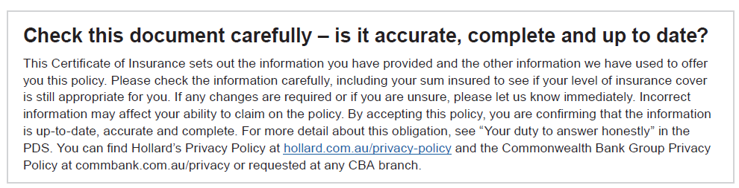

Ref | Variables | Content | Logic | Style
CDC 1 |  | Important notices – please check this document carefully | Always display | Heading_1_COI
CDC 2 | <PartnerPrivcyURL> | This Certificate of Insurance (COI) sets out the information you have provided and any other information we have used to decide whether we can insure you, on what terms and for what premium.  It is your responsibility to answer questions we ask of you as honestly, accurately and completely as you can. You must also take reasonable care not to make any misrepresentations to us. If you breach this responsibility, your policy may be cancelled or treated as if it never existed, or your claim may be denied or not paid in full. If you are not sure of the answers to any of the questions, you should take the time to find out before providing a response. In answering the questions, you are answering for yourself and anyone else to whom the questions apply.  This responsibility applies when you enter into, vary, renew or reinstate an insurance policy with us. This includes checking if any information in this COI has changed or is inaccurate or incomplete for the period of insurance. If you do not correct the information, we will take it that you agree with the information and that your answers are current, accurate and complete. If any of our questions are not clear to you and you need help, you can contact us. Please check the information carefully, including your sum insured to see if your level of insurance cover is still appropriate for you.  For more detail about this obligation, see ’Your responsibility to answer honestly’ in the PDS.  As the recipient of this document, you are responsible for ensuring that all policyholders are aware of this correspondence.  You can find Hollard’s Privacy Policy at <BrandPrivacyURL> and the CommBank Group Privacy Policy at <PartnerPrivcyURL> or request it at any CommBank branch. | Always display | Bodycopy_COI

Paperless (ALL)


Ref | Variables | Content | Logic | Style
TP 1 | <BrandCode>  <DeliveryChannelCode> | Thank you for choosing paperless Save the email containing your policy documents for easy access in the future. Brand_icon_paperless.jpg | IF <BrandCode> = “CBA”  AND <DeliveryChannelCode> = ” 1|Email” THEN Display | Heading_1_COI  Table_Bodycopy_COI  Brand_icon_paperless.jpg  Image Size: 94 x 94px (8x8mm)  Resolution: 300 x 300dpi
TP 2 | <BrandCode>  <DeliveryChannelCode>  <BrandPhoneNumberServicing> | Go paperless Save on paperwork and have your policy documents go direct to your inbox. Going paperless is easy, just call <BrandPhoneNumberServicing>. Brand_icon_paperless.jpg | ELSE IF<BrandCode> = “CBA” AND <DeliveryChannelCode> =” 2|Post” THEN Display | Heading_1_COI  Table_Bodycopy_COI  Brand_icon_paperless.jpg  Image Size: 94 x 94px (8x8mm)  Resolution: 300 x 300dpi

Need to get in contact? (ALL)
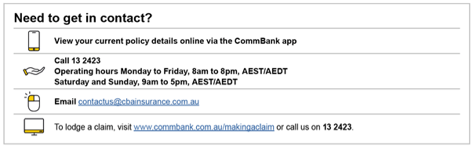

Ref | Variables | Content | Logic | Style
NC 1 | <BrandPhoneNumberServicing> <BrandWorkhoursServicing>  <BrandEmail> | Need to get in contact?  Brand_icon_phone6.jpg | View your current policy details online via NetBank or the the CommBank app  Brand_icon_help1.jpg | Call <BrandPhoneNumberServicing> [softreturn]  Operating hours <BrandWorkHoursServicing>  Brand_icon_email1.jpg | Email <BrandEmail>  Brand_icon_mouse3.jpg | To lodge a claim, visit NetBank or call us on <BrandPhoneNumberClaims> | Always display | As per GDS  **Contact_1**  Heading_1_COI  Table_Bodycopy_B_COI  Table_Bodycopy_COI

Payment method (ALL)

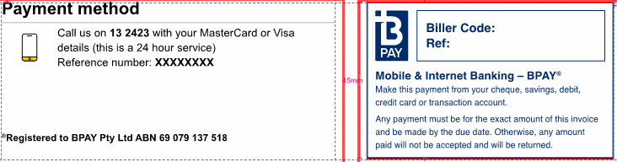

Ref | Variables | Content | Logic | Style
PM 1 | <TotalAmountDue>  <PaymentMethodCode> | **Payment_Section_2** **BPAY_2** | IF <PaymentMethodCode> = INV AND <CurrentTermGrossPremium> GREATER THAN 0 THEN Display  ELSE do not display | As per GDS and Styling & Layout FSD

Renewal Migration Customer Retention – Page 3

The following Publication is to be inserted into the COI and Renewal Offer as the Third Page (Page 3 – after the ‘Need to get in contact’ and ‘Payment method’ sections defined above, based on the following logic.

Publication | Logic | Comment
CUST_RETENTION_Publication | Insert CUST_RETENTION_Publication  IF <BrandCode> = “CBA”  AND IF <DocumentSubType> = “RENEWAL”  AND IF <IsMigration> = “1”  AND IF <FirstRenewalFromDC> = “1”  AND IF <ProductCode>=”Home” OR “Landlord”  AND IF (<PriceIncrease> =”1|Yes”  OR <ChangeToPV> =”1|Yes”  OR <SIIncreaseBuilding> =”1|Yes””  OR <SIIncreaseContents> =”1|Yes”  OR <Bankwest> =”1|Yes”  OR <AboutExcessBuilding> =”1|Yes”  OR <AboutExcessContents> =”1|Yes”  OR <NCBRemoved> =”1|Yes”)  ELSEIF <BrandCode> = “CBA”  AND IF <DocumentSubType> = “RENEWAL”  AND IF <IsMigration> = “1”  AND IF <FirstRenewalFromDC> = “1”  AND IF <ProductCode>=”Auto”  AND IF (<PriceIncrease>="1|Yes"  OR <NCBRemoved>="1|Yes”  OR <Bankwest>="1|Yes”)  ELSEIF SKIP | The content of the inserted page is based on the logic within the CUST_RETENTION_Publication FSD, which can be found here: FSD  Although a customer can be flagged as <IsMigration> = “1” and <FirstMigrationFromDC> = “1” they may not be impacted and therefore do not fit into one of the customer segments, in which case they will not receive Page 3.  If any of the variables within the () = “1|Yes”, then Page 3 is to be inserted.  If all of the variables within the () = “2|No” Page 3 is NOT to be inserted.


About your policy (Home/Landlord)
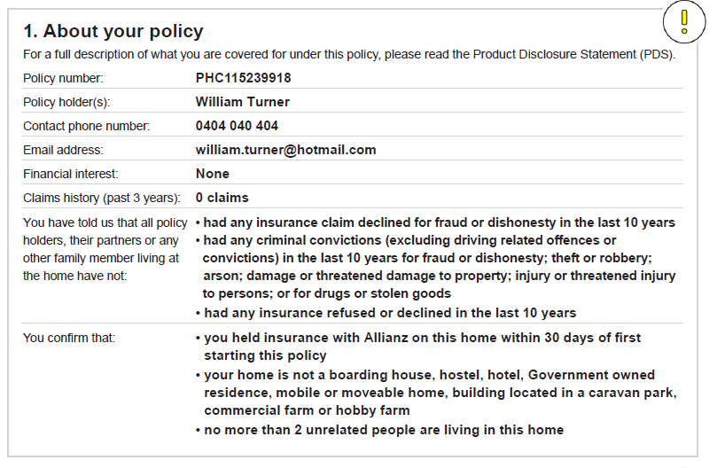
AYP 9
AYP 8
AYP 7
AYP 6
AYP 1
AYP 2
AYP 3
AYP 5
AYP 4

Section layout IF <ProductCode> = “Home” OR “Landlord”

Ref | Variables | Content | Logic | Style
AYP 1 |  | - About your policy  For a full description of what you are covered for under this policy, please read the Product Disclosure Statement (PDS). | Always display | Heading_1_COI  Bodycopy_COI
AYP 2 | <PolicyNumber> | Policy number: <PolicyNumber> | Always display | Column 1 text:  Bodycopy_COI  Column 2 text:  Bodycopy_B
AYP 3 | <PolicyHolderFirstName> <PolicyHolderLastName>  <EntityName>  <AdditFirstName>  <AdditLastName>  <ClientTypeCode>  <TrusteeCompanyName>  <TrusteeIndividualName> | Policyholder name(s): <PolicyHolderFirstName> <PolicyHolderLastName> / <EntityName>, <PolicyHolderFirstName> <PolicyHolderLastName> / <EntityName> <AdditFirstName> <AdditLastName> / <EntityName>, <AdditFirstName> <AdditLastName> / <EntityName> | Create PolicyHolders as an EO internal Variable which contains all the Policy Holders name separated by comma as a single line.  Iterate on Policyholders:  If <ClientTypeCode> = ‘6|Trust or 7|SMSF  THEN DO NOT DISPLAY  ELSE  IF<ClientTypeCode> = “4|Estate”  THEN set {EstateVariable} = “Estate of the Late” else {EstateVariable} = “”  IF <EntityName> = NULL  THEN DISPLAY  {EstateVariable} <PolicyHolderFirstName> <PolicyHolderLastName>  ELSE DISPLAY {EstateVariable} <EntityName>  Iterate on Additional Policyholders:  IF <AddClientTypeCode> <> (“2|AddThirdPartyAuthority” AND “3|Representative”)  IF <EntityName> = NULL  THEN DISPLAY  <PolicyHolderFirstName> <PolicyHolderLastName>  ENDIF  ELSEIF <AddClientTypeCode> = "4|Trustee" and <Trustee_IndividualName> is not null  THEN DISPLAY  <Trustee_IndividualName>  ELSE DISPLAY  <PolicyHolderFirstName> <PolicyHolderLastName>  ENDIF  ELSEIF <AddClientTypeCode> = "5|TrusteeCompany" and <Trustee_CompanyName> is not null  THEN DISPLAY  <Trustee_CompanyName>  ELSE DISPLAY  <EntityName> | Column 1 text:  Bodycopy_COI  Column 2 text:  Bodycopy_B
AYP 4 | <ClientTypeCode>  <InsuredPhoneNumber> | Contact phone number: <InsuredPhoneNumber> | IF <ClientTypeCode>=”1|PolicyHolder” THEN Display | Column 1 text:  Bodycopy_COI  Column 2 text:  Bodycopy_B
 | <ClientTypeCode>  <CompanyPhone> | Contact phone number: <CompanyPhone> | ELSEIF  <ClientTypeCode>!=”1|PolicyHolder”  THEN Display  ENDIF
AYP 5 | <ClientTypeCode>  <InsuredEmail> | Email address: <InsuredEmail> | IF <ClientTypeCode>=”1|PolicyHolder” THEN Display
 | <ClientTypeCode>  <CompanyEmail> | Email address: <CompanyEmail> | ELSEIF<ClientTypeCode>!=”1|PolicyHolder”  THEN Display  ENDIF
AYP 6 | <IsHomeFinancedCode>  <HomeFinancierCode>  <HomeFinancierDisplay> | Mortgagee(s): <HomeFinancierDisplay>  Mortgagee(s): None | IF <IsHomeFinancedCode>  = “1|MortgagedYes” AND <HomeFinancierCode>  Is not null  THEN Display  ELSEIF <IsHomeFinancedCode> = “2|MortgagedNo”  IF multiple <HomeFinancierDisplay> then list all separated by “ , “ | Column 1 text:  Bodycopy_COI  Column 2 text:  Bodycopy_B
AYP 7 | <ProductCode>  <HomeNoOfClaims> | Claims history in the last 3 years - includes building, contents or legal liability claims for a home you've lived in (or anyone to be covered by this policy): <HomeNoOfClaims> claim | IF <ProductCode> = “Home”  IF <HomeNoOfClaims> =1, THEN display [“<NoOfClaims> claim”]  ELSEIF <HomeNoOfClaims> >1 THEN display [“<HomeNoOfClaims> claims”]  ELSE display  [“Nil claims declared”]  ENDIF | Column 1 text:  Bodycopy_COI  Column 2 text:  Bodycopy_B
 |  | Claims history in the last 3 years - includes building, contents, loss of rent and/or legal liability claims for you (or anyone to be covered by this policy) as a landlord: Nil claims declared | IF <ProductCode> = “Landlord”  IF <HomeNoOfClaims> =1, THEN display [“<HomeNoOfClaims > claim”]  ELSEIF <HomeNoOfClaims> >1 THEN display [“<HomeNoOfClaims> claims”]  ELSE display  [“Nil claims declared”]  ENDIF | Column 1 text:  Bodycopy_COI  Column 2 text:  Bodycopy_B
AYP 8 V2 | <ProductCode>  <HasFraudDishonestyCode>  <IsMigration> | You have told us that all policyholders, their partners (legal or de-facto) or any family member living at the insured address: • have not had an insurance claim declined for fraud or dishonesty in the last 5 years | IF <ProductCode> = “Home”  AND  <ClaimDeniedCode > = “2|ClaimDeniedFalse”  THEN display  ELSE  Column 1 logic:  If <IsMigration> = ‘0’ then DISPLAY  “You have told us that all policyholders, their partners (legal or de-facto) or any family member living at the insured address:” | Column 1 Bodycopy_COI  Column 2: Bullet_1_B_COI
AYP 8 V3 | <ProductCode>  <HasFraudDishonestyCode>  <IsMigration> | We understand that in your previous policy terms policyholders, their partners (legal or de-facto) or any family member living at the insured address: • may have had an insurance claim declinedfor fraud or dishonesty in the last 5 years | IF <ProductCode> = “Home”  Column 2 text logic  IF  <ClaimDeniedCode > = “3|NotRecordedOnlyForMigration”  THEN display  ELSE  Column 1 logic:  IF’ If <IsMigration> = ‘1’ then DISPLAY  “We understand that in your previous policy terms policyholders, their partners (legal or de-facto) or any family member living at the insured address:” | Column 1 Bodycopy_COI  Column 2: Bullet_1_B_COI
AYP 8 V4 |  | You have told us that all policyholders, their partners (legal or de-facto) or any family member living at the insured address: • have not had any criminal convictions (excluding driving related offences or convictions) in the last 5 years for fraud or dishonesty; theft or robbery; arson; damage or threatened damage to property; injury or threatened injury to persons; or for drugs or stolen goods | IF <ProductCode> = “Home”  Column 2 text logic  IF  <CriminalConvictionCode> = “2|CriminalFalse”  THEN display  Column 1 logic:  If <IsMigration> = ‘0’ then DISPLAY  “You have told us that all policyholders, their partners (legal or de-facto) or any family member living at the insured address:” | Column 1 Bodycopy_COI  Column 2: Bullet_1_B_COI
AYP 8 V5 |  | You have told us that all policyholders, their partners (legal or de-facto) or any family member living at the insured address: • have not had any criminal conviction (excluding driving related convictions) in the last 5 years for fraud or dishonesty; theft or robbery; arson; damage or threatened damage to property; injury or threatened injury to persons; or for drugs or stolen goods | IF <ProductCode> = “Home”  Column 2 text logic  IF  <CriminalConvictionCode> = “1|CriminalTrue”  AND  <HomeConvictionTypeCode> = “7|Noneoftheabove”  THEN display  Column 1 logic:  If <IsMigration> = ‘0’ then DISPLAY  “You have told us that all policyholders, their partners (legal or de-facto) or any family member living at the insured address:” | Column 1 Bodycopy_COI  Column 2: Bullet_1_B_COI
AYP 8 V6 |  | We understand that in your previous policy terms policyholders, their partners (legal or de-facto) or any family member living at the insured address: • may have had criminal convictions (excluding driving related offences or convictions) in the last 5 years for fraud or dishonesty; theft or robbery; arson; damage or threatened damage to property; injury or threatened injury to persons; or for drugs or stolen goods | IF <ProductCode> = “Home”  Column 2 text logic  IF  <CriminalConvictionCode> = “1|CriminalTrue”  AND  <HomeConvictionTypeCode> = “8|DisclosedInLegacySystem”  THEN display  Column 1 logic:  IF <IsMigration> = ‘1’ then DISPLAY  “We understand that in your previous policy terms policyholders, their partners (legal or de-facto) or any family member living at the insured address:” | Column 1 Bodycopy_COI  Column 2: Bullet_1_B_COI
AYP 8 V7 |  | You have told us that all policyholders, their partners (legal or de-facto) or any family member living at the insured address: • have not had insurance cover declined to renew or cancelled by the insurer in the last 5 years | IF <ProductCode> = “Home”  Column 2 text logic  IF  <InsuranceRefusedCode> = “2|RefusedFalse”  THEN display  Column 1 logic:  If <IsMigration> = ‘0’ then DISPLAY  “You have told us that all policyholders, their partners (legal or de-facto) or any family member living at the insured address:” | Column 1 Bodycopy_COI  Column 2: Bullet_1_B_COI
AYP 8 V8 |  | We understand that in your previous policy terms policyholders, their partners (legal or de-facto) or any family member living at the insured address: • may have had insurance cover declined to renew or cancelled by the insurer in the last 5 years | IF <ProductCode> = “Home”  Column 2 text logic  IF  <InsuranceRefusedCode> = “3|NotRecordedOnlyForMigration”  THEN display  Column 1 logic:  IF <IsMigration> = ‘1’ then DISPLAY  “We understand that in your previous policy terms policyholders, their partners (legal or de-facto) or any family member living at the insured address:” | Column 1 Bodycopy_COI  Column 2: Bullet_1_B_COI
AYP 8 V10 | <ProductCode>  <HasFraudDishonestyCode>  <IsMigration> | You have told us that all policyholders and their partners (legal or de-facto): • have not had an insurance claim declined for fraud or dishonesty in the last 5 years | IF <ProductCode> = “Landlord”  AND  <ClaimDeniedCode > = “2|ClaimDeniedFalse”  THEN display  ELSE  Column 1 logic:  If <IsMigration> = ‘0’ then DISPLAY  “You have told us that all policyholders and their partners (legal or de-facto:” | Column 1 Bodycopy_COI  Column 2: Bullet_1_B_COI
AYP 8 V11 | <ProductCode>  <HasFraudDishonestyCode>  <IsMigration> | We understand that in your previous policy terms policyholders and their partners (legal or de-facto: • may have had an insurance claim declined for fraud or dishonesty in the last 5 years | IF <ProductCode> = “Landlord”  Column 2 text logic  IF  <ClaimDeniedCode > = “3|NotRecordedOnlyForMigration”  THEN display  ELSE  Column 1 logic:  IF’ If <IsMigration> = ‘1’ then DISPLAY  “We understand that in your previous policy terms policyholders and their partners (legal or de-facto):” | Column 1 Bodycopy_COI  Column 2: Bullet_1_B_COI
AYP 8 V12 |  | You have told us that all policyholders and their partners (legal or de-facto): • have not had any criminal convictions (excluding driving related offenses or convictions) in the last 5 years for fraud or dishonesty; theft or robbery; arson; damage or threatened damage to property; injury or threatened injury to persons; or for drugs or stolen goods | IF <ProductCode> = “Landlord”  Column 2 text logic  IF  <CriminalConvictionCode> = “2|CriminalFalse”  THEN display  Column 1 logic:  If <IsMigration> = ‘0’ then DISPLAY  “You have told us that all policyholders and their partners (legal or de-facto):” | Column 1 Bodycopy_COI  Column 2: Bullet_1_B_COI
AYP 8 V13 |  | You have told us that all policyholders and their partners (legal or de-facto) : • have not had any criminal conviction (excluding driving related convictions) in the last 5 years for fraud or dishonesty; theft or robbery; arson; damage or threatened damage to property; injury or threatened injury to persons; or for drugs or stolen goods | IF <ProductCode> = “Landlord”  Column 2 text logic  IF  <CriminalConvictionCode> = “1|CriminalTrue”  AND  <HomeConvictionTypeCode> = “7|Noneoftheabove”  THEN display  Column 1 logic:  If <IsMigration> = ‘0’ then DISPLAY  “You have told us that all policyholders and their partners (legal or de-facto) have not:” | Column 1 Bodycopy_COI  Column 2: Bullet_1_B_COI
AYP 8 V14 |  | We understand that in your previous policy terms policyholders and their partners (legal or de-facto: • may have had criminal convictions (excluding driving related offences or convictions) in the last 5 years for fraud or dishonesty; theft or robbery; arson; damage or threatened damage to property; injury or threatened injury to persons; or for drugs or stolen goods | IF <ProductCode> = “Landlord”  Column 2 text logic  IF  <CriminalConvictionCode> = “1|CriminalTrue”  AND  <HomeConvictionTypeCode> = “8|DisclosedInLegacySystem”  THEN display  Column 1 logic:  IF <IsMigration> = ‘1’ then DISPLAY  “We understand that in your previous policy terms policyholders andtheir partners (legal or de-facto):” | Column 1 Bodycopy_COI  Column 2: Bullet_1_B_COI
AYP 8 V14 |  | You have told us that all policyholders and their partners (legal or de-facto): • have not had insurance cover declined to renew or cancelled by the insurer in the last 5 years | IF <ProductCode> = “Landlord”  Column 2 text logic  IF  <InsuranceRefusedCode> = “2|RefusedFalse”  THEN display  Column 1 logic:  If <IsMigration> = ‘0’ then DISPLAY  “You have told us that all policyholders, their partners (legal or de-facto):” | Column 1 Bodycopy_COI  Column 2: Bullet_1_B_COI
AYP 8 V15 |  | We understand that in your previous policy terms policyholders and their partners (legal or de-facto): • may have had insurance cover declined to renew or cancelled by the insurer in the last 5 years | IF <ProductCode> = “Landlord”  Column 2 text logic  IF  <InsuranceRefusedCode> = “3|NotRecordedOnlyForMigration”  THEN display  Column 1 logic:  IF <IsMigration> = ‘1’ then DISPLAY  “We understand that in your previous policy terms policyholders and their partners (legal or de-facto):” | Column 1 Bodycopy_COI  Column 2: Bullet_1_B_COI
AYP 9-1 | <ProductCode>  <CoverType>  (<HomeCoverTypeCode>  <BuildingInsuredLast30DaysCode>  <ContentsInsuredLast30DaysCode>  {InternalVariable}  <InsuredLast30Days> | You confirm that: - you held insurance on this Insured Address within 30 days of first taking out this policy | IF (<ProductCode> = “Home” OR “Landlord”) AND (<HomeCoverTypeCode>= (“5|BuildingAndContents”  AND <BuildingInsuredLast30DaysCode> = “1|CurrentlyInsuredBuildingTrue” AND <ContentsInsuredLast30DaysCode> = “1|CurrentlyInsuredContentsTrue”  OR  <HomeCoverTypeCode>= “2|Building”) AND <BuildingInsuredLast30DaysCode> = “1|CurrentlyInsuredBuildingTrue”  OR  <HomeCoverTypeCode>= “3|Contents” AND  <ContentsInsuredLast30DaysCode> = “1|CurrentlyInsuredContentsTrue”  THEN display  ELSEIF | Column 1 text:  Bodycopy_COI  Column 2 text:  Table_Bullet_1_COI  Bullet_1_B_COI
AYP 9-2 | <ProductCode>  HomeCoverTypeCode>=  <ContentsInsuredLast30DaysCode> | You confirm that: - you did not hold insurance on this Insured Address within 30 days of first taking out this policy | IF (<ProductCode> = “Home” OR “Landlord”) AND (<HomeCoverTypeCode>= (“5|BuildingAndContents”  AND <BuildingInsuredLast30DaysCode> = “2|CurrentlyInsuredBuildingFalse” AND <ContentsInsuredLast30DaysCode> = “2|CurrentlyInsuredContentsFalse”  OR  <HomeCoverTypeCode>= “2|Building”) AND <BuildingInsuredLast30DaysCode> = “2|CurrentlyInsuredBuildingFalse”  OR  <HomeCoverTypeCode>= “3|Contents” AND  <ContentsInsuredLast30DaysCode> = “2|CurrentlyInsuredContentsFalse”  THEN display  ELSEIF | Column 1 text:  Bodycopy_COI  Column 2 text:  Table_Bullet_1_COI  Bullet_1_B_COI
AYP 9-3A | <ProductCode>  <HomeCoverTypeCode> | You confirm that: - your Insured Address is not a boarding house, hostel, hotel, Government owned residence, mobile or moveable home, building located in a caravan park or holiday park, commercial farm or hobby farm | IF (<ProductCode> = “Home” OR “Landlord”) AND (<HomeCoverTypeCode>= (“5|BuildingAndContents” OR “2|Building  OR  (“3|Contents””]  AND  <BuildingCoverConsiderationsHIPCode> != ‘2|GovernmentOwnedResidence’  AND  <IsMigration> = ‘0’  THEN display  ELSEIF | Column 1 text:  Bodycopy_COI  Column 2 text:  Table_Bullet_1_COI  Bullet_1_B_COI
AYP 9-3B | <ProductCode>  <HomeCoverTypeCode> | You confirm that: - your Insured Address is not a boarding house, hostel, hotel, mobile or moveable home, building located in a caravan park or holiday park, commercial farm or hobby farm | IF (<ProductCode> = “Home” OR “Landlord”) AND (<HomeCoverTypeCode>=  “3|Contents”  AND  <BuildingCoverConsiderationsHIPCode> = ‘2|GovernmentOwnedResidence’  AND  <IsMigration> = ‘0’  THEN display  ELSEIF | Column 1 text:  Bodycopy_COI  Column 2 text:  Table_Bullet_1_COI  Bullet_1_B_COI
AYP 9-3C | <ProductCode>  <HomeCoverTypeCode> | You confirm that: - your Insured Address is not a boarding house, hostel, hotel, Government owned residence, mobile or moveable home, building located in a caravan park or holiday park, commercial farm or hobby farm | IF (<ProductCode> = “Home” OR “Landlord”) AND (<HomeCoverTypeCode>= (“5|BuildingAndContents” OR “2|Building  OR  (“3|Contents”)  AND  <BuildingCoverConsiderationsHIPCode> NOT = ‘7|HobbyFarm’  AND  <IsMigration> = ‘1’  THEN display  ELSEIF | Column 1 text:  Bodycopy_COI  Column 2 text:  Table_Bullet_1_COI  Bullet_1_B_COI
AYP 9-4 | <ProductCode>  <HomeCoverTypeCode> | You confirm that: - your Insured Address is a hobby farm and is not a boarding house, hostel, hotel, Government owned residence, mobile or moveable home, building located in a caravan park or holiday park or commercial farm. | IF (<ProductCode> = “Home” OR “Landlord”) AND (<HomeCoverTypeCode>= (“5|BuildingAndContents” OR “2|Building  OR  (“3|Contents”]  AND  <IsMigration> = ‘1’  AND  <BuildingCoverConsiderationsHIPCode> = ‘7|HobbyFarm’  THEN display  ELSEIF | Column 1 text:  Bodycopy_COI  Column 2 text:  Table_Bullet_1_COI  Bullet_1_B_COI
AYP 9-5 | <BuildingTypeCode>  <HomeCoverTypeCode> | You confirm that: - you live in a manufactured/relocatable home which is council approved, permanently fixed to the site, plumbed to the main water supply and wired to the main electricity grid. | IF <BuildingTypeCode> = 5|ManufacturedOrRelocatableHome  AND <HomeCoverTypeCode>!= ” 3|Contents”  THEN display  ESLEIF | Column 1 text:  Bodycopy_COI  Column 2 text:  Table_Bullet_1_COI
AYP 9-6 | <ProductCode>  <UnderConstructionCode> | You confirm that: - your home will be renovated; and the value of the construction/renovation is expected to be less than $300,000. When you carry out building alterations, renovations or additions the cover under this policy is restricted. See section ’Special conditions and important notices’ below. | IF <ProductCode> =  ”Home” OR “Landlord” AND <UnderConstructionCode>= “1|UnderConstructionYes” THEN display  ELSEIF | Column 1 text:  Bodycopy_COI  Column 2 text:  Table_Bullet_1_COI
AYP 9-7 | <ProductCode>  <UnderConstructionCode> | You confirm that: - your home will be renovated. When you carry out building alterations, renovations or additions the cover under this policy is restricted. See section ’Special conditions and important notices’ below. | IF <ProductCode> =  ”Home” OR “Landlord” AND <UnderConstructionCode>= “3|YesCommencedBeforeMigrationMigrationOnly”  THEN display  ENDIF | Column 1 text:  Bodycopy_COI  Column 2 text:  Table_Bullet_1_COI

About your policy (Motor)
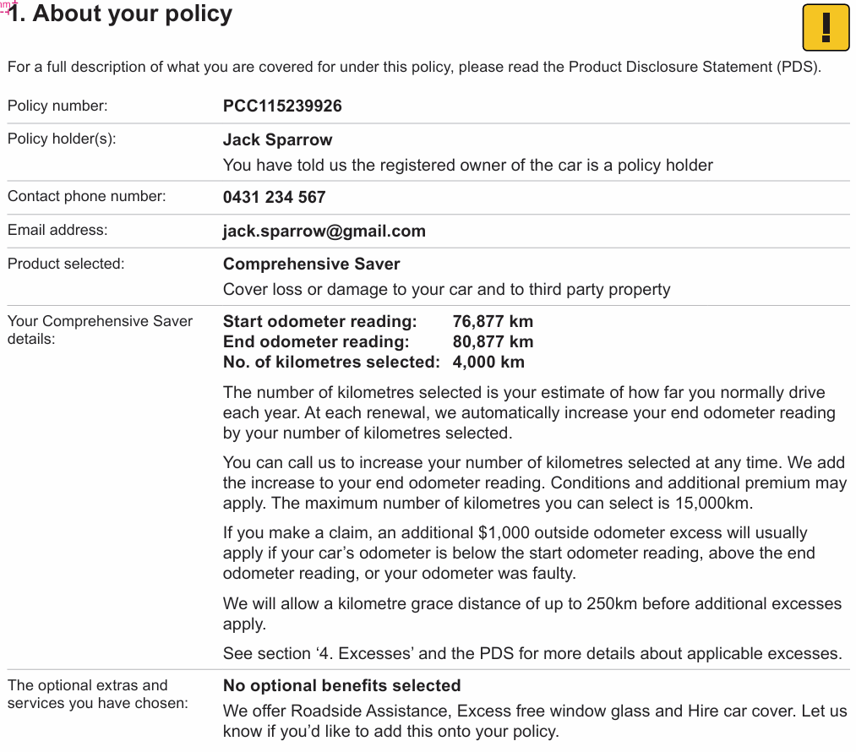

Ref | Variables | Content | Logic | Style
AYM 1 |  | 1. About your policy  For a full description of what you are covered for under this policy, please read the Product Disclosure Statement (PDS). | Always display | Heading_1_COI  Bodycopy_COI
AYM 2 | <PolicyNumber> | Policy number: <PolicyNumber> | Always display | Column 1 text:  Bodycopy_COI  Column 2 text:  Bodycopy_B
AYM 3 | <PolicyHolderFirstName> <PolicyHolderLastName>  <EntityName>  <AdditFirstName>  <AdditLastName>  <ClientTypeCode>  <TrusteeCompanyName>  <TrusteeIndividualName> | Policyholder name(s): <PolicyHolderFirstName> <PolicyHolderLastName> / <EntityName>, <PolicyHolderFirstName> <PolicyHolderLastName> / <EntityName> <AdditFirstName> <AdditLastName> / <EntityName>, <AdditFirstName> <AdditLastName> / <EntityName> | Create PolicyHolders as an EO internal Variable which contains all the Policy Holders name separated by comma as a single line.  Iterate on Policyholders:  If <ClientTypeCode> = ‘6|Trust or 7|SMSF  THEN DO NOT DISPLAY  ELSE  IF<ClientTypeCode> = “4|Estate”  THEN set {EstateVariable} = “Estate of the Late” else {EstateVariable} = “”  IF <EntityName> = NULL  THEN DISPLAY  {EstateVariable} <PolicyHolderFirstName> <PolicyHolderLastName>  ELSE DISPLAY {EstateVariable} <EntityName>  Iterate on Additional Policyholders:  IF <AddClientTypeCode> <> (“2|AddThirdPartyAuthority” AND “3|Representative”)  IF <EntityName> = NULL  THEN DISPLAY  <PolicyHolderFirstName> <PolicyHolderLastName>  ENDIF  ELSEIF <AddClientTypeCode> = "4|Trustee" and <Trustee_IndividualName> is not null  THEN DISPLAY  <Trustee_IndividualName>  ELSE DISPLAY  <PolicyHolderFirstName> <PolicyHolderLastName>  ENDIF  ELSEIF <AddClientTypeCode> = "5|TrusteeCompany" and <Trustee_CompanyName> is not null  THEN DISPLAY  <Trustee_CompanyName>  ELSE DISPLAY  <EntityName> | Column 1 text:  Bodycopy_COI  Column 2 text:  Bodycopy_B
AYM 4 |  | You have told us the registered owner of the car is a policyholder. | Always display | Bodycopy_COI
AYM 5 | <InsuredPhoneNumber> | Contact phone number: <InsuredPhoneNumber> | IF <ClientTypeCode>=”1|PolicyHolder”  THEN Display | Column 1 text:  Bodycopy_COI  Column 2 text:  Bodycopy_B
 | <CompanyPhoneNumber> | Contact phone number: <CompanyPhoneNumber> | ELSEIF <ClientTypeCode>!=”1|PolicyHolder”  THEN Display
AYM 6 | <InsuredEmail> | Email address: <InsuredEmail> | IF <ClientTypeCode>=”1|PolicyHolder”  THEN Display | Column 1 text:  Bodycopy_COI  Column 2 text:  Bodycopy_B
 | <CompanyEmail> | Email address: <CompanyEmail> | ELSEIF <ClientTypeCode>!=”1|PolicyHolder”  THEN Display  ENDIF
AYM 7 | <VehicleCoverTypeCode> | Product selected: Comprehensive Saver – Comprehensive Car Insurance Cover for loss or damage to your car and to third party property | IF <VehicleCoverTypeCode> = “2|Payasyoudrive” THEN display [“Comprehensive Saver - Comprehensive Car Insurance”]  Cover for loss or damage to your car and to third party property | Column 1 text:  Bodycopy_COI  Column 2 text:  Bodycopy_B  Bodycopy  Column 1 text:  Bodycopy_COI  Column 2 text:  Bodycopy_B  Bodycopy  Column 1 text:  Bodycopy_COI  Column 2 text:  Bodycopy_B  Bodycopy
 |  | Product selected: Comprehensive Car Insurance Cover for loss or damage to your car and to third party property | IF <VehicleCoverTypeCode> = “1|Comprehensive” THEN display [“Comprehensive Car Insurance”]  Cover for loss or damage to your car and to third party property
 |  | Product selected: Third Party Property, Fire and Theft Limited cover for loss or damage caused by Fire and Theft to your car and cover for loss or damage to third party property  You opted to renew on Third Party Property, Fire & Theft instead of accepting the offer for Comprehensive cover | IF <VehicleCoverTypeCode> = “4|Thirdpartypropertyfiretheft” THEN display [“Third Party, Fire and Theft”]  Limited cover for loss or damage caused by Fire and Theft to your car and cover for loss or damage to third party property  IF <TPFTSumInsuredCOI> = “Yes’  Then Display  “You opted to renew on Third Party Property, Fire & Theft instead of accepting the offer for Comprehensive cover”  ELSE Do Not Display
 |  | Product selected: Third Party Property Damage Cover for loss or damage to third party property | IF <VehicleCoverTypeCode> = “5|Thirdpartypropertydamage” THEN display [“Third Party Property Damage”]  Cover for loss or damage to third party property
AYM 8 | <OdometerStartValue>  <OdometerEndValue>  <VehicleDistanceDisplay>  <VehicleCoverTypeCode>  <DocumentSubType>  <NonPAYDSwitchToPAYD> | Your Comprehensive Saver details: Start odometer reading: <OdometerStartValue> km End odometer reading: <OdometerEndValue> km No. of kilometres selected: <VehicleDistanceDisplay> km  Your Comprehensive Saver details: Start odometer reading: <OdometerStartValue> km End odometer reading: <OdometerEndValue> km No. of kilometres selected: Not recorded | IF <VehicleCoverTypeCode> = “2|Payasyoudrive” AND <DocumentSubType> = “New Business” OR “Renewal”  AND <NonPAYDSwitchToPAYD>= ‘1’ THEN display  Logic for  No. of kilometres selected:  IF  <VehicleDistanceCode> = “27|-9999”  THEN display “Not recorded”  ELSEIF  <VehicleDistanceCode> != “27|-9999”  THEN display  <VehicleDistanceDisplay> | Column 1 text:  Bodycopy_COI  Column 2 & 3 text:  Table_Heading_3  Column 1 text:  Bodycopy_COI  Column 2 text:  Table_Heading_3  Bodycopy
AYM8 |  | The start odometer reading will only be shown for your first period of insurance with us (it is not applicable to renewal periods of insurance). You have an obligation to ensure that the start odometer reading you have disclosed immediately before entry into the first period of your insurance policy was/is accurate.  The number of kilometres selected is your estimate of how far you normally drive each year. At each renewal, we automatically increase your end odometer reading by the number of kilometres you’ve selected.  You can call us to increase your number of kilometres selected at any time. We add the increase to your end odometer reading. Conditions and additional premium may apply. The maximum number of kilometres you can select is 15,000km. If you wish to apply for a decrease to your number of kilometres selected, you can do this at renewal for the next period of insurance. Please call us to discuss.  If you make a claim, an additional $1,000 Outside odometer excess will usually apply if your car’s odometer is below the start odometer reading, above the end odometer reading, or your odometer was faulty.  We will allow a kilometre grace distance of up to 250 km before the Outside odometer excess applies.  See section ‘ Excesses’ for circumstances where additional excesses may apply. | IF <VehicleCoverTypeCode> = “2|Payasyoudrive” AND <DocumentSubType> = “New Business” OR “Renewal”  AND <NonPAYDSwitchToPAYD>= ‘1’ THEN display  Dev/Test Note: This associated text will only display if Odometer readings are displayed
AYM9 |  | Your Comprehensive Saver details: End odometer reading: <OdometerEndValue> km No. of kilometres selected: <VehicleDistanceDisplay> km  Your Comprehensive Saver details: End odometer reading: <OdometerEndValue> km No. of kilometres selected: Not recorded | ELSEIF IF <VehicleCoverTypeCode> = “2|Payasyoudrive” AND <DocumentSubType> = “Endorsement” OR “Renewal” AND  <NonPAYDSwitchToPAYD>= ‘0’  THEN display  ELSE do not display  ENDIF  Logic for  No. of kilometres selected:  IF  <VehicleDistanceCode> = “27|-9999”  THEN display “Not recorded”  ELSEIF  <VehicleDistanceCode> != “27|-9999”  THEN display  <VehicleDistanceDisplay>
AYM9 |  | The start odometer reading will only be shown for your first period of insurance with us (it is not applicable to renewal periods of insurance). You have an obligation to ensure that the start odometer reading you have disclosed immediately before entry into the first period of your insurance policy was/is accurate.  The number of kilometres selected is your estimate of how far you normally drive each year. At each renewal, we automatically increase your end odometer reading by the number of kilometres you’ve selected.  You can call us to increase your number of kilometres selected at any time. We add the increase to your end odometer reading. Conditions and additional premium may apply. The maximum number of kilometres you can select is 15,000km. If you wish to apply for a decrease to your number of kilometres selected, you can do this at renewal for the next period of insurance. Please call us to discuss.  If you make a claim, an additional $1,000 Outside odometer excess will usually apply if your car’s odometer is below the start odometer reading, above the end odometer reading, or your odometer was faulty.  We will allow a kilometre grace distance of up to 250 km before the Outside odometer excess applies.  See section ‘ Excesses’ for circumstances where additional excesses may apply. | IF <VehicleCoverTypeCode> = “2|Payasyoudrive” AND <DocumentSubType> = “Endorsement” OR “Renewal” AND  <NonPAYDSwitchToPAYD>= ‘0’  THEN display  Dev/Test Note: This associated text will only display if end Odometer reading is displayed

AYM 10 | <VehicleCoverageName>  <ProductCode>  <CoverageType>  <VehicleCoverageName>  <VehicleSelected CoverInd>  <VehicleOptionalCoverageType> | Optional Covers and Services you've added to your policy: <VehicleCoverageName> <VehicleCoverageName> <VehicleCoverageName> | IF <ProductCode> = “Auto”  AND  (VehicleOptionalCoverageInd = ‘0’ AND (<VehicleSelectedCoverageInd> = ‘1’)  THEN display  (List all coverages applicable to the cover type one below each other) | Column 1 text:  Bodycopy_COI  Column 2 text:  Table_Heading_3  Bodycopy_COI
 |  | Optional Covers and Services you've added to your policy: None | ELSEIF <ProductCode> = “Auto”  AND  (VehicleOptionalCoverageInd = ‘0’ AND (<VehicleSelectedCoverageInd> = ‘0’)  THEN display
AYM 11 |  | Hollard Roadside Assistance Terms and Conditions will be sent out separately. | IF <VehicleCoverageCode> = “RA”  AND  (VehicleOptionalCoverageInd = ‘0’ and (<VehicleSelectedCoverageInd> = ‘1’)  THEN display  Else Do Not Display
AYM 12 |  | Let us know if you'd like to add or amend any Optional Covers or Services onto your policy. | Always display

Your building (Home/Landlord)

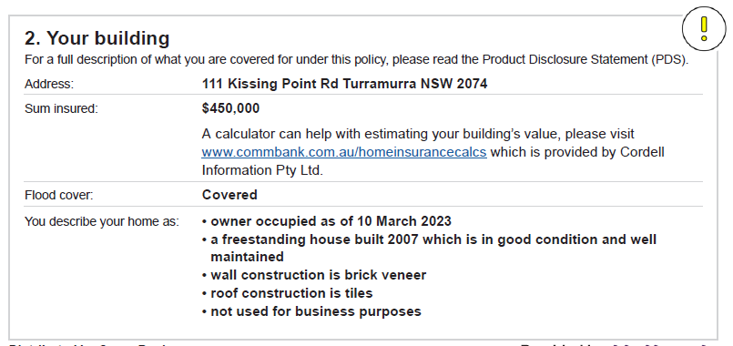
Section layout IF <ProductCode> = “Home” OR “Landlord”

Ref | Variables | Content | Logic | Style
YB 1 |  | - Your building  For a full description of what you are covered for under this policy, please read the Product Disclosure Statement (PDS). | Always display | Heading_1_COI  Bodycopy_COI
YB 2 | <RiskAdddressLine1>  <RiskAdddressLine2>  <RISKCITY>  <RISKSTATE>  <RiskPostcode>  <ProductCode> | Insured Address: <RiskAddressLine1>,<RiskAddressLine2>, <RISKCITY> <RISKSTATE> <RiskPostcode> | IF <ProductCode>= "Home" or “Landlord”  ELSE do not display.  ENDIF | Column 1 text:  Bodycopy_COI  Column 2 text:  Table_Heading_3
YB 3 | <BuildingSumInsured>  <ProductCode>  <BrandBuildingCalculator> | Sum Insured: $<BuildingSumInsured> | IF <ProductCode> = "Home" OR "Landlord"  AND <HomeCoverTypeCode> = "2|Building" OR “5|BuildingAndContents”  THEN display  ELSE do not display  ENDIF | Column 1 text:  Bodycopy_COI  Column 2 text:  Bodycopy_B  Bodycopy
 |  | Please check your sum insured to see if your level of insurance cover is still appropriate for you. A calculator can help with estimating your building’s value, please visit <BrandBuildingCalculator> | IF <BrandCode>= “CBA”  THEN display [“Please check your sum insured to see if your level of insurance cover is still appropriate for you. A calculator can help with estimating your building’s value, please visit <BrandBuildingCalculator>”]  ELSE do not display  ENDIF
YB 4 |  | Flood cover: Covered | IF <HomeCoverTypeCode> = "2|Building" OR “5|BuildingAndContents”  THEN display  [“Flood cover: Covered”]  ELSE do not display  ENDIF | Column 1 text:  Bodycopy_COI  Column 2 text:  Bodycopy_B
YB 5A |  | You describe your Insured Address as: • <OccupancyTypeDisplay> | If (<ProductCode> = “Home”  AND  (<HomeCoverTypeCode>= “5|BuildingAndContents” or “2|Building” or “3|Contents”  AND  (<OwnOrRentCode> = “1|IOwn”)  THEN display “OccupancyTypeDisplay”  ELSE Do not Display | Column 1 text:  Bodycopy_COI  Column 2 text:  Bullet_1_B_COI
YB 5AB |  | You describe your Insured Address as: • a rental property | If (<ProductCode> = “Home”  AND(<HomeCoverTypeCode>= “5|BuildingAndContents” or “2|Building” or “3|Contents”  AND  (<OwnOrRentCode> = “2|IRent”)  THEN display “OccupancyTypeDisplay”  ELSE Do not Display | Column 1 text:  Bodycopy_COI  Column 2 text:  Bullet_1_B_COI
YB 5B |  | You describe your Insured Address as: • <KindOfPropertyDisplay> | IF <ProductCode> = “Landlord”  AND  (<HomeCoverTypeCode>= “5|BuildingAndContents” or “2|Building” or “3|Contents”  AND  (<LandlordOrOccupantCode> = “1|Landlord”)  THEN display “KindOfPropertyDisplay”  ELSE DO NOT DISPLAY | Column 1 text:  Bodycopy_COI  Column 2 text:  Bullet_1_B_COI
YB 6 | <OccupancyTypeDisplay>  <OccupancyTypeCode>  <BuildingTypeDisplay>  <BuildingTypeCode>  <YearBuilt>  <Floor>  <RoofTypeDisplay>  <ConstructionTypeDisplay>  <PercentageBusinessPurposeCode>  <PercentageBusinessPurposeCodeDisplay>  <BusinessPurposeCode>  <UnderConstructionCode>  <HomeCoverTypeCode>  <Unoccupied60daysCode>  <KindOfPropertyCode>  <LevelNoCode>  <LevelNoDisplay>  <YearOfConstructionTypeDisplay>  <CurrentlyOccupiedCode>  <CurrentTermEffectiveDate> | You describe your Insured Address as: • occupied at least once a month | IF <ProductCode> = “Home”  AND  <OccupancyTypeCode> = “5|HolidayHome”  AND  <OccupiedCode> != “1|OccupiedYes”  THEN Display  ELSE Do Not Display | Column 1 text:  Bodycopy_COI  Column 2 text:  Bullet_1_B_COI
 |  | You describe your Insured Address as: •currently occupied | IF <ProductCode> = “Home”  AND  <OccupancyTypeCode> != “5|HolidayHome”  AND  <CurrentlyOccupiedCode> = “1|CurrentlyOccupiedYes”  THEN Display  ELSE Do Not Display | Column 1 text:  Bodycopy_COI  Column 2 text:  Bullet_1_B_COI
 |  | You describe your Insured Address as: • unoccupied for less than 60 days at a time. See section ‘Special conditions and important notices’ below | IF <ProductCode> = “Home”  AND  <OccupancyTypeCode> != “5|HolidayHome”  AND  <CurrentlyOccupiedCode> = “2|CurrentlyOccupiedNo”  AND  <Unoccupied60daysCode> = “2|UnoccupiedNo”  THEN Display  ELSE Do Not Display | Column 1 text:  Bodycopy_COI  Column 2 text:  Bullet_1_B_COI
 |  | You describe your Insured Address as: • unoccupied for less than 60 days at a time. See section ‘Special conditions and important notices’ below | IF <ProductCode> = “Home”  AND  <OccupancyTypeCode> != “5|HolidayHome”  AND  <CurrentlyOccupiedCode> = “3|UnoccupiedAtMigration  AND  <Unoccupied60daysCode> =  “2|UnoccupiedNo”  THEN Display  ELSE Do Not Display | Column 1 text:  Bodycopy_COI  Column 2 text:  Bullet_1_B_COI
 |  | You describe your Insured Address as: - unoccupied for less than 120 days at a time | IF <ProductCode> = “Home”  AND  <OccupancyTypeCode> = “5|HolidayHome”  AND  <CurrentlyOccupiedCode> = “3|UnoccupancyDurationAcceptedOnlyForMigration”  THEN Display  ELSE Do Not Display | Column 1 text:  Bodycopy_COI  Column 2 text:  Bullet_1_B_COI
 |  | You describe your Insured Address as: - unoccupied for less than 120 days at a time | IF <ProductCode> = “Home”  AND  <OccupancyTypeCode> != “5|HolidayHome”  AND  <CurrentlyOccupiedCode> = “3|UnoccupiedAtMigration”  AND  <Unoccupied60daysCode> = “3|UnoccupancyDurationAcceptedOnlyForMigration”  THEN Display  ELSE Do Not Display | Column 1 text:  Bodycopy_COI  Column 2 text:  Bullet_1_B_COI
 |  | You describe your Insured Address as: - unoccupied for less than 120 days at a time | IF <ProductCode> = “Home”  AND  <OccupancyTypeCode> != “5|HolidayHome”  AND  <CurrentlyOccupiedCode> = “2|CurrentlyOccupiedNo”  AND  <Unoccupied60daysCode> = “3|UnoccupancyDurationAcceptedOnlyForMigration”  THEN Display  ELSE Do Not Display | Column 1 text:  Bodycopy_COI  Column 2 text:  Bullet_1_B_COI
 |  | You describe your Insured Address as: • occupied at least once a month | IF <ProductCode> = “Landlord”  AND  <KindOfPropertyCode>= “2|HolidayShortTermRental”  AND  <OccupiedCode> != “1|OccupiedYes”  THEN Display  ELSE Do Not Display | Column 1 text:  Bodycopy_COI  Column 2 text:  Bullet_1_B_COI
 |  | You describe your Insured Address as: • unoccupied for less than 120 days at a time | IF <ProductCode> = “Landlord”  AND  <KindOfPropertyCode>= “2|HolidayShortTermRental”  AND  <OccupiedCode> != “3|UnoccupancyDurationAcceptedOnlyForMigration”  THEN Display  ELSE Do Not Display | Column 1 text:  Bodycopy_COI  Column 2 text:  Bullet_1_B_COI
 |  | You describe your Insured Address as: • currently occupied | IF <ProductCode> = “Landlord”  AND  <KindOfPropertyCode> != “2|HolidayShortTermRental”  AND  <CurrentlyOccupiedCode> = “1|CurrentlyOccupiedYes”  THEN Display  ELSE Do Not Display | Column 1 text:  Bodycopy_COI  Column 2 text:  Bullet_1_B_COI
 |  | You describe your Insured Address as: • unoccupied for less than 60 days at a time. See section ‘Special conditions and important notices’ below | IF <ProductCode> = “Landlord”  AND  <KindOfPropertyCode> != “2|HolidayShortTermRental”  AND  <CurrentlyOccupiedCode> = “2|CurrentlyOccupiedNo”  AND  <Unoccupied60daysCode> =  “2|UnoccupiedNo”  THEN Display  ELSE Do Not Display | Column 1 text:  Bodycopy_COI  Column 2 text:  Bullet_1_B_COI
 |  | You describe your Insured Address as: • unoccupied for less than 60 days at a time. See section ‘Special conditions and important notices’ below | IF <ProductCode> = “Landlord”  AND  <KindOfPropertyCode> != “2|HolidayShortTermRental”  AND  <CurrentlyOccupiedCode> = “3|UnoccupiedAtMigration”  AND  <Unoccupied60daysCode> =  “2|UnoccupiedNo”  THEN Display  ELSE Do Not Display | Column 1 text:  Bodycopy_COI  Column 2 text:  Bullet_1_B_COI
 |  | You describe your Insured Address as: • unoccupied for less than 120 days at a time | IF <ProductCode> = “Landlord”  AND  <KindOfPropertyCode> != “2|HolidayShortTermRental”  AND  <CurrentlyOccupiedCode> = “2|CurrentlyOccupiedNo”  AND  <Unoccupied60daysCode> = “3|UnoccupancyDurationAcceptedOnlyForMigration”  THEN Display  ELSE Do Not Display | Column 1 text:  Bodycopy_COI  Column 2 text:  Bullet_1_B_COI
 |  | You describe your Insured Address as: • unoccupied for less than 120 days at a time | IF <ProductCode> = “Landlord”  AND  <KindOfPropertyCode> != “2|HolidayShortTermRental”  AND  <CurrentlyOccupiedCode> = “3|UnoccupiedAtMigration”  AND  <Unoccupied60daysCode> = “3|UnoccupancyDurationAcceptedOnlyForMigration”  THEN Display  ELSE Do Not Display | Column 1 text:  Bodycopy_COI  Column 2 text:  Bullet_1_B_COI
 |  | You describe your Insured Address as: • having an actual or estimated weekly rental amount of <WeeklyRental> | IF <ProductCode> = “Landlord”  THEN Display  ELSE Do Not Display | Column 1 text:  Bodycopy_COI  Column 2 text:  Bullet_1_B_COI
 |  | You describe your Insured Address as: • a <BuildingTypeDisplay>,built <YearOfConstructionTypeDisplay> | IF <BuildingTypeCode> <> 4|ApartmentOrUnit THEN display  ElseIF | Column 1 text:  Bodycopy_COI  Column 2 text:  Bullet_1_B_COI
 |  | You describe your Insured Address as: • a <BuildingTypeDisplay>,built <YearBuilt> | IF <BuildingTypeCode> <> 4|ApartmentOrUnit  AND  <YearOfConstructionTypeCode> = “1|2000+”  THEN display | Column 1 text:  Bodycopy_COI  Column 2 text:  Bullet_1_B_COI
 |  | You describe your Insured Address as: • a <LevelNoDisplay> level apartment, built <YearOfConstructionTypeDisplay> | IF <BuildingTypeCode> = “4|ApartmentOrUnit”  AND <LevelNoCode> = “1|Ground”  THEN display  ELSEIF | Column 1 text:  Bodycopy_COI  Column 2 text:  Bullet_1_B_COI
 |  | You describe your Insured Address as: • a <LevelNoDisplay> level apartment, built <YearBuilt> | IF <BuildingTypeCode> = “4|ApartmentOrUnit”  AND <LevelNoCode> = “1|Ground”  AND  <YearOfConstructionTypeCode> = “1|2000+”  THEN display  ELSEIF | Column 1 text:  Bodycopy_COI  Column 2 text:  Bullet_1_B_COI
 |  | You describe your Insured Address as: • a level <LevelNoDisplay> apartment, built <YearOfConstructionTypeDisplay> | IF <BuildingTypeCode> = “4|ApartmentOrUnit”  AND <LevelNoCode>= “2|Floor1” or “3|Floor2” or “4|3Plus”  THEN display  ELSEIF | Column 1 text:  Bodycopy_COI  Column 2 text:  Bullet_1_B_COI
 |  | You describe your Insured Address as: • a level <LevelNoDisplay> apartment, built <YearBuilt> | IF <BuildingTypeCode> = “4|ApartmentOrUnit”  AND <LevelNoCode>= “2|Floor1” or “3|Floor2” or “4|3Plus”  AND  <YearOfConstructionTypeCode> = “1|2000+”  THEN display  ELSEIF | Column 1 text:  Bodycopy_COI  Column 2 text:  Bullet_1_B_COI
 |  | You describe your Insured Address as: • a level 2 or above apartment, built <YearOfConstructionTypeDisplay> | IF <BuildingTypeCode> = “4|ApartmentOrUnit”  AND <LevelNoCode> = “5|Floor2OrAboveOnlyForMigration”  THEN display  Else Do Not display | Column 1 text:  Bodycopy_COI  Column 2 text:  Bullet_1_B_COI
 |  | You describe your Insured Address as: • a level 2 or above apartment, built <YearBuilt> | IF <BuildingTypeCode> = “4|ApartmentOrUnit”  AND <LevelNoCode> = “5|Floor2OrAboveOnlyForMigration”  THEN display  AND  <YearOfConstructionTypeCode> = “1|2000+”  Else Do Not display | Column 1 text:  Bodycopy_COI  Column 2 text:  Bullet_1_B_COI
 |  | You describe your Insured Address as: • in good condition and well maintained | IF  <WellMaintainedCode> = “1|WellMaintainedYes”  THEN display  ELSEIF | Column 1 text:  Bodycopy_COI  Column 2 text:  Bullet_1_B_COI
 |  | You describe your Insured Address as: • not in good condition and not well maintained | IF  <WellMaintainedCode> = “3|DisclosedNoInLegacySystem”  THEN display  ELSEIF | Column 1 text:  Bodycopy_COI  Column 2 text:  Bullet_1_B_COI
 |  | You describe your Insured Address as: • the majority of the external walls are made of <ConstructionTypeDisplay> | Always display | Column 1 text:  Bodycopy_COI  Column 2 text:  Bullet_1_B_COI
 |  | You describe your Insured Address as: • roof construction is <RoofTypeDisplay> | Always display | Column 1 text:  Bodycopy_COI  Column 2 text:  Bullet_1_B_COI
 |  | You describe your Insured Address as: • not used for business purposes | IF <ProductCode> = Home OR Landlord AND <BusinessPurposeCode>= “2|HomeUsageBusinessUseNo”  THEN display  Else Do Not display | Column 1 text:  Bodycopy_COI  Column 2 text:  Bullet_1_B_COI
 |  | You describe your Insured Address as: • used for business purposes. See section ’Special conditions and important notices’ below | IF <ProductCode> = Home OR Landlord AND <BusinessPurposeCode>= “3|YesDisclosedInLegacyOnlyForMigration”  THEN display  Else Do Not display | Column 1 text:  Bodycopy_COI  Column 2 text:  Bullet_1_B_COI
 |  | You describe your Insured Address as: • <PercentageBusinessPurposeCodeDisplay> of the Insured Address is used for business purposes. See section ’Special conditions and important notices’ below | IF <ProductCode> = “Home” AND <BusinessPurposeCode>= “1|HomeUsageBusinessUseYes” AND <PercentageBusinessPurposeCode> = “1|0to25” or “2|26to49” or “3|50orMore”  THEN display  ELSEIF  Includes Migrating customers | Column 1 text:  Bodycopy_COI  Column 2 text:  Bullet_1_B_COI
 |  | You describe your Insured Address as: • used for business purposes. See section’Special conditions and important notices’ below | IF <ProductCode> = “Home” AND <BusinessPurposeCode>= “1|HomeUsageBusinessUseYes” AND <PercentageBusinessPurposeCode> = “4|PercentUnknownMigrationOnly”  THEN display  Else Do Not display | Column 1 text:  Bodycopy_COI  Column 2 text:  Bullet_1_B_COI
 |  | You describe your Insured Address as: • not currently or planned to be under construction or renovation | IF <UnderConstructionCode> = “2|UnderConstructionNo”  THEN display  Else Do Not display | Column 1 text:  Bodycopy_COI  Column 2 text:  Bullet_1_B_COI
 |  | You describe your Insured Address as: • currently or planned to be under construction or renovation and will be occupied for the duration of the renovation | IF <UnderConstructionCode> = 1|UnderConstructionYes  AND  <LivingInRenovationCode> = 1|LivingInRenovationYes  THEN display  ELSEIF | Column 1 text:  Bodycopy_COI  Column 2 text:  Bullet_1_B_COI
 |  | You describe your Insured Address as: • currently or planned to be under construction or renovation | IF  <UnderConstructionCode> = 3|YesCommencedBeforeMigrationMigrationOnly  AND  <LivingInRenovationCode> = “3|NotRecordedOnlyForMigration”  THEN display  Else Do Not display | Column 1 text:  Bodycopy_COI  Column 2 text:  Bullet_1_B_COI
 |  | You describe your Insured Address as: • not under a strata, community, or company title building insurance policy | IF <HomeCoverTypeCode> != ” 3|Contents” THEN display  Else Do Not display | Column 1 text:  Bodycopy_COI  Column 2 text:  Bullet_1_B_COI
 |  | You describe your Insured Address as: • situated on less than 2 acres of land | IF <HomeCoverTypeCode> != “3|Contents”  AND  <MoreThanTenAcresCode> = “2|MoreThanTenAcresNo”  THEN display  ELSEIF | Column 1 text:  Bodycopy_COI  Column 2 text:  Bullet_1_B_COI
 |  | You describe your Insured Address as: • situated on more than 2 acres of land | IF <HomeCoverTypeCode> != “3|Contents”  AND  <MoreThanTenAcresCode> = “1|MoreThanTenAcresYes”  THEN display  ELSEIF | Column 1 text:  Bodycopy_COI  Column 2 text:  Bullet_1_B_COI
 |  | You describe your Insured Address as: • unconfirmed whether it is situated on less than 2 acres of land | IF <HomeCoverTypeCode> != “3|Contents”  AND  <MoreThanTenAcresCode> = “3|NotRecordedOnlyForMigration”  THEN display  ELSEIF | Column 1 text:  Bodycopy_COI  Column 2 text:  Bullet_1_B_COI
 |  | You describe your Insured Address as: • not heritage listed | IF<HomeCoverTypeCode> != ” 3|Contents”  AND  <HeritageListedCode> = “2|HeritageListedNo”  THEN display  ELSEIF | Column 1 text:  Bodycopy_COI  Column 2 text:  Bullet_1_B_COI
 |  | You describe your Insured Address as: • heritage listed | IF<HomeCoverTypeCode> != “3|Contents”  AND <HeritageListedCode> = “1|HeritageListedYes”  THEN display  ELSEIF | Column 1 text:  Bodycopy_COI  Column 2 text:  Bullet_1_B_COI
 |  | You describe your Insured Address as: • unconfirmed whether it is heritage listed | IF<HomeCoverTypeCode> != “3|Contents”  AND <HeritageListedCode> = “3|NotRecordedOnlyForMigration”  THEN display  Else Do Not display | Column 1 text:  Bodycopy_COI  Column 2 text:  Bullet_1_B_COI
 |  | You describe your Insured Address as: • not planned to be demolished | Always display | Column 1 text:  Bodycopy_COI  Column 2 text:  Bullet_1_B_COI
 |  | You describe your Insured Address as: • has been completely rewired, and/or had a safety switch installed on each electricity circuit within 30 years of you first taking out this policy | IF <HomeCoverTypeCode> != “3|Contents”  AND  <PropertyRewiredCode> = “1|RewiringYes”  THEN display  ELSEIF | Column 1 text:  Bodycopy_COI  Column 2 text:  Bullet_1_B_COI
 |  | You describe your Insured Address as: • has not been completely rewired, and/or had a safety switch installed on each electricity circuit within 30 years of you first taking out this policy | IF <HomeCoverTypeCode> != “3|Contents”  AND  <PropertyRewiredCode> = “2|RewiringNo”  THEN display  ELSEIF | Column 1 text:  Bodycopy_COI  Column 2 text:  Bullet_1_B_COI
 |  | You describe your Insured Address as: • has not been confirmed as being completely rewired, and/or had a safety switch installed on each electricity circuit within 30 years of you first taking out this policy | IF <HomeCoverTypeCode> != “3|Contents”  AND  <PropertyRewiredCode> = “3|RewiringNotRecorded”  THEN display  ELSEIF | Column 1 text:  Bodycopy_COI  Column 2 text:  Bullet_1_B_COI

Your car (Motor)
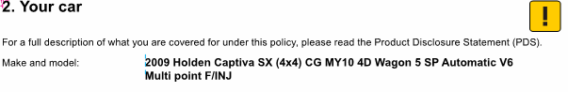
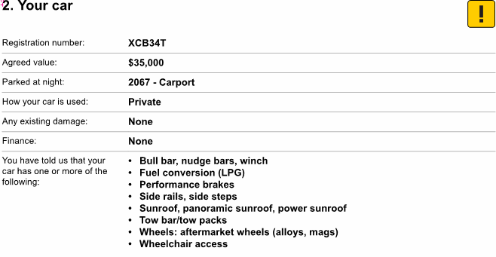
Section layout IF <ProductCode> = “Auto”

Ref | Variables | Content | Logic | Style
YC 1 |  | 2. Your Insured Car  For a full description of what you are covered for under this policy, please read the attached Product Disclosure Statement (PDS). | Always display | Heading_1_COI  Bodycopy_COI
YC 2 | <VehicleYear> <VehicleMake> <VehicleModel> <VehicleDescription> | Year, make and model: <VehicleDescription> | Always display | Column 1 text:  Bodycopy_COI  Column 2 text:  Table_Heading_3
YC 3 | <VehicleRegistration> | Registration number: <VehicleRegistration> | IF <VehicleRegistration> != “NULL” THEN display [“Registration: <VehicleRegistration>”]  ELSEIF <VehicleRegistration>=NULL, THEN display [“VIN: <SVIN>] | Column 1 text:  Bodycopy_COI  Column 2 text:  Bodycopy_B
YC 4 | <VehicleVIN> | VIN: <VehicleVIN> | ELSEIF <VehicleRegistration>=NULL, THEN display [“VIN: <VehicleVIN>] | Column 1 text:  Bodycopy_COI  Column 2 text:  Bodycopy_B
YC 5 | <VehicleCoverTypeCode>  <VehicleInsuredType>  <VehicleSumInsured> | Sum Insured: Agreed value of $ <VehicleSumInsured> | IF <VehicleCoverTypeCode> = "1|Comprehensive" OR "2|Payasyoudrive"  AND <VehicleSumInsuredTypeCode> = "Agreed Value"  THEN display | Column 1 text:  Bodycopy_COI  Column 2 text:  Bodycopy_B
YC 6 | <VehicleCoverTypeCode>  <VehicleInsuredType> | Sum Insured: Market value | IF <VehicleCoverTypeCode> = "1|Comprehensive" OR "2|Payasyoudrive"  AND <VehicleSumInsuredTypeCode> = "Market Value"  THEN display | Column 1 text:  Bodycopy_COI  Column 2 text:  Bodycopy_B
YC 7 | <VehicleCoverTypeCode> | Sum Insured: Up to the lesser of $10,000 or market value | IF <VehicleCoverTypeCode> = “4|Thirdpartypropertyfiretheft”  THEN display | Column 1 text:  Bodycopy_COI  Column 2 text:  Bodycopy_B
YC 8 | <VehicleCoverTypeCode> | Sum Insured: Third Party Property Damage only | IF <VehicleCoverTypeCode> = “5|Thirdpartypropertydamage”  THEN display | Column 1 text:  Bodycopy_COI  Column 2 text:  Bodycopy_B
YC 9 S1 | <ParkTypeDisplay>  <NightParkRiskAddress> | Car overnight location: <NightParkRiskAddress>- < ParkTypeDisplay> | IF <ParkTypeCode> != “7|NotRecordedOnlyForMigration”  THEN display  <NightParkRiskAddress>- < ParkTypeDisplay>  ELSE | Column 1 text:  Bodycopy_COI  Column 2 text:  Bodycopy_B
YC 9 S2 | <ParkTypeDisplay>  <NightParkRiskAddress> | Car overnight location: <NightParkRiskAddress>- Not recorded | IF <ParkTypeCode> = “7|NotRecordedOnlyForMigration”  THEN display  <NightParkRiskAddress>- Not recorded | Column 1 text:  Bodycopy_COI  Column 2 text:  Bodycopy_B
YC 10 | <VehicleUseCode>  <VehicleUseDisplay> | How your car is used: <VehicleUseDisplay> | IF <VehicleUseCode> = "1|Private” THEN display | Column 1 text:  Bodycopy_COI  Column 2 text:  Bodycopy_B
 |  | How your car is used: <VehicleUseDisplay> | IF <VehicleUseCode> = "2|Business” THEN display | Column 1 text:  Bodycopy_COI  Column 2 text:  Bodycopy_B
 |  | How your car is used: Private and less than 50% used for business | IF <VehicleUseCode> = "3|PrivateAndBusiness” and (<CentOfBusinessUseCode> = “ 1|0to25” or “2|26to49”)  THEN display | Column 1 text:  Bodycopy_COI  Column 2 text:  Bodycopy_B
 |  | How your car is used: Private and more than 50% used for business | IF  <VehicleUseCode> = "3|PrivateAndBusiness” AND <CentOfBusinessUseCode> = "3|50orMore” THEN display | Column 1 text:  Bodycopy_COI  Column 2 text:  Bodycopy_B
 |  | How your car is used: Private and unknown percentage of business use | IF  <VehicleUseCode> = "3|PrivateAndBusiness” AND <CentOfBusinessUseCode> = "4|UnknownMigrationOnly”  THEN display | Column 1 text:  Bodycopy_COI  Column 2 text:  Bodycopy_B
YC 11 | <VehicleDistanceDisplay>  <VehicleCoverTypeCode> | Distance driven per year (approximate): <VehicleDistanceDisplay> km  Distance driven per year (approximate): Not recorded | IF <VehicleCoverTypeCode> = “1|Comprehensive” OR “4|Thirdpartypropertyfiretheft” OR “5|Thirdpartypropertydamage”  AND  IF  <VehicleDistanceCode> = “27|-9999  THEN display “Not recorded”  ELSEIF  <VehicleDistanceCode> != “27|-9999”  THEN display  <VehicleDistanceDisplay>  ELSE do not display  ENDIF | Column 1 text:  Bodycopy_COI  Column 2 text:  Bodycopy_B
YC 12 | <ExistingDamageCode> | Any existing damage: None | IF <ExistingDamageCode> = " 2|ExistingDamageFalse " THEN display | Column 1 text:  Bodycopy_COI  Column 2 text:  Bodycopy_B
YC 13 | <ExistingDamageCode>  <<DamageOptionsDisplay> | Any existing damage: - <DamageOptionsDisplay> | ELSEIF  <ExistingDamageCode> = " 1|ExistingDamageTrue " THEN display <DamageOptionsDisplay>  <DamageOptionsDisplay> is an array so display all entries passed | Column 1 text:  Bodycopy_COI  Column 2 text:  Bullet_1_B_COI
YC 14 | <IsVehicleFinancedCode> | Finance: None | IF <IsVehicleFinancedCode> = "1|No" THEN display | Column 1 text:  Bodycopy_COI  Column 2 text:  Bodycopy_B
 | <IsVehicleFinancedCode>  <VehicleFinancierDisplay> | Finance: Lease/Hire purchase with <VehicleFinancierDisplay> | IF <IsVehicleFinancedCode> = "2|YesLease" THEN display  IF multiple <VehicleFinancierDisplay> then list all separated by “ , “ | Column 1 text:  Bodycopy_COI  Column 2 text:  Bodycopy_B
 | <IsVehicleFinancedCode> | Finance: Loan with <VehicleFinancierDisplay> | IF <IsVehicleFinancedCode> = "3|YesLoan" THEN display  IF multiple <VehicleFinancierDisplay> then list all separated by “ , “ | Column 1 text:  Bodycopy_COI  Column 2 text:  Bodycopy_B
YC 15 | <AfterMarketExtrasCode> | You have told us that your car does not have any of the following: - Bull bar, nudge bars, winch - Fuel conversion (LPG) - Performance brakes - Side rails, side steps - Sunroof, panoramic sunroof, power sunroof - Tow bar/tow packs - Wheels: aftermarket wheels (alloys, mags) | IF <AfterMarketExtrasCode>= “2|0” THEN display | Column 1 text:  Bodycopy_COI  Column 2 text:  Bullet_1_B_COI
 |  | You have told us that your car has one or more of the following: - Bull bar, nudge bars, winch - Fuel conversion (LPG) - Performance brakes - Side rails, side steps - Sunroof, panoramic sunroof, power sunroof - Tow bar/tow packs - Wheels: aftermarket wheels (alloys, mags) | IF <AfterMarketExtrasCode>= “1|1” THEN display | Column 1 text:  Bodycopy_COI  Column 2 text:  Bullet_1_B_COI

Declarations and driver history (Motor)
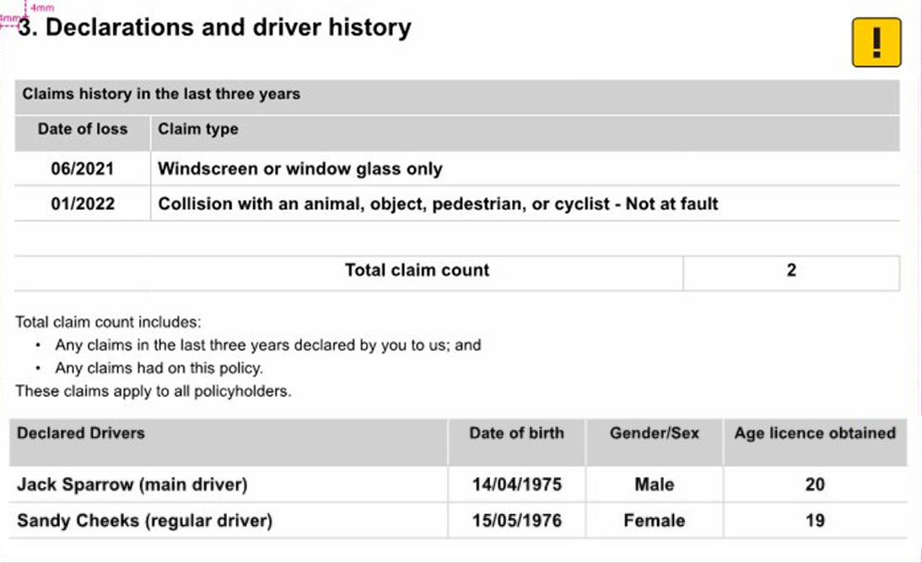
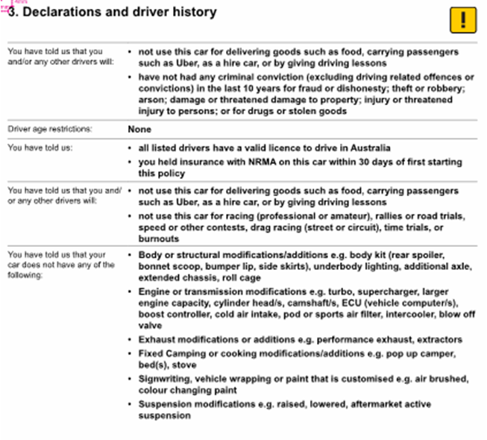

Ref | Variables | Content | Logic | Style
DDH 1 |  | 3.Declarations and driver history | Always display | Heading_1_COI
DDH 2 | <DriverNoOfClaims> <DriverClaimDateofLossMonth> <DriverClaimDateofLossYear>  <AdditionalDriverClaimDateofLossMonth>  <AdditionalDriverClaimDateofLossYear><DriverClaimTypeDisplay>  <AdditionalDriverClaimTypeDisplay> | Claims history in the last three years  Date of loss Claim type  <DriverClaimDateofLossMonth>/< DriverClaimDateofLossYear> <DriverClaimTypeDisplay>  <AdditionalDriverClaimDateofLossMonth>/<AdditionalDriverClaimDateofLossYear> <AdditionalDriverClaimTypeDisplay> | IF <VehicleTotalClaimsCount> GREATER THAN 0 THEN display  Else DO NOT Display  The date of loss and claim type should be a repeated array) | Table Style: COI_Table_2  Table Heading: Bodycopy_B_COI  Table heading Column 1: Table_Bodycopy_B_C_COI  Table heading Column 2: Bodycopy_B_COI  Table text Column 1: Table_Heading_3_C  Table text Column 2: Table_Heading_3
DDH 3 | <VehicleTotalClaimsCount> | Total claim count <VehicleTotalClaimsCount> | Always Display | Table Style: COI_Table_3  Table_Heading_3_C
DDH 4 |  | Total claim count includes:  - Any claims in the last three years declared by you to us; and  - Any claims had on this policy.  These claims apply to all policyholders. | Always Display | Table_Bodycopy_COI  Bullet_2_COI
DDH 5 | <DriverFirstname>  <DriverSurname>  <DriverDOB >  <DriverGenderDisplay>  <DriverYearsLicensed> | Declared drivers Date of birth Gender Age licence obtained  <DriverFirstName><DriverSurname> <DriverDOB> <DriverGenderDisplay> <DriverYearsLicensed>  <DriverFirstName><DriverSurname> <DriverDOB> <DriverGenderDisplay> <DriverYearsLicensed> | Always display  Driver array of up to 7 drivers can be listed * each driver listed in own row across 4 column table - all details in bold | Table Style: COI_Table_2  Table headings: Table_Bodycopy_B_COI  Table Text  Column 1: Table_Heading_3  Table Text Columns 2 – 4:  Table_Heading_3_C
DDH 6 | <ProductCode>  <EndorsementClause> | Driver age restrictions: None | IF <ProductCode> = "Auto" AND  <EndorsementClause> = NULL  THEN display  “None” | Column 1: Bodycopy_COI  Column 2: Table_Heading_3
DDH 7 | <EndorsementClause>  <ProductCode> | Driver age restrictions: There are age restrictions on this policy. See section ‘Special conditions and important notices'. | IF <ProductCode> ="Auto" AND  <EndorsementClause> = “AUTOEND01 “ or “AUTOEND02” or “AUTOEND04”  THEN display | Column 1: Bodycopy_COI  Column 2: Table_Heading_3
DDH 8 |  | Excluded Drivers: None | IF <DriverTypeCode> != 2|ExcludedDriver  THEN Display | Column 1 Bodycopy_COI  Column 2: Bullet_1_B_COI
DDH 9 |  | Excluded Drivers: There are Excluded Driver restrictions on this policy. See section ‘ Special conditions and important notices'. | IF <DriverTypeCode> = 2|ExcludedDriver  THEN Display | Column 1 Bodycopy_COI  Column 2: Bullet_1_B_COI
DDH 10 V1 |  | You have told us that all policyholders and/or any other declared drivers of this car: • have not had insurance cover declined to renew or cancelled by the insurer in the last 5 year | Column 1 logic:  DEV & Test note- Column 1 logic is applicable from ref DDH 10 until DDH 23  IF <IsMigration> = ’0’  Then Display  “You have told us that all policyholders and/or any other declared drivers of this car:”  ELSEIF  IF <IsMigration> = ’1’  Then Display  “We understand that in your previous policy terms policyholders and/or other declared drivers of this car:”  Column 2 text logic  IF  <HasBeenDeniedInsuranceCode> = “2|RefusedFalse”  Then Display | Column 1 Bodycopy_COI  Column 2: Bullet_1_B_COI
DDH 11 |  | You have told us that all policyholders and/or any other declared drivers of this car: • have not had any criminal conviction (excluding driving related convictions) in the last 5 years for fraud or dishonesty; theft or robbery; arson; damage or threatened damage to property; injury or threatened injury to persons; or for drugs or stolen goods | Column 2 text logic  IF  <HasAnyCriminalConvictionCode> = “2|CriminalFalse”  THEN display | Column 1 Bodycopy_COI  Column 2: Bullet_1_B_COI
DDH 12 |  | You have told us that all policyholders and/or any other declared drivers of this car: • have not had any criminal conviction (excluding driving related convictions) in the last 5 years for fraud or dishonesty; theft or robbery; arson; damage or threatened damage to property; injury or threatened injury to persons; or for drugs or stolen goods | Column 2 text logic  IF  <HasAnyCriminalConvictionCode> = “1|CriminalTrue”  AND  <ConvictionTypeCode> = “7|Noneoftheabove”  THEN display | Column 1 Bodycopy_COI  Column 2: Bullet_1_B_COI
DDH 13 |  | We understand that in your previous policy terms policyholders and/or other declared drivers of this car: • have had a criminal conviction (excluding driving related convictions) in the last 5 years for fraud or dishonesty; theft or robbery; arson; damage or threatened damage to property; injury or threatened injury to persons; or for drugs or stolen goods | Column 2 text logic  IF  <HasAnyCriminalConvictionCode> = “1|CriminalTrue”  AND  <ConvictionTypeCode> = “8|DisclosedInLegacySystem”  THEN display | Column 1 Bodycopy_COI  Column 2: Bullet_1_B_COI
DDH 14 V1 |  | You have told us that all policyholders and/or any other declared drivers of this car: • do not have any pending prosecutions for any motoring offence | Column 1 logic defined in DDH 10 V1 | Column 1 Bodycopy_COI  Column 2: Bullet_1_B_COI |  | Always display | Column 1 Bodycopy_COI  Column 2: Bullet_1_B_COI
DDH 14 V2 |  | We understand that in your previous policy terms policyholders and/or other declared drivers of this car: • do not have any pending prosecutions for any motoring offence | Column 1 logic defined in DDH 10 V1 | Column 1 Bodycopy_COI  Column 2: Bullet_1_B_COI
DDH 15 |  | You have told us that all policyholders and/or any other declared drivers of this car: • have not been convicted of any criminal driving related convictions, including driving under the influence of alcohol or drugs, within the last 5 years | Column 2 text logic  IF  <HasDrivingCriminalConvictionCode> = “2|DrivingFalse” | Column 1 Bodycopy_COI  Column 2: Bullet_1_B_COI
DDH 16 |  | We understand that in your previous policy terms policyholders and/or other declared drivers of this car: • have criminal driving related convictions, including driving under the influence of alcohol or drugs, within the last 5 years | Column 2 text logic  IF  <HasDrivingCriminalConvictionCode> = “3|DisclosedInLegacySystem”  THEN display | Column 1 Bodycopy_COI  Column 2: Bullet_1_B_COI
DDH 17 |  | You have told us that all policyholders and/or any other declared drivers of this car: • have not had an insurance claim denied for fraud or dishonesty in the last 5 years | IF  <HasFraudDishonestyCode> = “2|ClaimDeniedFalse”  THEN display  ELSE | Column 1 Bodycopy_COI  Column 2: Bullet_1_B_COI
DDH 18 |  | We understand that in your previous policy terms policyholders and/or other declared drivers of this car: • may have had an insurance claim denied for fraud or dishonesty in the last 5 years | Column 2 text logic  IF  <HasFraudDishonestyCode> = “3|NotRecordedOnlyForMigration”  THEN display  ELSE | Column 1 Bodycopy_COI  Column 2: Bullet_1_B_COI
DDH 20 |  | You have told us that all policyholders and/or any other declared drivers of this car: • have not had a disqualification from driving due to any driving offence(s) in the last 3 years | Column 2 text logic  IF  <HasLicenceDisqualifiedCode> = “2|DisqualifiedFalse”  THEN display  ELSE | Column 1 Bodycopy_COI  Column 2: Bullet_1_B_COI
DDH 21 |  | We understand that in your previous policy terms policyholders and/or other declared drivers of this car: • had a disqualification from driving due to any driving offence(s) in the last 3 years | Column 2 text logic  IF  <HasLicenceDisqualifiedCode> = “1|DisqualifiedTrue”  THEN display  ELSE | Column 1 Bodycopy_COI  Column 2: Bullet_1_B_COI
DDH 22 |  | We understand that in your previous policy terms policyholders and/or other declared drivers of this car: • may have had a disqualification from driving due to any driving offence(s) in the last 3 years | Column 2 text logic  IF  <HasLicenceDisqualifiedCode> = “3|NotRecordedOnlyForMigration”  THEN display  ELSE | Column 1 Bodycopy_COI  Column 2: Bullet_1_B_COI
DDH 23 |  | You have told us that all policyholders and/or any other declared drivers of this car: • have not had their licence cancelled, suspended or restricted due to any driving offence(s) in the last 3 years | Column 2 text logic  IF  <HasLicenceCancelledCode> = “2|LicenseFalse”  THEN display  ELSE | Column 1 Bodycopy_COI  Column 2: Bullet_1_B_COI
DDH 24 |  | We understand that in your previous policy terms policyholders and/or other declared drivers of this car: • had their licence cancelled, suspended or restricted due to driving offence(s) in the last 3 years | Column 2 text logic  IF  <HasLicenceCancelledCode> = “1|LicenseTrue”  THEN display  ELSE | Column 1 Bodycopy_COI  Column 2: Bullet_1_B_COI
DDH 25 |  | We understand that in your previous policy terms policyholders and/or other declared drivers of this car: • may have had their licence cancelled, suspended or restricted due to driving offence(s) in the last 3 years | Column 2 text logic  IF  <HasLicenceCancelledCode> = “3|NotRecordedOnlyForMigration”  THEN display | Column 1 Bodycopy_COI  Column 2: Bullet_1_B_COI
DDH 26 | <VehicleInsuredLast30DaysCode> | You have told us: • all declared drivers have a valid licence to drive in Australia | Always display | Column 1 Bodycopy_COI  Column 2: Bullet_1_B_COI
DDH 27 | <VehicleInsuredLast30DaysCode> | You have told us: • you held insurance excluding Compulsory Third Party insurance (CTP/Green Slip) on this car within 30 days of first taking out this policy | IF <VehicleInsuredLast30DaysCode> = 1|True THEN display
DDH 28 | <VehicleInsuredLast30DaysCode> | You have told us: • you did not hold insurance excluding Compulsory Third Party insurance (CTP/Green Slip) on this car within the first 30 days of first taking out this policy | IF <VehicleInsuredLast30DaysCode> = 2|False  THEN display
DDH 29 |  | You have told us that your car does not have any of the following: • Body or structural modifications/additions e.g. body kit (rear spoiler, bonnet scoop, bumper lip, side skirts), underbody lighting, additional axle, extended chassis, roll cage • Engine or transmission modifications e.g. turbo, supercharger, larger engine capacity, cylinder head/s, camshaft/s, ECU (car computer/s), boost controller, cold air intake, pod or sports air filter, intercooler, blow off valve • Exhaust modifications or additions e.g. performance exhaust, extractors • Fixed Camping or cooking modifications/additions e.g. pop up camper, bed(s), stove • Car wrapping or customised paint (airbrushed, colour changing, etc) other than business signwriting/logos • Suspension modifications e.g. raised, lowered, aftermarket active suspension  You have told us that your car has one or more of the following: • Body or structural modifications/additions e.g. body kit (rear spoiler, bonnet scoop, bumper lip, side skirts), underbody lighting, additional axle, extended chassis, roll cage • Engine or transmission modifications e.g. turbo, supercharger, larger engine capacity, cylinder head/s, camshaft/s, ECU (car computer/s), boost controller, cold air intake, pod or sports air filter, intercooler, blow off valve • Exhaust modifications or additions e.g. performance exhaust, extractors • Fixed Camping or cooking modifications/additions e.g. pop up camper, bed(s), stove • Car wrapping or customised paint (airbrushed, colour changing, etc) other than business signwriting/logos • Suspension modifications e.g. raised, lowered, aftermarket active suspension  You have told us that your car does not have any of the following: • Body or structural modifications/additions e.g. body kit (rear spoiler, bonnet scoop, bumper lip, side skirts), underbody lighting, additional axle, extended chassis, roll cage • Engine or transmission modifications e.g. turbo, supercharger, larger engine capacity, cylinder head/s, camshaft/s, ECU (car computer/s), boost controller, cold air intake, pod or sports air filter, intercooler, blow off valve • Exhaust modifications or additions e.g. performance exhaust, extractors • Fixed Camping or cooking modifications/additions e.g. pop up camper, bed(s), stove • Car wrapping or customised paint (airbrushed, colour changing, etc) other than business signwriting/logos • Suspension modifications e.g. raised, lowered, aftermarket active suspension | Column 1 logic:  IF <IsMigration> = ‘0’  AND  <PrimaryModificationCode> = "1|1" and <VehicleModificationCode> = "2|0"  OR <PrimaryModificationCode> = "2|0"  then DISPLAY  “You have told us that your car does not have any of the following:”  IF  <IsMigration> = ‘1’  AND  <PrimaryModificationCode> = "1|1" and <VehicleModificationCode> = "3|DisclosedInLegacySystem"  then DISPLAY  "You have told us that your car has one or more of the following:"  ELSEIF  <IsMigration> = ‘1’  AND  <PrimaryModificationCode> = "1|1" and <VehicleModificationCode> = "2|0"  OR  <PrimaryModificationCode> = "2|0"  then DISPLAY  “You have told us that your car does not have any of the following:” | Column 1 Bodycopy_COI  Column 2: Bullet_1_B_COI

Excesses (Motor)
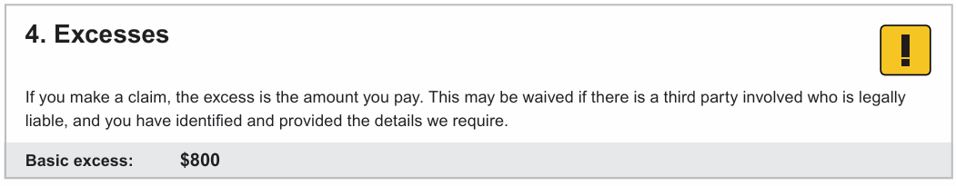

Ref | Variables | Content | Logic | Style
EXM 1 |  | 4. Excesses | Always display | Brand_icon_attention2.jpg  Heading_1_COI
EXM 2 |  | If you make a claim, the excess is the amount you pay. This may be waived if there is a third party involved who is legally liable, and you have identified and provided the details we require. | Always display | Text Style: Bodycopy_COI
EXM 3 | <VehicleExcessAmount> | Basic excess: $<VehicleExcessAmount> | Always display | Table style: COI_Table_4  Column 1: Bodycopy_B_COI  Column 2: Table_Heading_3

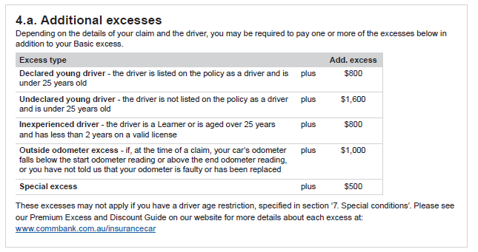

Ref | Variables | Content | Logic | Style
AE 1 |  | 4.a. Additional excesses | Always display | Heading_1_COI
AE 2 |  | Depending on the details of your claim and the driver, you may be required to pay one or more of the excesses below in addition to your Basic excess. | Always display | Bodycopy_COI
AE 3 |  | Excess Type Add. excess  Declared young driver - the driver is declared on the policy as a driver and is under 25 years old plus $800  Undeclared young driver - the driver is not declared on the policy as a driver and is under 25 years old plus $1600  Inexperienced driver – the driver is a learner driver or is aged over 25 years and has less than 2 years on a valid licence plus $800  Outside odometer - if, at the time of a claim, your car's odometer is below the start odometer reading or above the end odometer reading as noted on this COI, or you have not told us that your odometer is faulty and is not repaired or has been replaced and your odometer reading has changed, and you have not notified us plus $1000 | Always display  IF <VehicleCoverTypeCode>= "2|Payasyoudrive"  THEN Display  “Outside odometer - if, at the time of a claim, your car's odometer is below the start odometer reading or above the end odometer reading, or you have not told us that your odometer is faulty or has been replaced  Else Do Not Display | Table style: COI_Table_5  Table Heading: Bodycopy_B_COI  Table rows:  Bodycopy_B_COI  Bodycopy_COI
AE 4 |  | Some of these excesses may not apply if you have a driver age restriction, specified in ‘ Special conditions and important notices’. If your claim is not covered, you will not be liable to pay any excess. Please see our Premium Excess and Discount Guide on our website for more details about each excess at: <BrandPEDGURL>www.commbank.com.au/insurancecar | Always display | Text Style: Table_Bodycopy_COI

Security Features (Home/Landlord)

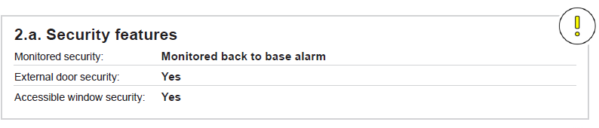

Ref | Variables | Content | Logic | Style
SF 1 | <HomeCoverTypeCode> | 2.a. Security features | .  IF <HomeCoverTypeCodeCoverType> = “5|BuildingAndContents” OR “3|Contents”  THEN display  ELSE Do not display  ENDIF | Heading_1_COI  Table style: COI_Table_4
SF 2 | <HomeCoverTypeCode>  <ProductCode> | Monitored security: <AlarmTypeDisplay> | IF <ProductCode> =”Home” OR “Landlord”  AND <HomeCoverTypeCode> = “5|BuildingAndContents” OR “3|Contents”  THEN display  ELSE do not display | Column 1: Bodycopy_ COI  Column 2: Table_Heading_3
SF 3 | <HomeCoverTypeCode>  <ProductCode>  <DoorlocksCode> | External door security: <DoorlocksDisplay> | IF <ProductCode> =”Home” OR “Landlord” AND <HomeCoverTypeCode> = “5|BuildingAndContents” OR “3|Contents  AND  <DoorlocksCode> != “5|NotRecordedOnlyForMigration”  THEN display  ELSE do not display  ENDIF | Column 1: Bodycopy_ COI  Column 2: Table_Heading_3
 | <HomeCoverTypeCode>  <ProductCode>  <DoorlocksCode> | External door security: Not confirmed | IF <ProductCode> =”Home” OR “Landlord” AND <HomeCoverTypeCode> = “5|BuildingAndContents” OR “3|Contents  AND  <DoorlocksCode> = “5|NotRecordedOnlyForMigration”  THEN display  ELSE do not display  ENDIF | Column 1: Bodycopy_ COI  Column 2: Table_Heading_3
SF 4 S1 | <HomeCoverTypeCode>  <ProductCode>  <WindowlocksCode> | Accessible window security: <WindowlocksDisplay> | IF <ProductCode> =”Home” OR “Landlord”  AND <HomeCoverTypeCode > = “5|BuildingAndContents” OR “3|Contents  AND  <WindowlocksCode> != “7|NotRecordedOnlyForMigration”  THEN display  ELSE do not display  ENDIF | Column 1: Bodycopy_ COI  Column 2: Table_Heading_3
SF 4 S2 | <HomeCoverTypeCode>  <ProductCode>  <WindowlocksCode> | Accessible window security: Not confirmed | IF <ProductCode> =”Home” OR “Landlord”  AND <HomeCoverTypeCode > = “5|BuildingAndContents” OR “3|Contents  AND  <WindowlocksCode> = “7|NotRecordedOnlyForMigration”  THEN display  ELSE do not display  ENDIF | Column 1: Bodycopy_ COI  Column 2: Table_Heading_3
SF 5 | <ProductCode> | Additional security  You have advised us that the following security features are present on the Insured Address.  - <EndorsementDetails> (Manual entries entered by agent.) | IF <EndorsementType> = “2|Manual  THEN Display (iteratively)  <EndorsementDetails> | Heading:  Bodycopy_B_COI  Text:  Table_Bodycopy_COI  Bullet_2_COI

Your contents (Home/Landlord)

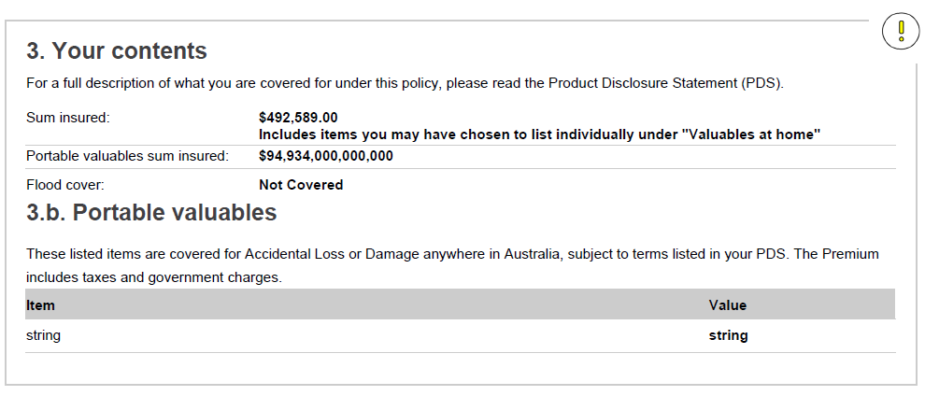

Ref | Variables | Content | Logic | Style
YRC 1 | <HomeCoverTypeCode> | - Your contents | Always display  IF <HomeCoverTypeCode>= ”5|BuildingAndContents” OR “3|Contents” THEN display | Heading_1_COI
YRC 2 |  | For a full description of what you are covered for under this policy, please read the Product Disclosure Statement (PDS). |  | Bodycopy_COI
YRC 3 | <BrandContentsCalculator>  <SpecifiedItemArray>  <HomeCoverTypeCode>=  <BrandCode> | Sum Insured: $<ContentsSumInsured>  Please check your sum insured to see if your level of insurance cover is still appropriate for you. A calculator can help with estimating your contents value, please visit <BrandContentsCalculator>. | IF <HomeCoverTypeCode>= ”5|BuildingAndContents” OR “3|Contents”)  THEN display  IF <BrandCode> = CBA THEN display [“Please check your sum insured to see if your level of insurance cover is still appropriate for you. A calculator can help with estimating your building’s value, please visit <BrandContentsCalculator>”  ELSE do not display | Table style: COI_Table_6  Column 1 Text Style: Bodycopy_COI​  Column 2 Text Style: Table_Heading_3  Text style: Bodycopy_COI
YRC 4 | <ProductCode>  <HomeCoverTypeCode>  <ContentsOptionalCoverageType>  < TotalSumInsuredPortableItems> | Portable valuables sum insured: $<TotalSumInsuredPortableItems>  You do not need to include the value of your Portable valuables in your contents sum insured. | IF <ProductCode> =”Home”AND <HomeCoverTypeCode>= ”5|BuildingAndContents” OR “3|Contents AND <ContentsOptionalCoverageType> != NULL THEN display | Column 1 Text Style: Bodycopy_COI​  Column 2 Text Style: Table_Heading_3  Bodycopy_COI
YRC 5 | <ProductCode>  <HomeCoverTypeCode>= | Flood cover: Covered | IF <ProductCode> =”Home” OR “Landlord”)AND <HomeCoverTypeCode>= ”5|BuildingAndContents” OR “3|Contents  THEN display  ELSE do not display  ENDIF | Column 1 Text Style: Bodycopy_COI​  Column 2 Text Style: Table_Heading_3
YRC 6 | <SpecifiedItemsCategoryCode> | 3.a. Portable valuables | IF  <SpecifiedItemsCategoryCode>!= Null  THEN display  ELSE Do Not Display whole section | Heading_1_COI
YRC 7 | <SpecifiedItemsCategoryCode> | These listed items are covered for accidental loss or damage anywhere in Australia and New Zealand, subject to terms and conditions listed in your PDS. | IF  <SpecifiedItemsCategoryCode> OR!= Null  THEN display  ELSE Do Not Display | Bodycopy_COI​
YRC 8 | <SpecifiedItemsCategoryCode> | Group Cover: Value | IF <SpecifiedItemsCategoryCode> = 13|UnspecifiedGroupCover  THEN display table else do not display table | Bodycopy_B_COI
YRC 9 | <SpecifiedItemsCategoryCode>  <Suminsuredunspecifiedportableitems> | <SpecifiedItemsCategoryDisplay> $<Suminsuredunspecifiedportableitems>  Group Cover has a maximum claim limit of up to $1000 per item, up to an overall Group Cover claim limit selected by you. | IF <SpecifiedItemsCategoryCode> 13|UnspecifiedGroupCover  THEN display | Column 1: Bodycopy_COI  Column 2: Table_Heading_3  Text: BodyCopy_COI
YRC 10 | <SpecifiedItemsCategoryCode> | Itemised Cover: Value | IF <SpecifiedItemsCategoryCode>!=NULL  AND < SpecifiedItemsValue>!=NULL AND <SpecifiedItemsCategoryCode> ! = 13|UnspecifiedGroupCover THEN display | Bodycopy_B_COI
YRC 11 S1 | <SpecifiedItemsCategoryDisplay>  <SpecifiedItemsValue>  <SpecifiedItemsDescription> | <SpecifiedItemsCategoryDisplay> - <SpecifiedItemsDescription> $<SpecifiedItemsValue>  <SpecifiedItemsCategoryDisplay> - <SpecifiedItemsDescription> $<SpecifiedItemsValue>  <SpecifiedItemsCategoryDisplay> - <SpecifiedItemsDescription> $<SpecifiedItemsValue>  Example:  Baby Equipment - Baby capsule or child car seat $285.00 | IF SpecifiedItemsCategoryCode>!=NULL  AND < SpecifiedItemsValue>!=NULL  AND <SpecifiedItemsDescription> !=NULL AND <SpecifiedItemsCategoryCode> != 13|UnspecifiedGroupCover  THEN display  Note: if any portable valuable item has a prefix then we want to display that prefix when listing the item | Column 1: Bodycopy_COI  Column 2: Table_Heading_3  Text: BodyCopy_COI

Special Conditions (Home/Landlord)

Ref | Variables | Content | Logic | Style
SCH 1 |  | - Special conditions and important notices | Always display | Heading Text Style: Heading_1_COI
SCH 2 | <ProductCode>  <EndorsementType>  <EndorsementDetails> | Special conditions of your cover: <EndorsementDetails> | IF <ProductCode> =”Home” OR “Landlord”)  AND  <EndorsementType> = “3|Custom”  THEN Display (iteratively)  <EndorsementDetails>  ELSE | Column 1: Bodycopy_COI​  Column 2: Table_Heading_3
SCH 3 V1 | <ProductCode>  UnderConstructionCode  <HomeCoverTypeCode> | Special conditions of your cover: Renovations You have confirmed that your Insured Address will be renovated; and the value of the construction/renovation is expected to be less than $300,000. When you carry out building alterations, renovations or additions (of any value) the cover under this policy is restricted. Below we have highlighted the exclusions that apply while building works are underway. You are not covered for: • Loss or damage caused by water entering your building due to building alterations, renovations or additions; • Loss or damage as a result of theft or attempted theft by a person who is at the Insured Address with your consent or the consent of another person who normally resides or resided at the insured address; • Loss or damage due to theft or attempted theft or where the building or insured address security has been compromised due to the works being carried out; • Legal liability in respect to any loss or damage caused by or as a consequence of the building renovations, alterations and/or additions if the total value of the project is greater than $50,000; • Accidental damage caused by or as a consequence of the building alterations, renovations or additions. This policy does not cover you for loss or damage caused by the building works or damage to the building works. If you require cover, you may need to take out a separate insurance product with another insurer. Hollard does not provide this type of cover. | IF <ProductCode> =”Home” OR “Landlord”  AND <UnderConstructionCode>= 1|UnderConstructionYes  THEN display  ELSE | Column 1: Bodycopy_COI​  Column 2 Heading: Table_Heading_3  Column 2 body: Bodycopy_COI
SCH 3 V2 |  | Special conditions of your cover: Renovations You have confirmed that your Insured Address will be renovated. When you carry out building alterations, renovations or additions (of any value) the cover under this policy is restricted. Below we have highlighted the exclusions that apply while building works are underway. You are not covered for: • Loss or damage caused by water entering your building due to building alterations, renovations or additions; • Loss or damage as a result of theft or attempted theft by a person who is at the Insured Address with your consent or the consent of another person who normally resides or resided at the insured address; • Loss or damage due to theft or attempted theft or where the building or insured address security has been compromised due to the works being carried out; • Legal liability in respect to any loss or damage caused by or as a consequence of the building renovations, alterations and/or additions if the total value of the project is greater than $50,000; • Accidental damage caused by or as a consequence of the building alterations, renovations or additions. This policy does not cover you for loss or damage caused by the building works or damage to the building works. If you require cover, you may need to take out a separate insurance product with another insurer. Hollard does not provide this type of cover. | IF <ProductCode> =”Home” OR “Landlord”  AND <UnderConstructionCode>= 3|YesCommencedBeforeMigrationMigrationOnly  THEN display  ELSE | Column 1: Bodycopy_COI​  Column 2 Heading: Table_Heading_3  Column 2 body: Bodycopy_COI
SCH 4 V1 | <ProductCode>  <Unoccupied60daysCode> | Special conditions of your cover: You have confirmed that your Insured Address is currently unoccupied and expected to be occupied within 60 days. If your building is unoccupied for longer than 60 consecutive days, cover under this policy is limited to loss or damage caused by Fire, Storm, Rainwater, Flood, Lightning, Earthquake, Tsunami, Volcanic Eruption and Impact during the period of time in which the building is unoccupied. | ELSEIF (<ProductCode> =”Home” OR “Landlord”) AND  <Unoccupied60daysCode> = “2|UnoccupiedNo” THEN display  ELSE | Column 1:Bodycopy_COI​  Column 2: Bodycopy_COI
SCH 4 V2 | <Unoccupied60daysCode>  <ProductCode> | Special conditions of your cover: You have confirmed that your Insured Address is currently unoccupied. If your building is unoccupied for longer than 60 consecutive days, cover under this policy is limited to loss or damage caused by Fire, Storm, Rainwater, Flood, Lightning, Earthquake, Tsunami, Volcanic Eruption and Impact during the period of time in which the building is unoccupied. | ELSEIF (<ProductCode> =”Home” OR “Landlord”) AND  <Unoccupied60daysCode> = “3|UnoccupancyDurationAcceptedOnlyForMigration” THEN display  ELSE | Column 1:Bodycopy_COI​  Column 2: Bodycopy_COI
SCH 5 | <BusinessPurposeCode>  <ProductCode> | Special conditions of your cover: Business Use Exclusions This policy does not cover; stock, liability, interruption, cash, loss of profit, malicious acts, theft, or attempted theft directly or indirectly arising out of or in connection with any business, profession, or occupation. | IF <ProductCode> =”Home” or “Landlord” AND (<BusinessPurposeCode> = “1|HomeUsageBusinessUseYes” or <BusinessPurposeCode> = ‘3|YesDisclosedInLegacyOnlyForMigration’)  THEN display  ELSE | Column 1: Bodycopy_COI​  Column 2 Heading Text Style: Table_Heading_3  Column 2 body Text style: Bodycopy_COI
SCH 6 | <EndorsementClause>  <ProductCode> | Special conditions of your cover: No special conditions apply | Else Display  This is the default if no other special conditions apply | Inner table style: COI_Table_6  Column 1: Bodycopy_COI​  Column 2: Table_Heading_3
SCH 7 |  | Important notices:  You are not covered for bushfire, storm, rainwater or flood that occurs in the 72 hours following the purchase of your policy, unless you are replacing an insurance policy with equivalent levels of cover to ours, without a break in cover; or on the same day your cover started you entered into a contract to purchase the home; or moved into the home as a tenant.  If you increase your sum(s) insured with us, or your replacement policy with us has higher sum(s) insured than you had with your previous insurer, you will not be covered for the higher amount/s until 72 hours after the increase was made. Please see the PDS for full details. | IF <ProductCode> =”Home”  AND  <DocumentSubType> = “New Business”  THEN display  ELSEIF | BodyCopy_COI
SCH 8 |  | Important notices:  You are not covered for bushfire, storm, rainwater or flood that occurs in the 72 hours following the purchase of your policy, unless you are replacing an insurance policy with equivalent levels of cover to ours, without a break in cover; or on the same day your cover started you entered into a contract to purchase the property.  If you increase your sum(s) insured with us, or your replacement policy with us has higher sum(s) insured than you had with your previous insurer, you will not be covered for the higher amount/s until 72 hours after the increase was made. Please see the PDS for full details. | IF <ProductCode> = “Landlord”  AND  <DocumentSubType> = “New Business”  THEN display  ENDIF | BodyCopy_COI

Excesses (Home/Landlord)

Ref | Variables | Content | Logic | Style
EXH 1 |  | - Excesses | IF <ProductCode> =”Home” OR “Landlord”  THEN Display  ELSE do not display  ENDIF | Brand_icon_attention2.jpg  Heading_1_COI
EXH 2 |  | If you make a claim, the excess is the amount(s) of money you pay or must contribute towards the cost of a claim. | Always display | Text Style: Bodycopy_COI
EXH 3 | <ProductCode>  <HomeCoverTypeCode>  <BuildingExcessAmount> | Building Basic excess: $<BuildingExcessAmount> | IF <ProductCode> =”Home” OR “Landlord” AND <HomeCoverTypeCode> = “2|Building” OR “5|BuildingAndContents”  THEN display  ELSE do not display  ENDIF | Table Style: COI_Table_4  Column 1: Bodycopy_B_COI  Column 2: Table_Heading_3
EXH 4 | <ProductCode>  < HomeCoverTypeCode > | Contents Basic excess: $<ContentsExcessAmount> | IF <ProductCode> =”Home” OR “Landlord”  AND < HomeCoverTypeCode > = “3|Contents” OR “5|BuildingAndContents”  THEN display  ELSE do not display  ENDIF | Column 1: Bodycopy_B_COI  Column 2: Table_Heading_3
EXH 5 | <ProductCode>  < HomeCoverTypeCode >  <ContentsSelected CoverInd> | Portable valuables excess: $100 | IF <ProductCode> = “Home” AND <HomeCoverTypeCode> = “3|Contents” OR “5|BuildingAndContents” AND IF (<ContentsSelected CoverageInd> = “1” AND <ContentsOptionalCoverageInd> = “0”)  AND  <ContentsCoverageCode> = “PortableItemised”  THEN Display  ELSE do not display  ENDIF | Column 1: Bodycopy_B_COI  Column 2: Table_Heading_3
EXH 6 |  | Food spoilage excess: $100 | IF <ProductCode> = “Home” AND <HomeCoverTypeCode> = “3|Contents” OR “5|BuildingAndContents”  THEN display  ELSE do not display  ENDIF | Column 1: Bodycopy_B_COI  Column 2: Table_Heading_3
EXH 7 |  | Motor burnout - Building excess: $100 | IF <ProductCode> = ”Home” OR “Landlord” AND <HomeCoverTypeCode> = “2|Building” OR “5|BuildingAndContents” AND IF (<BuildingSelected CoverageInd> = “1” AND <BuildingOptionalCoverageInd> = “0”) AND  <BuildingCoverageCode> = “MotorBurnoutBuildings”  THEN display  ELSE do not display  ENDIF | Column 1: Bodycopy_B_COI  Column 2: Table_Heading_3
EXH 8 |  | Motor burnout - Contents excess: $100 | IF <ProductCode> = ”Home” OR “Landlord” AND <HomeCoverTypeCode> = “5|BuildingAndContents” OR “3|Contents”  AND  <ContentsSelectedCoverageInd> = “1” AND <ContentsOptionalCoverageInd> = “0” AND <ContentsCoverageCode> = “MotorBurnoutContents”  THEN display  ELSE do not display  ENDIF | Column 1: Bodycopy_B_COI  Column 2: Table_Heading_3
EXH 9 |  | If you have a claim for one of the following events, the higher of your basic excess (above) or these fixed excesses will apply. | Always display | Bodycopy_COI
EXH 10 |  | Earthquake excess: $500 | Always display | Column 1: Bodycopy_B_COI  Column 2: Table_Heading_3
EXH 11 |  | Flood excess: $500 | Always display | Column 1 Heading Text style: Bodycopy_B_COI  Column 2 Text Style: Table_Heading_3
EXH 12 | <ProductCode>  <BuildingSelected <CoverInd>  <BuildingOptionalCoverInd> | Rent default and legal expenses excess: $400 | IF <ProductCode> = “Landlord”  AND IF (<BuildingSelected CoverageInd> = “1” AND <BuildingOptionalCoverageInd> = “0”) THEN Display | Column 1: Bodycopy_B_COI  Column 2: Table_Heading_3
EXH 13 | <ProductCode> | Malicious Acts and Theft by Tenants excess: $500 | IF <ProductCode> = “Landlord”  THEN display  ELSE do not display  ENDIF | Column 1: Bodycopy_B_COI  Column 2: Table_Heading_3
EXH 14 |  | Please see the Premium Excess and Discount Guide for more details about each excess at: <BrandPEDGURL> | Always display | Bodycopy_COI

Special Conditions (Motor)

Ref | Variables | Content | Logic | Style
SCM 1 |  | - Special conditions and important notices | Always display | Heading_1_COI
SCM 2 | <ProductCode>  <EndorsementType>  <EndorsementDetails> | Special conditions of your cover: <EndorsementDetails> | IF <ProductCode> =”Auto”  AND  <EndorsementType> = “3|Custom”  THEN Display (iteratively)  <EndorsementDetails>  THEN display  ELSE | Column 1: Bodycopy_COI  Column 2: Table_Heading_3
SCM 3 | <ProductCode>  <DriverAgeRestrictions> | Special conditions of your cover: Driver age restriction as selected by you There is no cover when the car is being driven, where the driver, learner driver, or supervising driver is under 25 years of age. In all other respects the policy conditions, exclusions, and limitations remain unaltered. | IF <ProductCode> = “Auto” AND <EndorsementClause> = “AUTOEND01”  THEN display  ELSE | Column 1: Bodycopy_COI  Column 2 heading: Table_Heading_3  Column 2 body: Bodycopy_COI
SCM 4 | <EndorsementClause>  <ProductCode> | Special conditions of your cover: Under 25 Driver Age Exclusion There is no cover when the car is being driven where the driver, learner driver, or supervising driver is under 25 years of age. In all other respects the policy conditions, exclusions, and limitations remain unaltered. | IF <ProductCode> = “Auto” AND  <EndorsementClause> = “AUTOEND02”  THEN display  ELSE | Column 1: Bodycopy_COI  Column 2 heading: Table_Heading_3  Column 2 body: Bodycopy_COI
SCM 5 | <EndorsementClause>  <ProductCode> | Special conditions of your cover: Under 30 Driver Age Exclusion There is no cover when the car is being driven where the driver, learner driver, or supervising driver is under 30 years of age. In all other respects the policy conditions, exclusions, and limitations remain unaltered | IF <ProductCode> = “Auto” AND  <EndorsementClause> = “AUTOEND04”  THEN display  ELSE | Column 1: Bodycopy_COI  Column 2 heading: Table_Heading_3  Column 2 body: Bodycopy_COI
SCM 6 | <ProductCode>  <EndorsementClause> | Special conditions of your cover: Named Driver Limitation There is no cover when the car is being driven by a learner driver, or anyone other than the declared drivers listed on the policy. In all other respects the policy conditions, exclusions, and limitations remain unchanged. | IF <ProductCode> =”Auto”  AND  <EndorsementClause> = “MANUEND04”  THEN display  ELSE | Table_Heading_3  Bodycopy_COI
SCM 7 | <ProductCode>  <DriverTypeCode>  <AdditionalDriverFirstname>  <AdditionalDriverSurname>]  <AdditionalDriverDOB> | Special conditions of your cover: There is no cover when the car is being driven by: • [<AdditionalDriverFirstname> <AdditionalDriverSurname>] – [<AdditionalDriverDOB>] • [<AdditionalDriverFirstname> <AdditionalDriverSurname>] – [<AdditionalDriverDOB>] | IF <ProductCode> =”Auto” AND <EndorsementClause> = ‘AUTOEND03’ AND  <DriverTypeCode> = “2|ExcludedDriver”  THEN display  ELSE  Dev Note: If ‘AUTOEND03’ passed for the policy, check each of the drivers and only display the names of the EXCLUDED driver(s) here. | Bodycopy_COI  Bullet_2_COI
SCM 8 | <ProductCode>  <EndorsementClause> | Special conditions of your cover: No special conditions apply | Else if none of the above apply display  This is the default if no special conditions apply | Table style: COI_Table_6  Column 1: Bodycopy_COI  Column 2: Table_Heading_3
SCM 9 |  | Important notices: | IF <ProductCode> =”Auto”  THEN display | Bodycopy_COI
SCM 10 |  | You are not covered as a result of a fire (including bushfire) or weather events that occur in the 24 hours following the purchase of your policy, unless you are replacing an insurance policy with equivalent levels of cover to ours, without a break in cover; or you have owned your car for less than 24 hours prior to the commencement of this cover. | IF <ProductCode> =”Auto”  THEN display  ELSEIF | Bodycopy_COI
SCM 11 |  | This policy does not offer a choice of repairer option. In the event of a claim, we will work with you to appoint a recommended repairer. We will only guarantee materials and workmanship on repairs done by a repairer appointed or approved by us. Please see the PDS for full details. | IF <ProductCode> =”Auto” AND <VehicleCoverTypeCode><>ThirdPartyPropertyDamage  THEN display | Bodycopy_COI

Cost Breakdown (ALL)
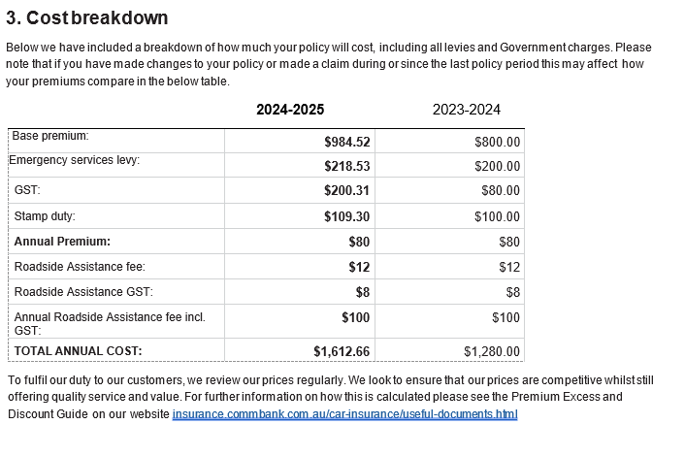

Ref | Variables |  |  | Content | Logic |  |  | Style
CB 1 |  | - Cost breakdown |  |  | Always display | Heading_1_COI
CB 2 | <DocumentSubType> | Below we have included a breakdown of how much your policy will cost, including all levies and Government charges. Please note that if you have made changes to your policy or made a claim during or since the last policy period this may affect how your premiums compare in the below table. |  |  | IF <DocumentSubType>  <> “New Business” THEN display | Bodycopy_COI
CB 3 | <DocumentSubType> | Below we have included a breakdown of how much your policy will cost, including all levies and Government charges. |  |  | ELSEIF = <DocumentSubType>  = “New Business” THEN display | Bodycopy_COI
CB 4 | <DocumentSubType>  <PolicyInceptionDate> <PolicyExpiryDate>  <CurrentTermEffectiveDate>  <CurrentTermExpiryDate> | <Blank> {StartYear} – {ExpiryYear} |  |  | IF <DocumentSubType>= “New Business” OR “Endorsement” THEN display  Dev Note – Use the 4 digit YYYY from <CurrentTermEffectiveDate>to display the {StartYear} variable and CurrentTermExpiryDate> to display the {ExpiryYear} variable | Table Style: COI_Table_7  Column 1: Table_Bodycopy_COI​  Column 2: Table_Heading_3_R
CB 5 | <DocumentSubType>  <PreviousTermEffectiveDate>  <PreviousTermExpiryDate>  <CurrentTermEffectiveDate>  <CurrentTermExpiryDate> | <Blank> {StartYear} – {ExpiryYear} {StartYear} – {ExpiryYear} |  |  | ELSEIF <DocumentSubType>= “Renewal” THEN display  Column 1:  Dev Note – Use the 4 digit YYYY from <CurrentTermEffectiveDate> to display the {StartYear} variable and <CurrentTermExpiryDate> to display the {ExpiryYear} variable  Column 2:  Dev Note – Use the 4 digit YYYY from <PreviousTermEffectiveDate>  to display the {EffectiveYear} variable and <PreviousTermExpiryDate>  to display the {ExpiryYear} variable | Column 1: Table_Bodycopy_COI​  Column 2 & 4: Table_Heading_3_R
CB 8 | <DocumentSubType>  <CurrentAnnualNetPremium> | Base premium: <CurrentAnnualNetPremium>/ <CurrentPremiumWrittenWithoutRA> |  |  | IF <DocumentSubType>= “New Business” OR “Endorsement” AND  <ProductCode> = ”Auto”  AND  <VehicleCoverageCode>  = “RA”  AND  (VehicleOptionalCoverageInd = ‘0’ and (<VehicleSelectedCoverageInd> = ‘0’ or ‘1’)  AND  <TotalRSAFee> != ‘0’  Then Display  <CurrentPremiumWrittenWithoutRA>  ELSE IF  Display  <CurrentAnnualNetPremium> | Column 1: Table_Bodycopy_COI​  Column 2: Table_Heading_3_R
CB 9 | <DocumentSubType>  <CurrentAnnualNetPremium>  <PreviousAnnualNetPremium> | Base premium: <CurrentAnnualNetPremium>/ <CurrentPremiumWrittenWithoutRA> <PreviousAnnualNetPremium>/<PreviousPremiumWrittenWithoutRA> |  |  | Previous term logic:  IF <DocumentSubType>= “Renewal”  AND<ProductCode>= “Auto”  AND  <VehicleCoverageCode>  = “RA”  AND  (VehicleOptionalCoverageInd = ‘0’ and (<VehicleSelectedCoverageInd> = ‘0’ or ‘1’)  AND  <TotalRSAFee> != ‘0’  Then Display  <PreviousPremiumWrittenWithoutRA>  ELSE IF Display  <PreviousAnnualNetPremium> | Column 1: Table_Bodycopy_COI  Column 2: Table_Heading_3_R
CB 10 | <DocumentSubType>  <CurrentAnnualESL> | Emergency services levy: <CurrentAnnualESL>/ <CurrentESLPremWithoutRA> |  |  | IF <DocumentSubType>= “New Business” OR “Endorsement” AND  <ProductCode> = ”Auto”  AND  <VehicleCoverageCode>  = “RA”  AND  (VehicleOptionalCoverageInd = ‘0’ and (<VehicleSelectedCoverageInd> = ‘0’ or ‘1’)  AND  <TotalRSAFee> != ‘0’  THEN display <CurrentESLPremWithoutRA>  ELSE IF  Display<CurrentAnnualESL> | Column 1: Table_Bodycopy_COI  Column 2: Table_Heading_3_R
CB 11 | <DocumentSubType>  <CurrentAnnualESL>  <PreviousAnnualESL> | Emergency services levy: <CurrentAnnualESL>/ <CurrentESLPremWithoutRA> <PreviousAnnualESL>/<PreviousESLPremWithoutRA> |  |  | IF <DocumentSubType>= “Renewal”  AND <ProductCode>= “Auto”  AND  <VehicleCoverageCode>  = “RA”  AND  (VehicleOptionalCoverageInd = ‘0’ and (<VehicleSelectedCoverageInd> = ‘0’ or ‘1’)  AND  <TotalRSAFee> != ‘0’  Then Display  <PreviousESLPremWithoutRA>  ELSE IF Display  <PreviousAnnualESL> | Column 1: Table_Bodycopy_COI  Column 2 & 4: Table_Heading_3_R
CB 12 | <DocumentSubType>  <CurrentAnnualGST> | GST: <CurrentAnnualGST>/<CurrentGSTPremWithoutRA> |  |  | IF <DocumentSubType>= “New Business” OR “Endorsement” AND  <ProductCode> = ”Auto” AND  <VehicleCoverageCode>  = “RA”  AND  (VehicleOptionalCoverageInd = ‘0’ and (<VehicleSelectedCoverageInd> = ‘0’ or ‘1’)  AND  <TotalRSAFee> != ‘0’  THEN display  <CurrentGSTPremWithoutRA>  ELSE IF  Display <CurrentAnnualGST> | Column 1: Table_Bodycopy_COI​  Column 2: Table_Heading_3_R
CB 13 | <DocumentSubType>  <CurrentAnnualGST>  <PreviousAnnualGST> | GST: <CurrentAnnualGST>>/<CurrentGSTPremWithoutRA> <PreviousAnnualGST>/<PreviousGSTPremWithoutRA> |  |  | IF <DocumentSubType>= “Renewal”  AND <ProductCode>= “Auto”  AND  <VehicleCoverageCode>  = “RA”  AND  (VehicleOptionalCoverageInd = ‘0’ and (<VehicleSelectedCoverageInd> = ‘0’ or ‘1’)  AND  <TotalRSAFee> != ‘0’  Then Display  <PreviousGSTPremWithoutRA>  ELSE IF Display  <PreviousAnnualGST> | Column 1: Table_Bodycopy_COI  Column 2 & 4: Table_Heading_3_R
CB 14 | <DocumentSubType>  <CurrentAnnualStampDuty> | Stamp duty: <CurrentAnnualStampDuty>/ <CurrentStampDutyPremWithoutRA> |  |  | IF <DocumentSubType>= “New Business” OR “Endorsement” AND  <ProductCode> = ”Auto”  AND  <VehicleCoverageCode>  = “RA”  AND  (VehicleOptionalCoverageInd = ‘0’ and (<VehicleSelectedCoverageInd> = ‘0’ or ‘1’)  AND  <TotalRSAFee> != ‘0’  THEN display  <CurrentStampDutyPremWithoutRA>  ELSE IF  Display  <CurrentAnnualStampDuty> | Column 1: Table_Bodycopy_COI​  Column 2: Table_Heading_3_R
CB 15 | <DocumentSubType>  <CurrentAnnualStampDuty>  <PreviousAnnualStampDuty> | Stamp duty: <CurrentAnnualStampDuty>/ <CurrentStampDutyPremWithoutRA> <PreviousAnnualStampDuty>/<PreviousStampDutyPremWithoutRA> |  |  | IF <DocumentSubType>= “Renewal”  AND <ProductCode>= “Auto”  AND  <VehicleCoverageCode>  = “RA”  AND  (VehicleOptionalCoverageInd = ‘0’ and (<VehicleSelectedCoverageInd> = ‘0’ or ‘1’)  AND  <TotalRSAFee> != ‘0’  Then Display  <PreviousStampDutyPremWithoutRA>  ELSE IF Display  <PreviousAnnualStampDuty> | Column 1: Table_Bodycopy_COI​  Column 4: Table_Heading_3_R
CB 16 | <DocumentSubType>  <VehicleCoverageName>  <CurrentAnnualGrossTotalWithoutRSA> | Annual Premium: <CurrentAnnualGrossTotalWithoutRSA> |  |  | IF <DocumentSubType>= “New Business” OR “Endorsement” AND <VehicleCoverageCode>  = “RA”  AND  (VehicleOptionalCoverageInd = ‘0’ and (<VehicleSelectedCoverageInd> = ‘0’ or‘1’)  AND  <TotalRSAFee> != ‘0’  THEN display  ELSE Do Not Display | Column 1: Table_Bodycopy_COI​  Column 2: Table_Heading_3_R
CB 17 | <DocumentSubType>  <VehicleCoverageName>  <CurrentAnnualGrossTotalWithoutRSA>  <PreviousAnnualGrossTotalWithoutRSA> | Annual Premium: <CurrentAnnualGrossTotalWithoutRSA> <PreviousAnnualGrossTotalWithoutRSA> |  |  | IF <DocumentSubType>= “Renewal”  AND <VehicleCoverageCode>  = “RA”  AND  (VehicleOptionalCoverageInd = ‘0’ and (<VehicleSelectedCoverageInd> = ‘1’)  AND  <TotalRSAFee> != ‘0’  THEN display  ELSE Do Not Display | Column 1: Table_Bodycopy_COI​  Column 4: Table_Heading_3_R
CB 18 | <DocumentSubType>  <VehicleCoverageName>  <CurrentAnnualBaseRSA> | Roadside Assistance fee: <CurrentAnnualBaseRSA> |  |  | IF <DocumentSubType>= “New Business” OR “Endorsement” AND <VehicleCoverageCode>  = “RA”  AND  (VehicleOptionalCoverageInd = ‘0’ and (<VehicleSelectedCoverageInd> = ‘0’ or‘1’)  AND  <TotalRSAFee> != ‘0’  THEN display  ELSE Do Not Display | Column 1: Table_Bodycopy_COI​  Column 2: Table_Heading_3_R
CB 19 | <DocumentSubType>  <VehicleCoverageName>  <CurrentAnnualBaseRSA>  <PreviousAnnualBaseRSA> | Roadside Assistance fee: <CurrentAnnualBaseRSA> <PreviousAnnualBaseRSA> |  |  | IF <DocumentSubType>= “Renewal”  AND <VehicleCoverageCode>  = “RA”  AND  (VehicleOptionalCoverageInd = ‘0’ and (<VehicleSelectedCoverageInd> = ‘1’)  AND  <TotalRSAFee> != ‘0’  THEN display  ELSE Do Not Display | Column 1: Table_Bodycopy_COI​  Column 4: Table_Heading_3_R
CB 20 | <DocumentSubType>  <VehicleCoverageName>  <CurrentAnnualRSAGST> | Roadside Assistance GST: <CurrentAnnualRSAGST> |  |  | IF <DocumentSubType>= “New Business” OR “Endorsement” AND <VehicleCoverageCode>  = “RA”  AND  (VehicleOptionalCoverageInd = ‘0’ and (<VehicleSelectedCoverageInd> = ‘0’ or‘1’)  AND  <TotalRSAFee> != ‘0’  THEN display  ELSE Do Not Display | Column 1: Table_Bodycopy_COI​  Column 2: Table_Heading_3_R
CB 21 | <DocumentSubType>  <VehicleCoverageName>  <CurrentAnnualRSAGST>  <PreviousAnnualRSAGST> | Roadside Assistance GST: <CurrentAnnualRSAGST> <PreviousAnnualRSAGST> |  |  | IF <DocumentSubType>= “Renewal”  AND <VehicleCoverageCode>  = “RA”  AND  (VehicleOptionalCoverageInd = ‘0’ and (<VehicleSelectedCoverageInd> = ‘0’ or‘1’)  AND  <TotalRSAFee> != ‘0’  THEN display  ELSE Do Not Display | Column 1: Table_Bodycopy_COI​  Column 4: Table_Heading_3_R
CB 22 | <DocumentSubType>  <VehicleCoverageName>  <CurrentAnnualTotalRSA> | Annual Roadside Assistance fee incl. GST: <CurrentAnnualTotalRSA> |  |  | IF <DocumentSubType>= “New Business” OR “Endorsement” AND <VehicleCoverageCode>  = “RA”  AND  (VehicleOptionalCoverageInd = ‘0’ and (<VehicleSelectedCoverageInd> = ‘0’ or‘1’)  AND  <TotalRSAFee> != ‘0’  THEN display  ELSE Do Not Display | Column 1: Table_Bodycopy_COI​  Column 2: Table_Heading_3_R
CB 23 | <DocumentSubType>  <VehicleCoverageName>  <CurrentAnnualTotalRSA>  <PreviousAnnualTotalRSA> | Annual Roadside Assistance fee incl. GST: <CurrentAnnualTotalRSA> <PreviousAnnualTotalRSA> |  |  | IF <DocumentSubType>= “Renewal”  AND <VehicleCoverageCode>  = “RA”  AND  (VehicleOptionalCoverageInd = ‘0’ and (<VehicleSelectedCoverageInd> = ‘1’)  AND  <TotalRSAFee> != ‘0’  THEN display  ELSE Do Not Display | Column 1: Table_Bodycopy_COI​  Column 4: Table_Heading_3_R
CB 24 | <DocumentSubType>  <CurrentAnnualGrossPremium> |  | TOTAL ANNUAL COST: <CurrentAnnualGrossPremium> |  | IF <DocumentSubType>= “New Business” OR “Endorsement” AND <CurrentGrossPremium> !=NULL  THEN display |  | Column 1: Table_Heading_3_R  Column 2: Table_Heading_3_R
CB 25 | <DocumentSubType>  <PreviousAnnualGrossPremium>  <CurrentAnnualGrossPremium> |  | TOTAL ANNUAL COST: <CurrentAnnualGrossPremium> <PreviousAnnualGrossPremium> |  | IF <DocumentSubType>= “Renewal”  AND <PreviousGrossPremium>  !=NULL  THEN display  ELSE do not display |  | Column 1: Table_Heading_3_R  Column 2 & 4: Table_Heading_3_R
CB 26 |  |  |  | ESL is a levy imposed by the NSW State Government on insurers to cover the cost of running the NSW Fire Services and State Emergency Services. This amount is charged on the basic premium where the insured address/garage address is within NSW | IF <VehicleCoverageESL> or <BuildingCoverageESL> or <ContentCoverageESL>!= Null then display |  |  | Bodycopy_COI
YD 1 | <DiscountTypeCode>  <DocumentSubType> |  |  | Your Discount | IF <DocumentSubType>= “New Business” OR “Endorsement” OR “Renewal” AND <DiscountTypeCode> !=NULL  THEN display  ELSE do not display |  |  | Table_Heading_2
YD 2 | <DiscountTypeCode> <DiscountPercent>  <DocumentSubType> |  |  | Includes <DiscountTypeName> <DiscountPercent>%  Example:  - Staff Member CommBank Discount 5%  - Seniors Discount 10% | IF <DocumentSubType>= “New Business” OR “Endorsement” OR “Renewal” AND <DiscountTypeCode> <>NULL  THEN display  ELSE do not display |  |  | Table_Bodycopy_COI
YD 3 | <DocumentSubType>  <ProductCode> |  |  | Discount applies to premium amount before levies, Government charges and Hollard Roadside Assistance are added. | IF <DocumentSubType>= “New Business” OR “Endorsement” OR “Renewal” AND <ProductCode> = ”Auto”  THEN display  ELSE do not display |  |  | Table_Bodycopy_COI
YD 4 | <DocumentSubType>  <ProductCode> |  |  | Discount applies to premium amount before levies and Government charges are added. | ELSEIF <DocumentSubType>= “New Business” OR “Endorsement” OR “Renewal” AND <ProductCode> = “Home” OR “Landlord”  THEN display  ELSE do not display |  |  | Table_Bodycopy_COI
YD 5 | <DocumentSubType>  <DiscountPercent> |  |  | By applying as a current CommBank employee you receive up to <DiscountPercent>% discount. This discount offer can be withdrawn at any time. | IF <DocumentSubType>= “New Business” OR “Endorsement” OR “Renewal” AND <DiscountTypeCode> = DiscountStaffMember  THEN display  ELSE do not display |  |  | Table_Bodycopy_COI
YD 6 |  |  |  | For further information about your discount, please refer to discount terms and conditions at <BrandPEDGURL>. | IF <DiscountTypeCode> <> “DiscountStaffMemberHollard” or “DiscountStaffMember”  THEN Display  ELSE Do Not Display
YD 7 | <DocumentSubType>  <DiscountPercent>  <DiscountTypeCode> |  |  | By applying as a current Hollard Employee you receive <DiscountPercent>% discount. This discount offer can be withdrawn at any time. | IF <DocumentSubType>= “New Business” OR “Endorsement” OR “Renewal” AND <DiscountTypeCode> = ‘DiscountStaffMemberHollard’  THEN display  ELSE do not display |  |  | Table_Bodycopy_COI
YD 8 | <DocumentSubType>  <BrandPEDGURL> |  |  | We look to ensure that our prices are competitive whilst still offering quality service and value. For further information on how this is calculated please see the Premium Excess and Discount Guide at <BrandPEDGURL> | IF <DocumentSubType>= “New Business” OR “Endorsement”  THEN display  ELSE do not display |  |  | Table_Bodycopy_COI
YD 9 | <DocumentSubType>  <BrandPEDGURL> |  |  | Anytime you renew your insurance, your premium is likely to change even if your circumstances haven't. Your premium is calculated based on your sum insured and multiple risk factors that relate to your circumstances. We also factor in aspects such as changes in government taxes, duties and levies, the volume of claims we experience and operational costs. For further information on how this is calculated please see the Premium Excess and Discount Guide at <BrandPEDGURL> | IF <DocumentSubType>= “Renewal”  THEN display  ELSE do not display |  |  | Table_Bodycopy_COI

Your payments (ALL)
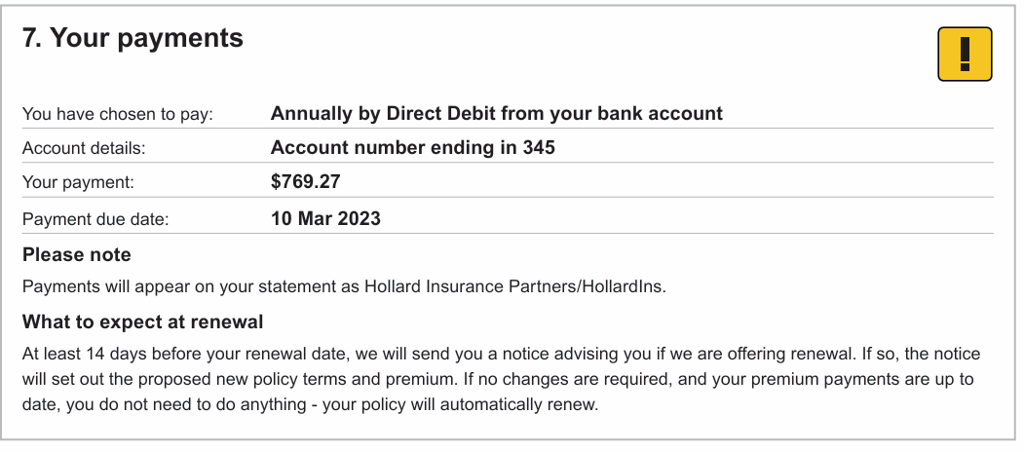

Ref | Variables | Content | Logic | Style
YRP 1 |  | 7. Your payments | Always display | Heading_1_COI
YRP 2 | <PaymentFrequencyCode>  <PaymentMethodCode> | You have chosen to pay: Annually by Direct Debit from your bank account | IF <PaymentFrequencyCode> = "2|PaymentPlanAnnual" AND <PaymentMethodCode> = "EFT"  THEN display  ELSE do not display | Column 1 text:  Bodycopy_COI  Column 2 text:  Table_Heading_3
YRP 3 | <PaymentFrequencyCode>  <PaymentMethodCode> | You have chosen to pay: Annually by Direct Debit from your credit card | IF <PaymentFrequencyCode> = "2|PaymentPlanAnnual" AND <PaymentMethodCode> = "EFTC"  THEN display  ELSE do not display | Column 1 text:  Bodycopy_COI  Column 2 text:  Table_Heading_3
YRP 4 | <PaymentFrequencyCode>  <PaymentMethodCode> | You have chosen to pay: Monthly by Direct Debit from your bank account | IF <PaymentFrequencyCode> = "1|PaymentPlanMonthly" AND <PaymentMethodCode> = "EFT"  THEN display  ELSE do not display | Column 1 text:  Bodycopy_COI  Column 2 text:  Table_Heading_3
YRP 5 | <PaymentFrequencyCode>  <PaymentMethodCode> | You have chosen to pay: Monthly by Direct Debit from your credit card | IF <PaymentFrequencyCode> = "1|PaymentPlanMonthly" AND <PaymentMethodCode> = "EFTC"  THEN display  ELSE do not display | Column 1 text:  Bodycopy_COI  Column 2 text:  Table_Heading_3
YRP 6 | <PaymentFrequencyCode>  <PaymentMethodCode> | You have chosen to pay: Annually by invoice | IF <PaymentFrequencyCode> = "2|PaymentPlanAnnual" AND <PaymentMethodCode> = "INV"  THEN display  ELSE do not display | Column 1 text:  Bodycopy_COI  Column 2 text:  Table_Heading_3
YRP 7 | <PaymentMethodCode>  <AccountNumber> | Account details: Account number ending in <AccountNumber> | IF <PaymentMethodCode> = "EFT"  THEN display  ELSE do not display  Note:  To display last 3 digits of Bank account number | Column 1 text:  Bodycopy_COI  Column 2 text:  Table_Heading_3
YRP 8 | <PaymentMethodCode>  <CardNumber> | Account details: Credit card number ending in <CardNumber> | IF <PaymentMethodCode> = "EFTC"  THEN display  ELSE do not display  Note:  To display last 3 digits of masked credit card number | Column 1 text:  Bodycopy_COI  Column 2 text:  Table_Heading_3
YRP 9 | <PaymentFrequencyCode>  <CurrentAnnualGrossPremium> <DocumentSubType> | Your payment: <CurrentTermGrossPremium> | IF  <DocumentSubType>= “New Business” AND <PaymentFrequencyCode> = "2|PaymentPlanAnnual”  THEN display  ELSE do not display | Column 1 text:  Bodycopy_COI  Column 2 text:  Table_Heading_3
YRP 10 | <PaymentFrequencyCode>  <CurrentTermGrossPremium> <DocumentSubType> | Your payment: <CurrentTermGrossPremium> per month | IF  <DocumentSubType>= “New Business” AND <PaymentFrequencyCode> = "1|PaymentPlanMonthly”  THEN display  ELSE do not display | Column 1 text:  Bodycopy_COI  Column 2 text:  Table_Heading_3
YRP 11 | <PaymentFrequencyCode>  <CurrentAnnualGrossPremium> <DocumentSubType>  <RenewalDate> | Your payment: <CurrentTermGrossPremium> (will automatically renew on <CurrentTermEffectiveDate>) | IF  <DocumentSubType>= “Renewal” AND <PaymentFrequencyCode> = "2|PaymentPlanAnnual”  THEN display  ELSE do not display | Column 1 text:  Bodycopy_COI  Column 2 text:  Table_Heading_3
YRP 12 | <PaymentFrequencyCode>  <CurrentTermGrossPremium> <DocumentSubType>  <RenewalDate> | Your payment: <CurrentTermGrossPremium> per month (will automatically renew on <CurrentTermEffectiveDate>) | IF  <DocumentSubType>= “Renewal” AND <PaymentFrequencyCode> = "1|PaymentPlanMonthly”  THEN display  ELSE do not display | Column 1 text:  Bodycopy_COI  Column 2 text:  Table_Heading_3
YRP 13 | <PaymentMethodCode> <PaymentFrequencyCode>  <TransactionPremium>  <DocumentSubType>  <AmountDue> | Your payment: <TransactionPremium> | IF  <DocumentSubType> = "Endorsement" AND <PaymentFrequencyCode> = "2|PaymentPlanAnnual" AND <TransactionPremium> GREATER THAN 0 THEN display  ELSE do not display | Column 1 text:  Bodycopy_COI  Column 2 text:  Table_Heading_3
YRP 14 | <PaymentMethodCode> <PaymentFrequencyCode>  <TransactionPremium>  <DocumentSubType>  <AmountDue>  <RefundAmount> | Your refund: <TransactionPremium> | IF  <DocumentSubType> = "Endorsement" AND <PaymentFrequencyCode> = "2|PaymentPlanAnnual" AND <TransactionPremium> less THAN 0  THEN display  ELSE do not display | Column 1 text:  Bodycopy_COI  Column 2 text:  Table_Heading_3
YRP 15 | <PaymentMethodCode> <PaymentFrequencyCode>  <TransactionPremium>  <DocumentSubType>  <AmountDue>  <TotalAmountDue> | Your payment: No additional payment | IF  <DocumentSubType> = "Endorsement" AND <PaymentFrequencyCode> = "2|PaymentPlanAnnual" AND <TransactionPremium> = 0 THEN display  ELSE do not display | Column 1 text:  Bodycopy_COI  Column 2 text:  Table_Heading_3
YRP 20 | <IsAfterFinalPayment> <PaymentFrequencyCode>  <TransactionPremium>  <DocumentSubType>  <CurrentTermGrossPremium> | Your payment: <CurrentTermGrossPremium> per month | IF  <DocumentSubType> = "Endorsement" AND <PaymentFrequencyCode> = "1|PaymentPlanMonthly" AND <TransactionPremium> Not Equal 0 AND <IsAfterFinalPayment> = "0"  THEN display  ELSE do not display | Column 1 text:  Bodycopy_COI  Column 2 text:  Table_Heading_3
YRP 21 | <IsAfterFinalPayment> <PaymentFrequencyCode>  <TransactionPremium>  <DocumentSubType> | Your payment: No additional premium | IF  <DocumentSubType> = "Endorsement" AND <PaymentFrequencyCode> = "1|PaymentPlanMonthly" AND <TransactionPremium> = 0  AND <IsAfterFinalPayment> = "1" or "0”  THEN display  ELSE do not display | Column 1 text:  Bodycopy_COI  Column 2 text:  Table_Heading_3
YRP 22 | <IsAfterFinalPayment> <PaymentFrequencyCode>  <TransactionPremium>  <DocumentSubType> | Your payment: <CurrentAnnualGrossPremium> | IF  <DocumentSubType> = "Endorsement" AND <PaymentFrequencyCode> = "1|PaymentPlanMonthly" AND <TransactionPremium> GREATER THAN 0 AND <IsAfterFinalPayment> = "1"  THEN display  ELSE do not display | Column 1 text:  Bodycopy_COI  Column 2 text:  Table_Heading_3
YRP 23 | <IsAfterFinalPayment> <PaymentFrequencyCode>  <TransactionPremium>  <DocumentSubType> | Your refund: <TransactionPremium> | IF  <DocumentSubType> = "Endorsement" AND <PaymentFrequencyCode> = "1|PaymentPlanMonthly" AND <TransactionPremium> LESS THAN 0  AND <IsAfterFinalPayment> = "1"  THEN display  ELSE do not display | Column 1 text:  Bodycopy_COI  Column 2 text:  Table_Heading_3
YRP23B |  | Your payment: <CurrentTermGrossPremium> per month | IF  <DocumentSubType> = "Endorsement"  AND <PaymentFrequencyCode> = "1|PaymentPlanMonthly"  AND <TransactionPremium> = “0”  THEN display  ELSE do not display | Column 1 text:  Bodycopy_COI  Column 2 text:  Table_Heading_3
YRP 24 | <PaymentDate>  <PaymentFrequencyCode>  <TransactionPremium>  <DocumentSubType> | Payment due date: <PaymentDate> | IF  <DocumentSubType>= “New Business” OR “Renewal” AND <PaymentFrequencyCode> = "2|PaymentPlanAnnual”  THEN display  ELSE do not display | Column 1 text:  Bodycopy_COI  Column 2 text:  Table_Heading_3
YRP 25 | <PaymentDate>  <PaymentFrequencyCode>  <TransactionPremium>  <DocumentSubType> | First payment due date: <PaymentDate> | IF  <DocumentSubType>= “New Business” OR “Renewal” AND <PaymentFrequencyCode> = "1|PaymentPlanMonthly”  THEN display  ELSE do not display | Column 1 text:  Bodycopy_COI  Column 2 text:  Table_Heading_3
YRP 26 | <PaymentDate>  <PaymentFrequencyCode>  <TransactionPremium>  <DocumentSubType> | Payment due date: <PaymentDate> | IF  <DocumentSubType>= “Endorsement” AND <PaymentFrequencyCode> = "2|PaymentPlanAnnual”  AND  <TransactionPremium> GREATER THAN 0  THEN display  ELSE do not display | Column 1 text:  Bodycopy_COI  Column 2 text:  Table_Heading_3
YRP 27 | <PaymentDate>  <PaymentFrequencyCode>  <TransactionPremium>  <DocumentSubType> | Payment due date: <PaymentDate> | IF  <DocumentSubType>= “Endorsement” AND <PaymentFrequencyCode> = "2|PaymentPlanAnnual”  AND  <TransactionPremium> < or = “0”  AND <AmountDue> > “0"  THEN display  ELSE do not display | Column 1 text:  Bodycopy_COI  Column 2 text:  Table_Heading_3
YRP 28 | <PaymentDate>  <PaymentFrequencyCode>  <TransactionPremium>  <DocumentSubType>  <IsAfterFinalPayment> | Payment due date: <PaymentDate> | IF  <DocumentSubType> = "Endorsement" AND <PaymentFrequencyCode> = "1|PaymentPlanMonthly" AND <TransactionPremium> GREATER THAN 0  AND <IsAfterFinalPayment> = "1" or "0”  THEN display  ELSE do not display | Column 1 text:  Bodycopy_COI  Column 2 text:  Table_Heading_3
PLN 1 |  | Please note  Payments will appear on your statement as Hollard Insurance Partners/HollardIns. | ALWAYS display | Heading:  Bodycopy_B  Body:  Table_Bodycopy_COI
WTE 1 |  | What to expect at renewal  At least 14 days before your renewal date, we will send you a notice advising you if we are offering renewal. If so the notice will set out the proposed new policy terms and premium. | IF <DocumentSubType> = “New Business” OR “Endorsement”  AND  <RenewalTypeCode>  = “1|AutoRenewal”  THEN display | Heading:  Bodycopy_B  Body:  Table_Bodycopy_COI
WTE 2 |  | If no changes are required to your policy, and your premium payments are up to date, you do not need to do anything - your policy will automatically renew. | IF  <DocumentSubType> = “New Business” OR “Endorsement”  AND  <RenewalTypeCode>  = “1|AutoRenewal”  AND  <PaymentMethodCode> != INV  THEN display “If no changes are required, and your premium payments are up to date, you do not need to do anything - your policy will automatically renew.”  ELSE Do Not display
WTE 3 |  | What to expect at renewal  At least 14 days before your renewal date, we will send you a notice advising you if we are offering renewal. If so the notice will provide the offer of renewal and advise you to call us if you'd like to proceed with the renewal. If you don’t contact us, your policy will cancel. | IF <DocumentSubType> = 'New Business' OR Endorsement”  AND  <RenewalTypeCode>= “2|ForceManualRenewal”  THEN display  ELSE do not display | Heading:  Bodycopy_B  Body:  Table_Bodycopy_COI
WTE 4 |  | If you are experiencing vulnerability or financial hardship, we encourage you to tell us, as we have extra care options in place. You can also access further information at <BrandVunerableURL> | Always Display | Table_Bodycopy_COI

